**PRACTICLE FILE OF WEB PROGRAMMING**

**INDEX**

|  |  |  |  |  |
| --- | --- | --- | --- | --- |
| S.NO. | TOPIC | DATE | REMARKS | SIGNATURE |
| 1. | Write a program to print Hello World! |  |  |  |
| 2. | Write a program to perform sum of a two variable. |  |  |  |
| 3. | Write a program to perform arithmetic operations using arithmetic operator. |  |  |  |
| 4. | Write a program in PHP to show the use of Turnary Operator. |  |  |  |
| 5. | Write a program to perform Comparison using Comparison Operator. |  |  |  |
| 6. | Write a program in PHP to show the use of Logical Operator. |  |  |  |
| 7. | Write a program to show the usage of Assignment Operator. |  |  |  |
| 8. | Write a program in PHP using if and else. |  |  |  |
| 9. | Write a program in PHP using else if. |  |  |  |
| 10. | Create an array and display its content using foreach loop in PHP. |  |  |  |
| 11. | Create an Associative Array using PHP. |  |  |  |
| 12. | Create a multi-dimensional array using PHP. |  |  |  |
| 13. | Write a program in PHP to show the use of foreach and continue statement. |  |  |  |
| 14. | Write a program in PHP to show the use of while loop and break statement. |  |  |  |
| 15. | Write a program to show the usage of DO-WHILE loop. |  |  |  |
| 16. | Write a program in PHP to perform the increment and decrement in While loop. |  |  |  |
| 17. | Write a program to showcase the For loop. |  |  |  |
| 18. | Write a program in PHP to perform a function preg_match_all in string. |  |  |  |
| 19. | Write a program in PHP to perform a function ereg_replace in string. |  |  |  |
| 20. | Write a program in PHP to perform a function preg_split in string. |  |  |  |
| 21. | Write a program in PHP to show the use of preg_replace and str_replace in string. |  |  |  |
| 22. | Write a program in PHP to perform a function perg_grep in string. |  |  |  |
| 23. | Write a program in PHP to showcase the printing of an Indexed Array. |  |  |  |
| 24. | Write a program to print the contents of an array in Upper Case. |  |  |  |
| 25. | Write a program show the use of function array_chunk. |  |  |  |
| 26. | Write a program to perform count() function. |  |  |  |
| 27. | Write a program to perform sorting on array elements. |  |  |  |
| 28. | Write a program in PHP to reverse an array using array_reverse function. |  |  |  |
| 29. | Write a program in PHP to search an element in an array. |  |  |  |
| 30. | Write a program in PHP to intersect a array. |  |  |  |
| 31. | Write a program in PHP to perfrom a function preg_match in string. |  |  |  |
| 32. | Write a program to perform all four types of sorting. |  |  |  |
| 33. | Write a program to validate the form data using Filter_var() function. |  |  |  |
| 34. | Write a program to show the usage of Cookie. |  |  |  |
| 35. | Write a program to show the usage of Session. |  |  |  |
| 36. | Write a program to implement oops concepts. |  |  |  |
| 37. | Do Form handling in PHP. Design a personal information form, then submit &retrieve the data form using $_GET, $_POST() and $_REQUEST() variables. |  |  |  |
| 38. | Design a login form and validate that form using PHP programming. |  |  |  |
| 39. | Create admin login, logout form using session variables. |  |  |  |
| 40. | Write a program to create a file. |  |  |  |
| 41. | Write a program that use various PHP library functions, and that manipulate files and directories. |  |  |  |
| 42. | Write a program to read and display the content of previously created file. |  |  |  |
| 43. | Write a program to modify the content of an existing file. |  |  |  |
| 44. | Create a web page and which provides file uploading and downloading a file. |  |  |  |
| 45. | Design a form which upload and display image in PHP. |  |  |  |
| 46. | Use phpMyAdmin and perform the following: import, review data and structure, run SQL statements, create users and privileges. |  |  |  |
| 47. | Write a program to create mysql database. |  |  |  |
| 48. |  |  |  |  |
| 49. |  |  |  |  |
| 50. | Write a program to create a table and insert few records into it using form. |  |  |  |
| 51. | Write a program to select all the records and display it in table. |  |  |  |
| 52. | Write a program to modify(delete/modify/add) a table. |  |  |  |

**PROGRAM 1:** Write a program to print Hello World!

**SOURCE CODE:**

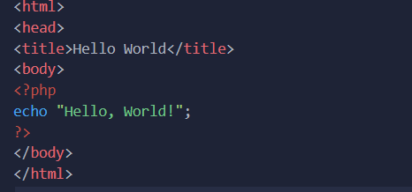

**OUTPUT:**



**PROGRAM 2:** Write a program to perform sum of two variables.

**SOURCE CODE:**

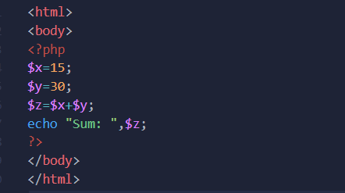

**OUTPUT:**



**PROGRAM 3:** Write a program to perform arithmetic operation using arithmetic operator.

**SOURCE CODE:**

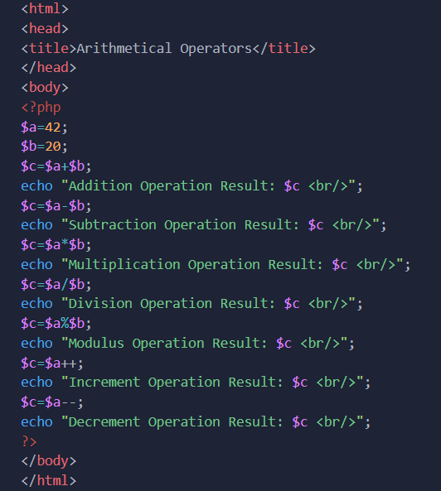

**OUTPUT:**

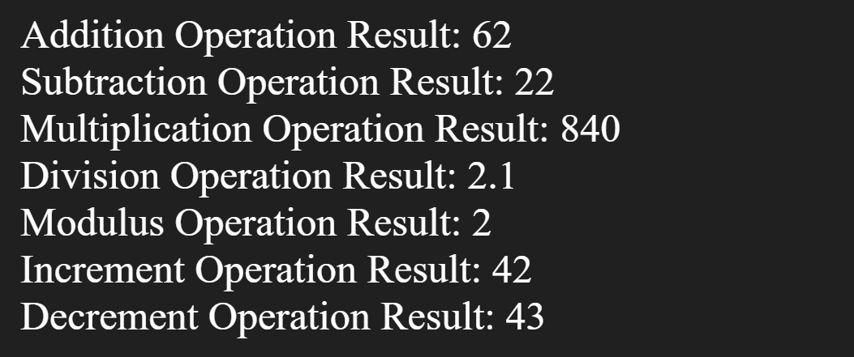

**PROGRAM 4:** Write a program in PHP to show the use of Turnary Operator.

**SOURCE CODE:**

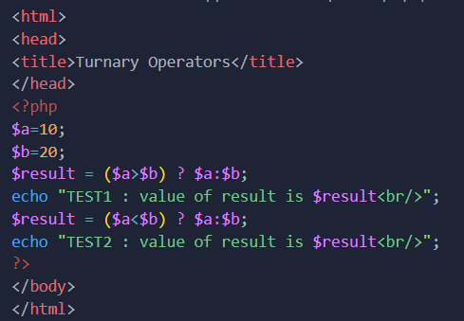

**OUTPUT:**



**PROGRAM 5:** Write a program in PHP to perform Comparison using Comparison Operator.

**SOURCE CODE:**

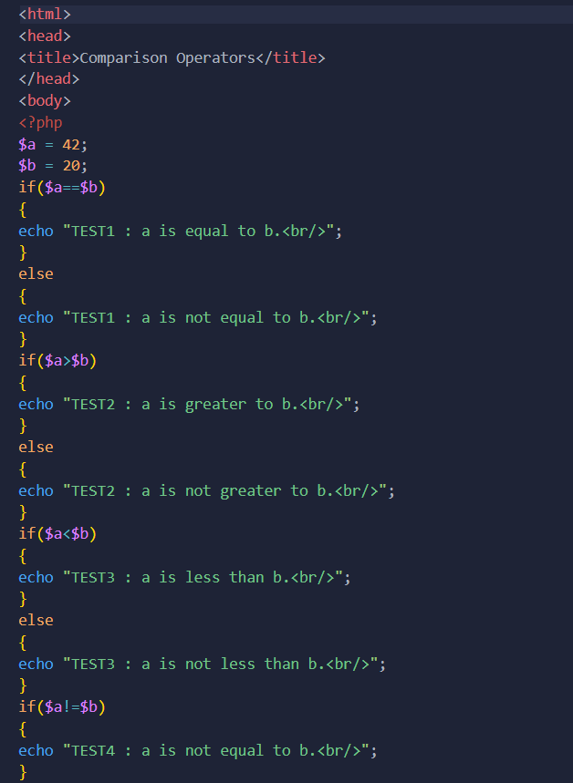

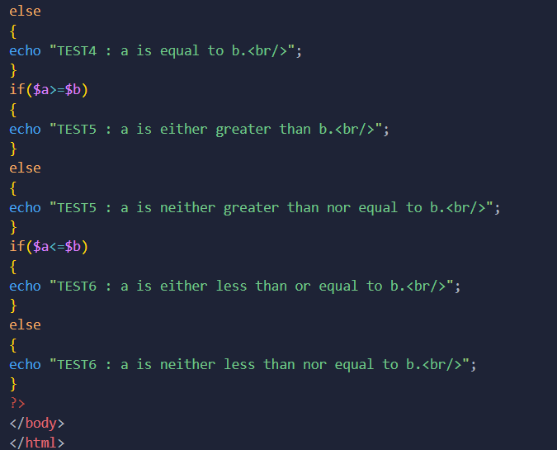

**OUTPUT:**

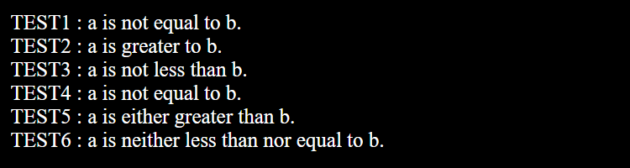

**PROGRAM 6:** Write a program in PHP to show the use of logical operator.

**SOURCE CODE:**

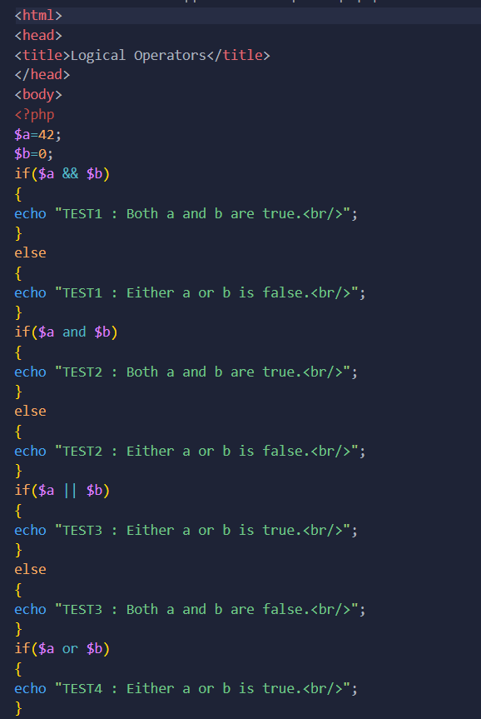

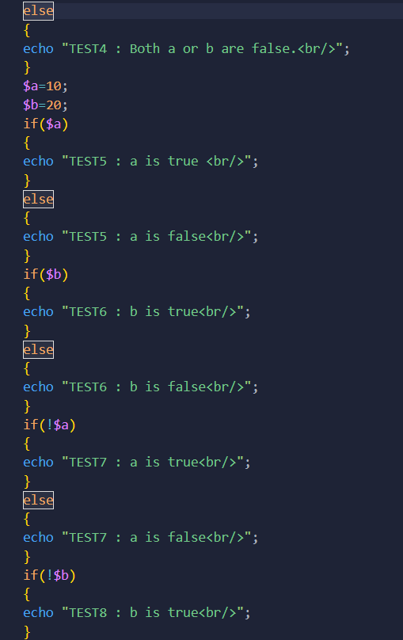

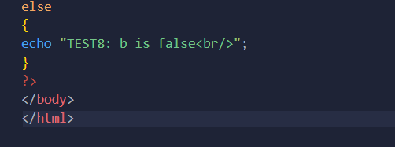

**OUTPUT:**

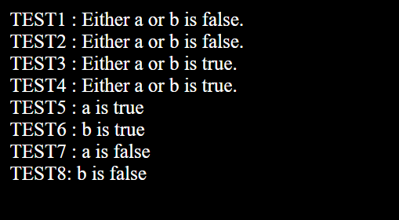

**PROGRAM 7:** Write a program to show the usage of assignment operator.

**SOURCE CODE:**

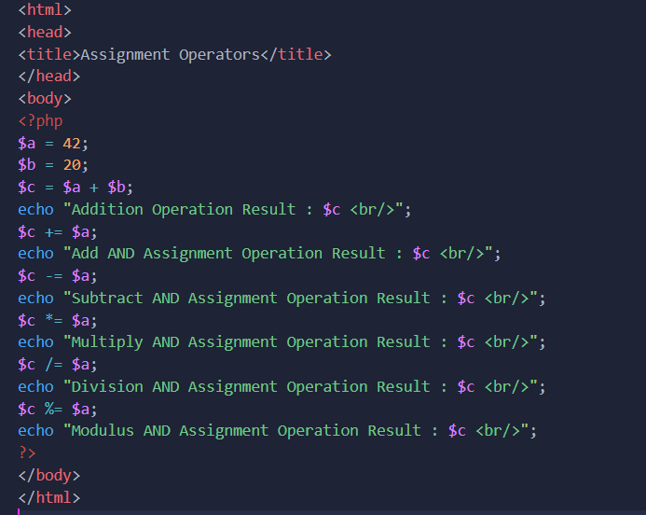

**OUTPUT:**

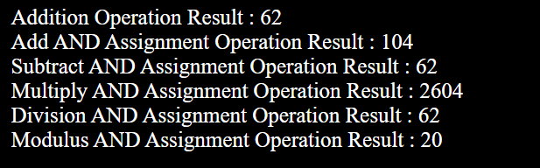

**PROGRAM 8:** Write a program in PHP using if and else.

**SOURCE CODE:**

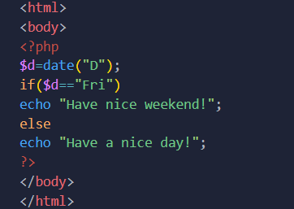

**OUTPUT:**

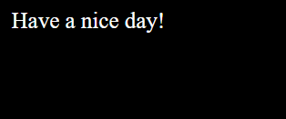

**PROGRAM 9:** Write a program in PHP using else if.

**SOURCE CODE:**

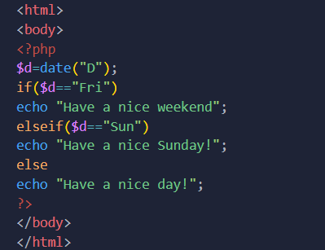

**OUTPUT:**

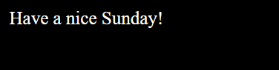

**PROGRAM 10:** Create and array and display its content using foreach loop in PHP.

**SOURCE CODE:**

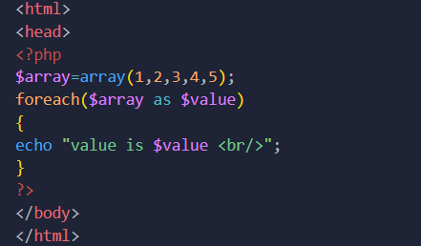

**OUTPUT:**

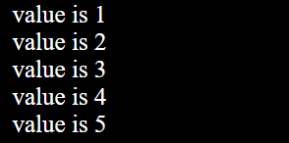

**PROGRAM 11:** Create an associative array using PHP.

**SOURCE CODE:**

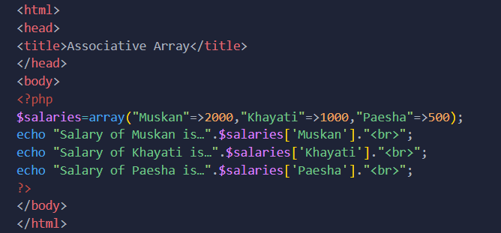

**OUTPUT:**

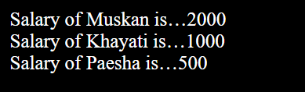

**PROGRAM 12:** Create a multi-dimensional array using PHP.

**SOURCE CODE:**

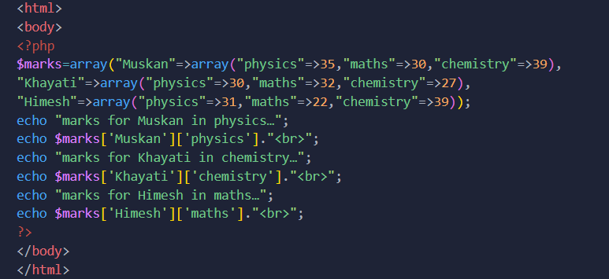

**OUTPUT:**

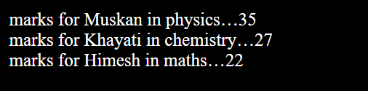

**PROGRAM 13:** Write a program in PHP to show the use of foreach and continue statement.

**SOURCE CODE:**

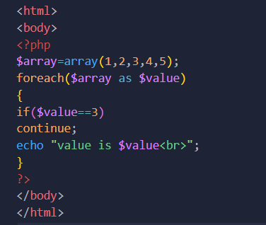

**OUTPUT:**

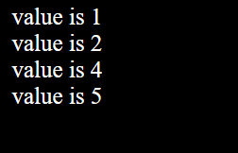

**PR0GRAM 14:** Write a program in PHP to show the use of while loop and break statement.

**SOURCE CODE:**

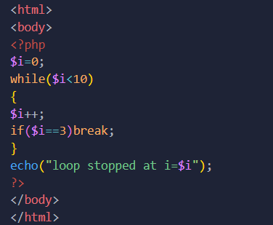

**OUTPUT:**

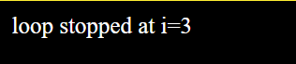

**PROGRAM 15:** Write a program to show the usage of do while loop.

**SOURCE CODE:**

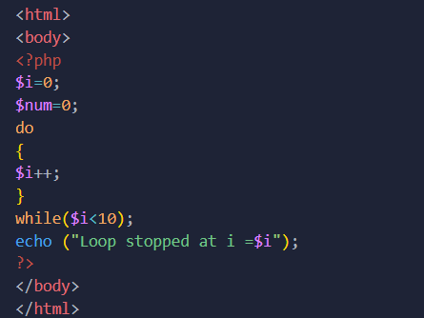

**OUTPUT:**

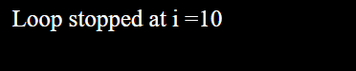

**PROGRAM 16:** Write a program in PHP to perform the increment and decrement in while loop.

**SOURCE CODE:**

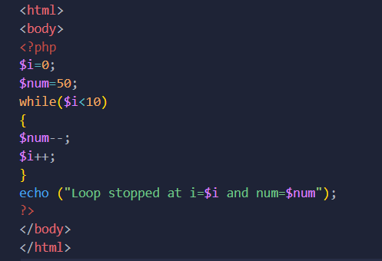

**OUTPUT:**

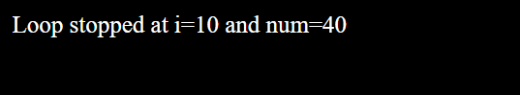

**PROGRAM 17:** Write a program to showcase the for loop.

**SOURCE CODE:**

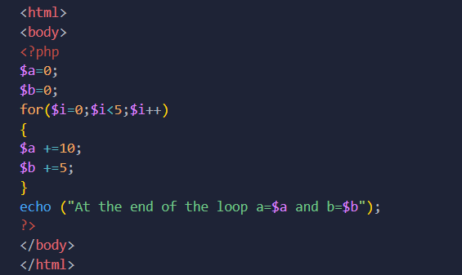

**OUTPUT:**

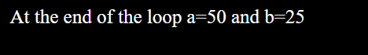

**PROGRAM 18:** Write a program in PHP to perform a preg_match_all in string**.**

**SOURCE CODE:**

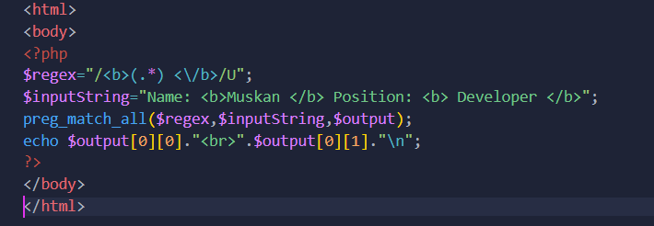

**OUTPUT:**

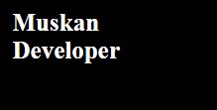

**PROGRAM 19:** Write a program in PHP to perform a function ereg_replace in string.

**SOURCE CODE:**

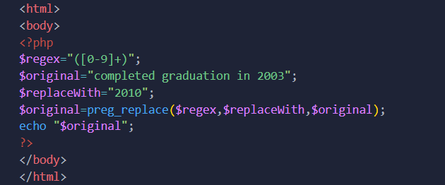

**OUTPUT:**

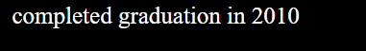

**PROGRAM 20:** Write a program in PHP to perform a function preg_split in string.

**SOURCE CODE:**

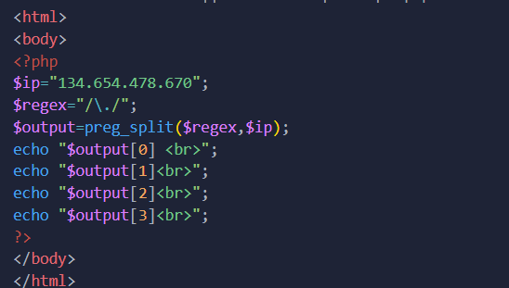

**OUTPUT:**

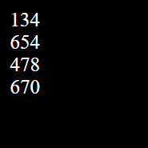

**PROGRAM 21:** Write a program in PHP to show the use of preg_replace and str_replace in string.

**SOURCE CODE:**

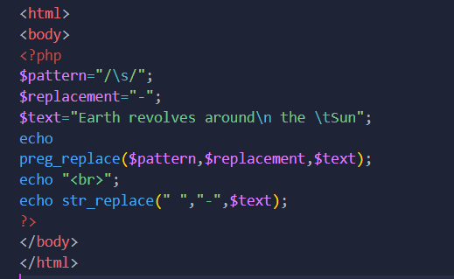

**OUTPUT:**

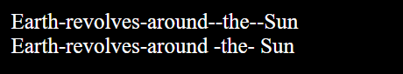

**PROGRAM 22:** Write a program in PHP to perform a function preg_grep in string.

**SOURCE CODE:**

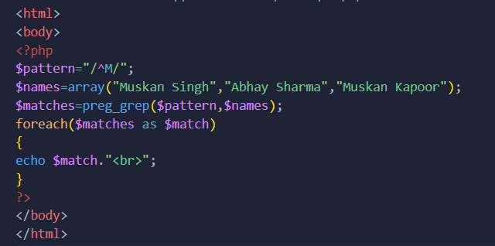

**OUTPUT:**

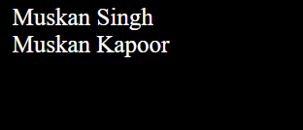

**PROGRAM 23:** Write a program in PHP to showcase the printing of an indexed array.

**SOURCE CODE:**

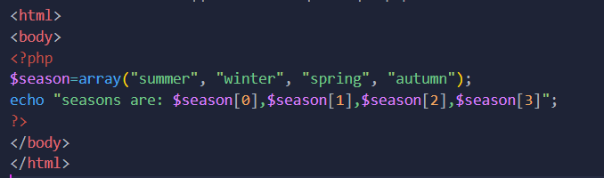

**OUTPUT:**

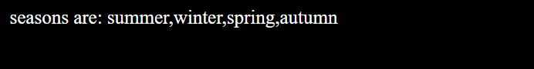

**PROGRAM 24:** Write a program to print the contents of an array in upper case.

**SOURCE CODE:**

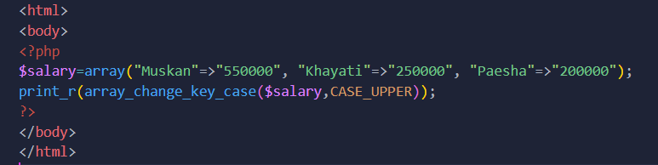

**OUTPUT:**



**PROGRAM 25:** Write a program to show the use of function array_chunk.

**SOURCE CODE:**

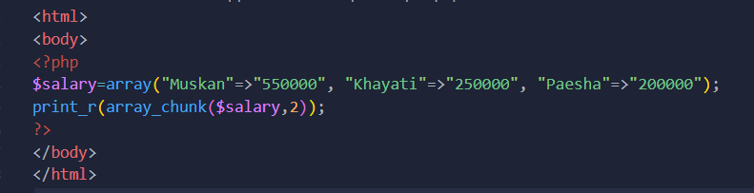

**OUTPUT:**



**PROGRAM 26:** Write a program to perform count() function.

**SOURCE CODE:**

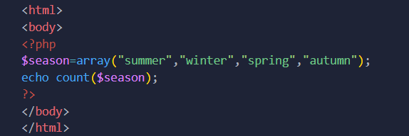

**OUTPUT:**

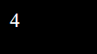

**PROGRAM 27:** Write a program to perform sorting on array elements.

**SOURCE CODE:**

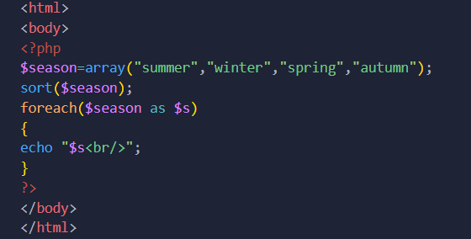

**OUTPUT:**

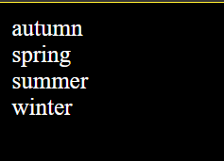

**PROGRAM 28:** Write a program in PHP to reverse an array using array_reverse function.

**SOURCE CODE:**

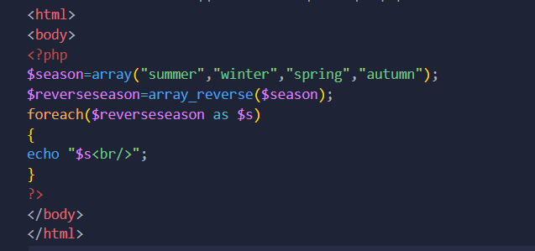

**OUTPUT:**

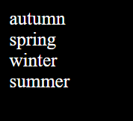

**PROGRAM 29:** Write a program in PHP to search an element in an array.

**SOURCE CODE:**

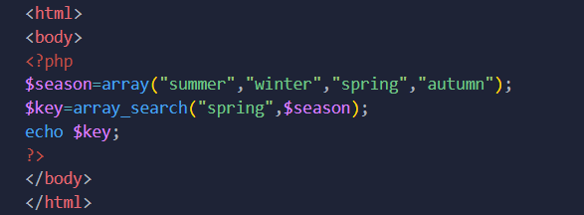

**OUTPUT:**

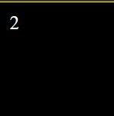

**PROGRAM 30:** Write a program in PHP to intersect a array.

**SOURCE CODE:**

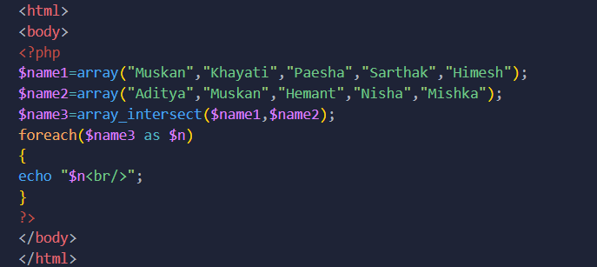

**OUTPUT:**

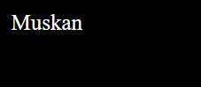

**PROGRAM 31:** Write a program in PHP to perform a function preg_match in string.

**SOURCE CODE:**

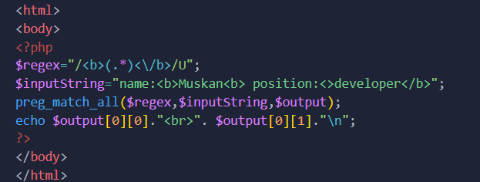

**OUTPUT:**

**PROGRAM 32:** Write a program to perform all four types of sorting.

**SOURCE CODE:**

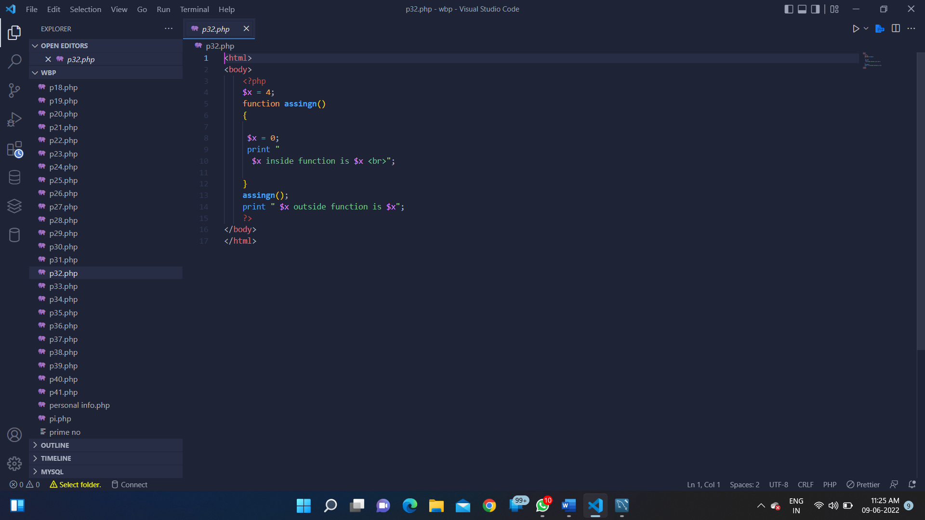

**OUTPUT:**

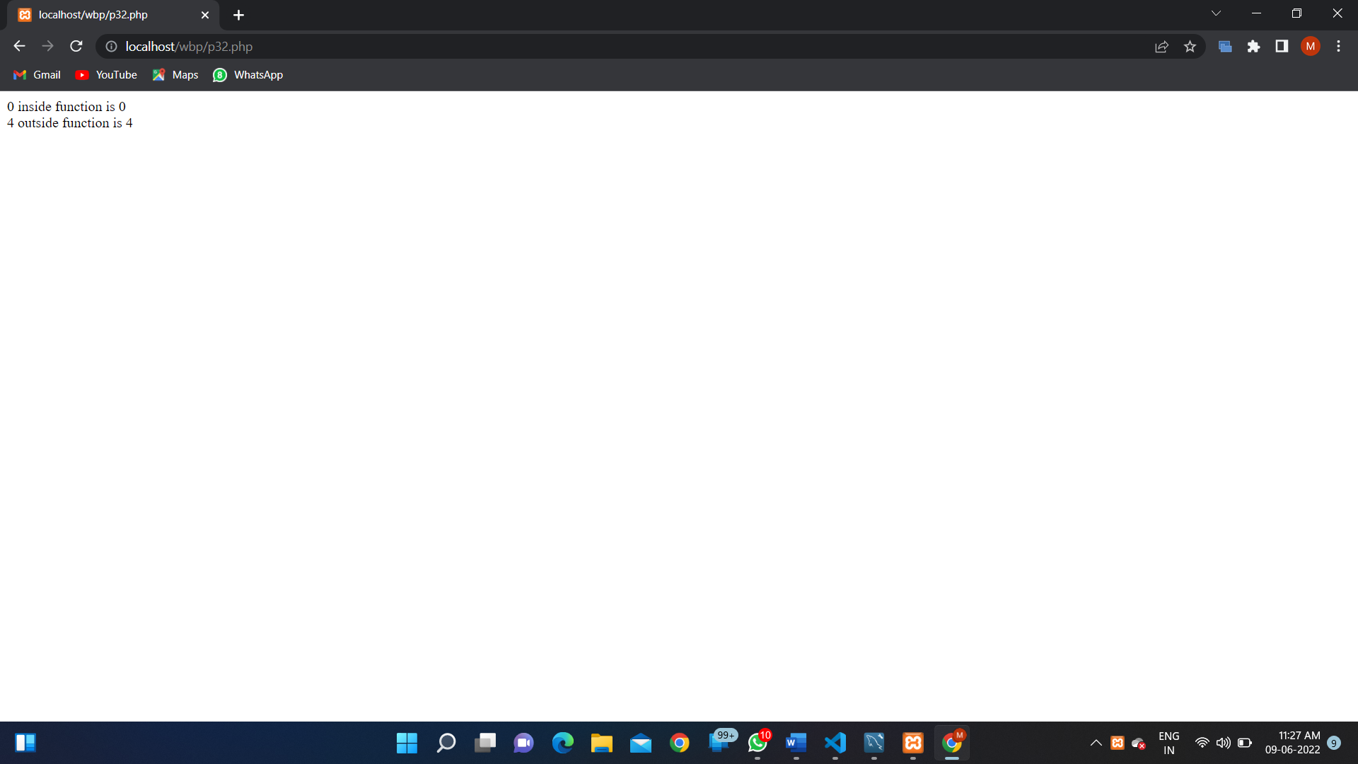

**PROGRAM 33:** Write a program to validate the form data using Filter_var() function.

**SOURCE CODE:**

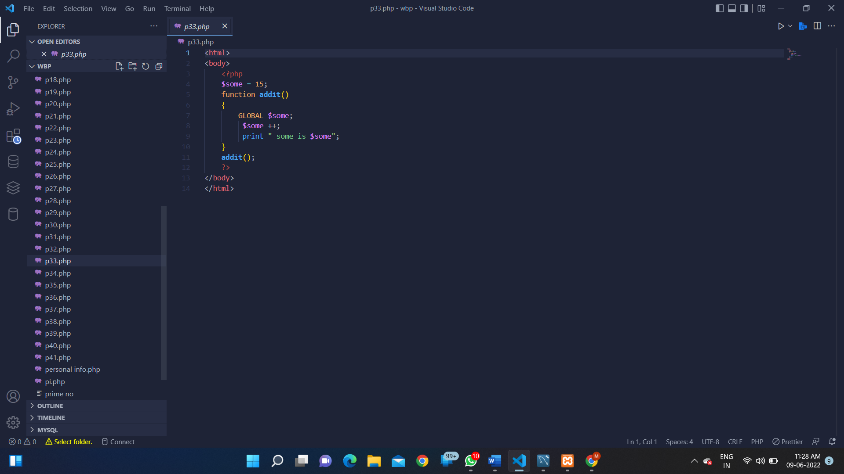

**OUTPUT:**

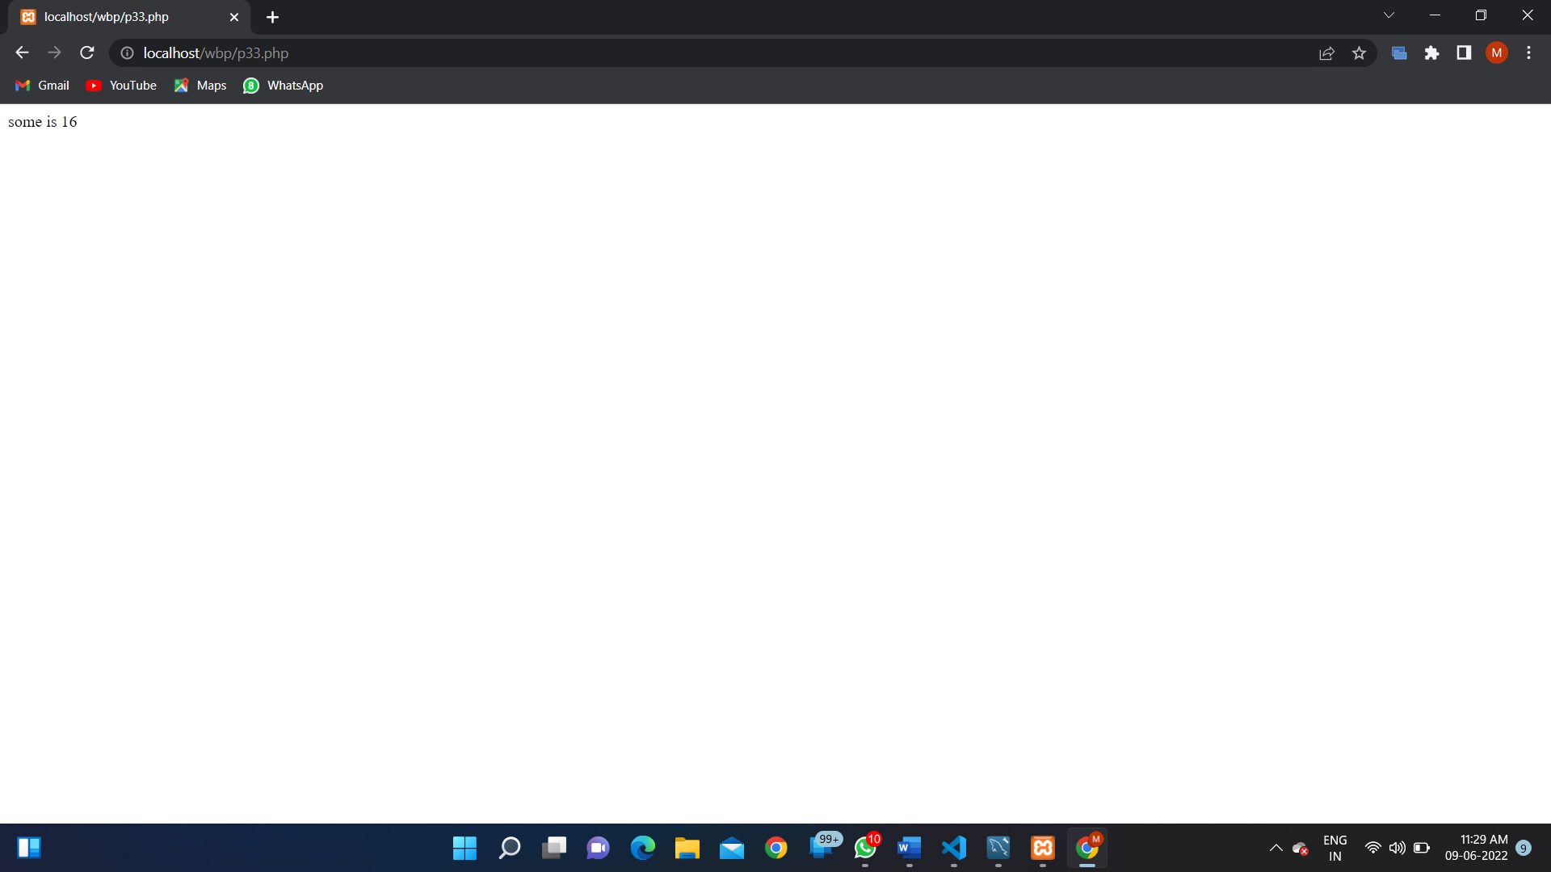

**PROGRAM 34:** Write a program to show the usage of Cookie.

**SOURCE CODE:**

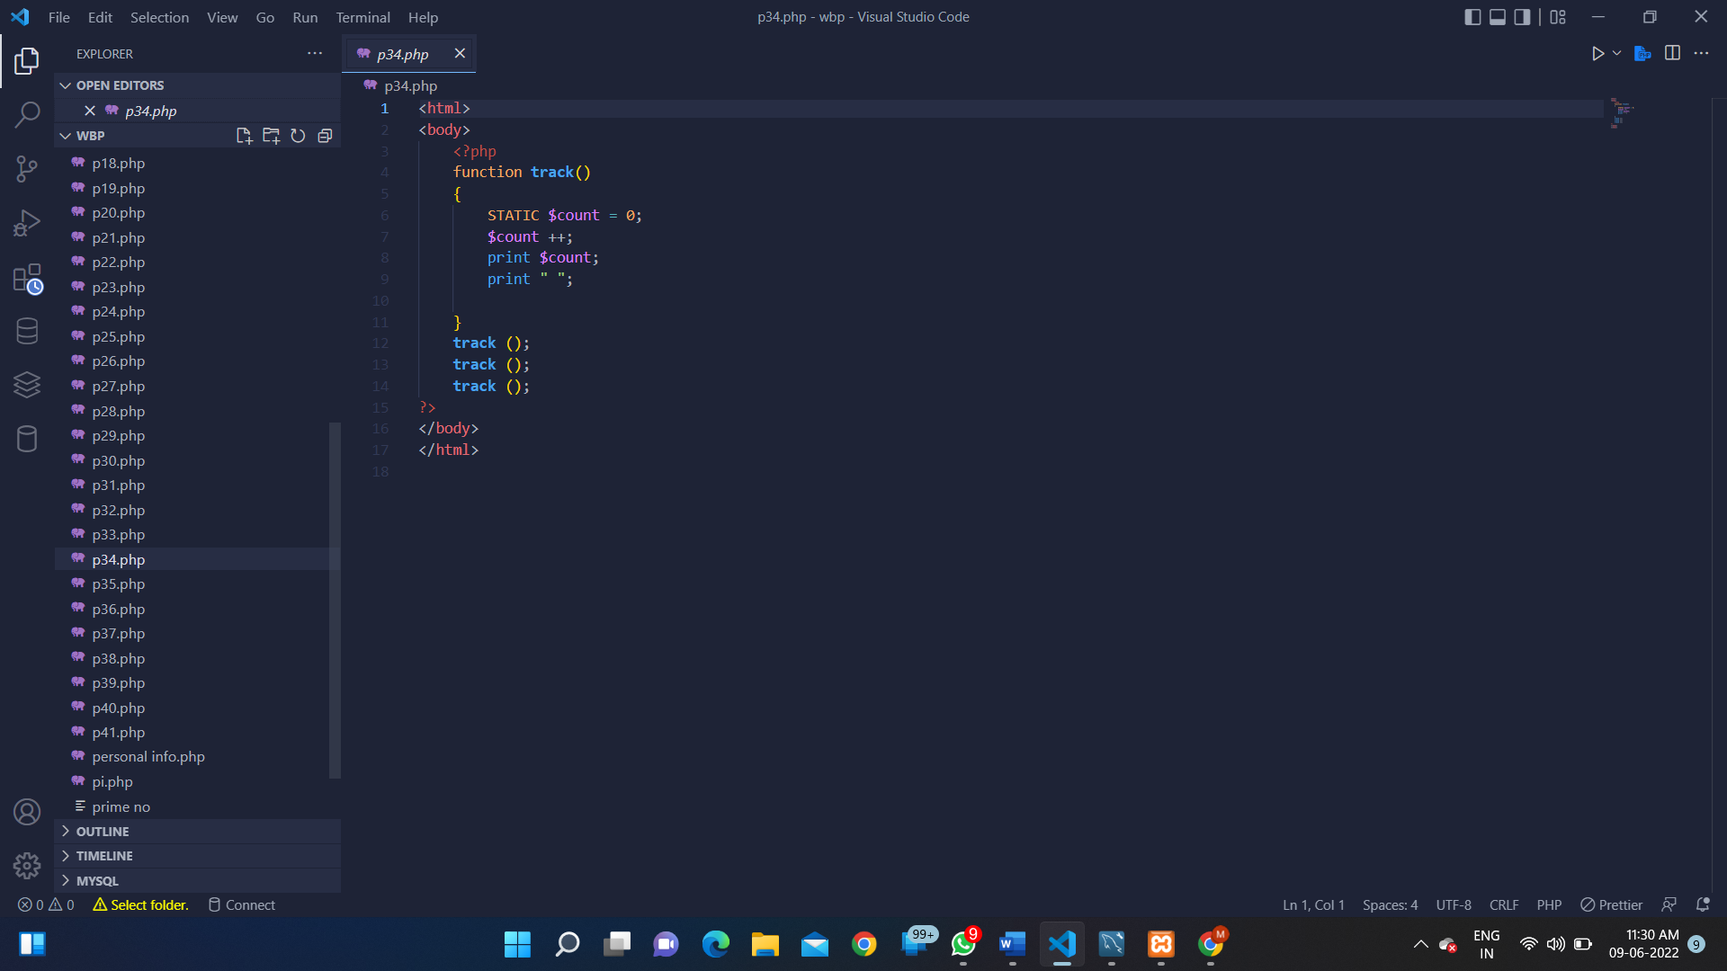

**OUTPUT:**

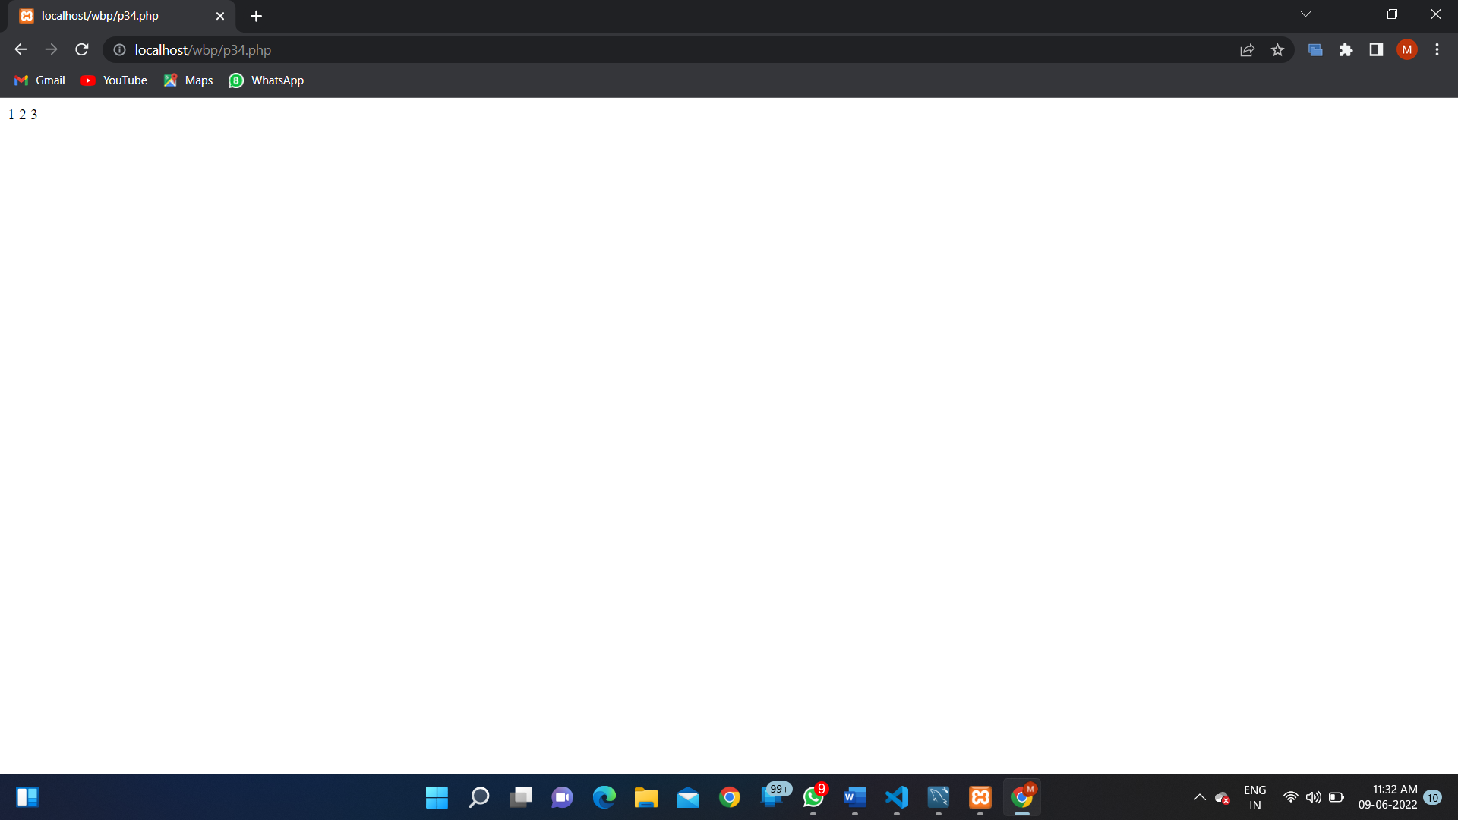

**PROGRAM 35:** Write a program to show the usage of Session.

**SOURCE CODE:**

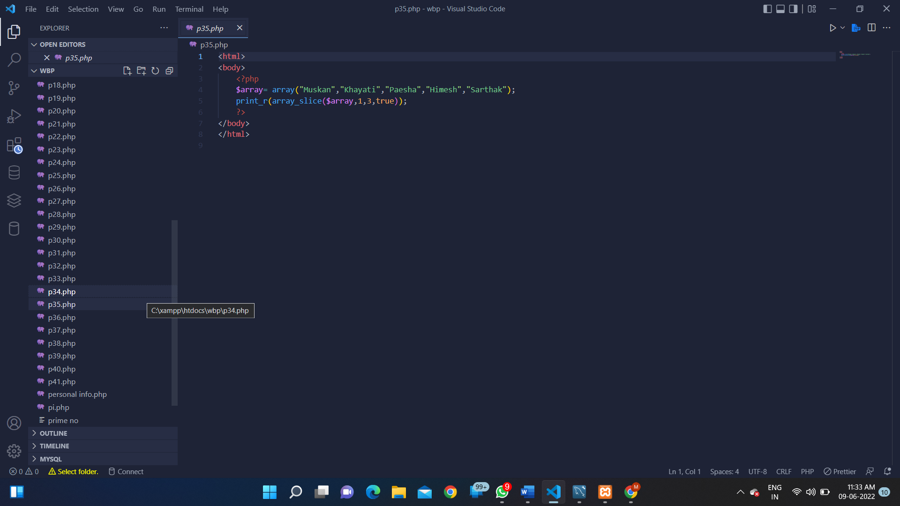

**OUTPUT:**

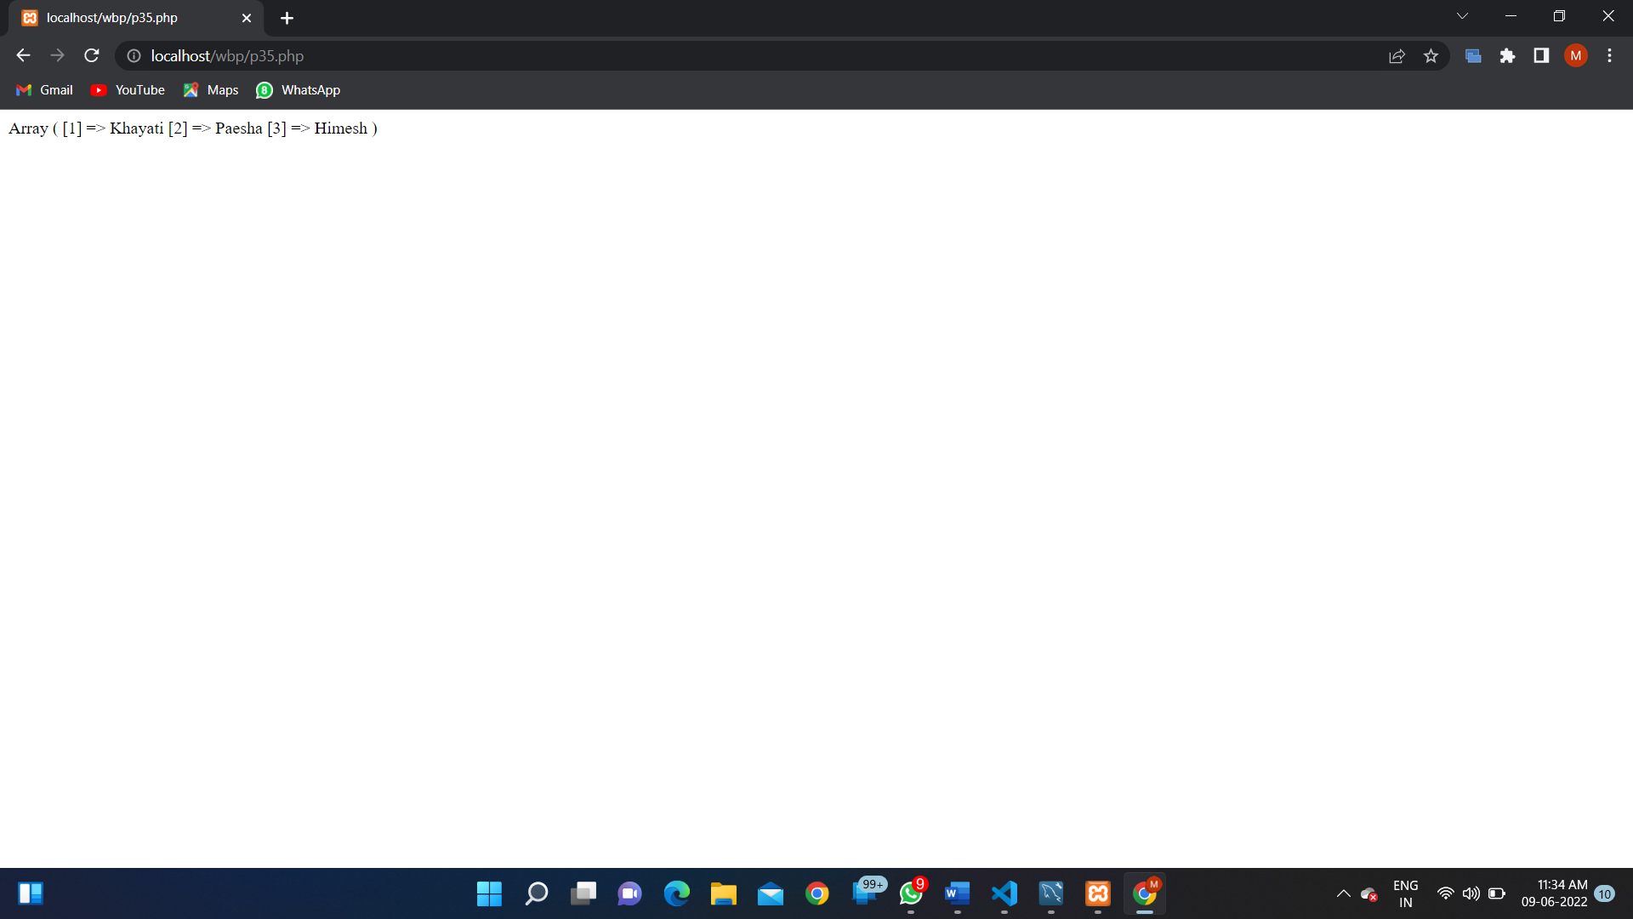

**PROGRAM 36:** Write a program to implement oops concepts.

**SOURCE CODE:**

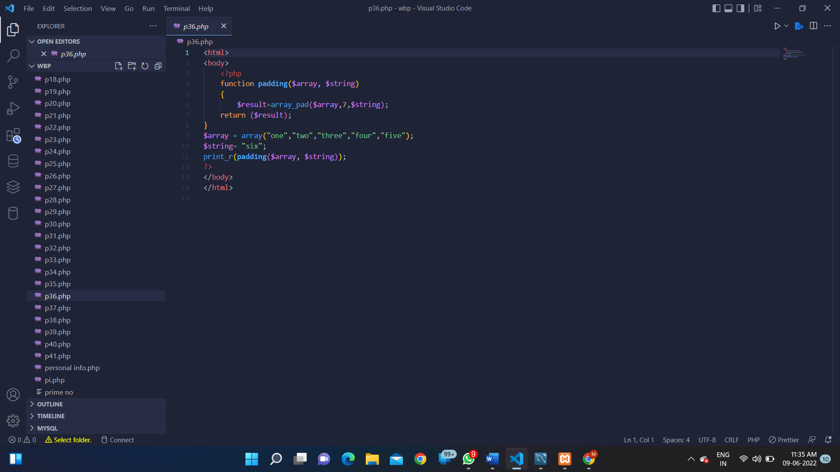

**OUTPUT:**

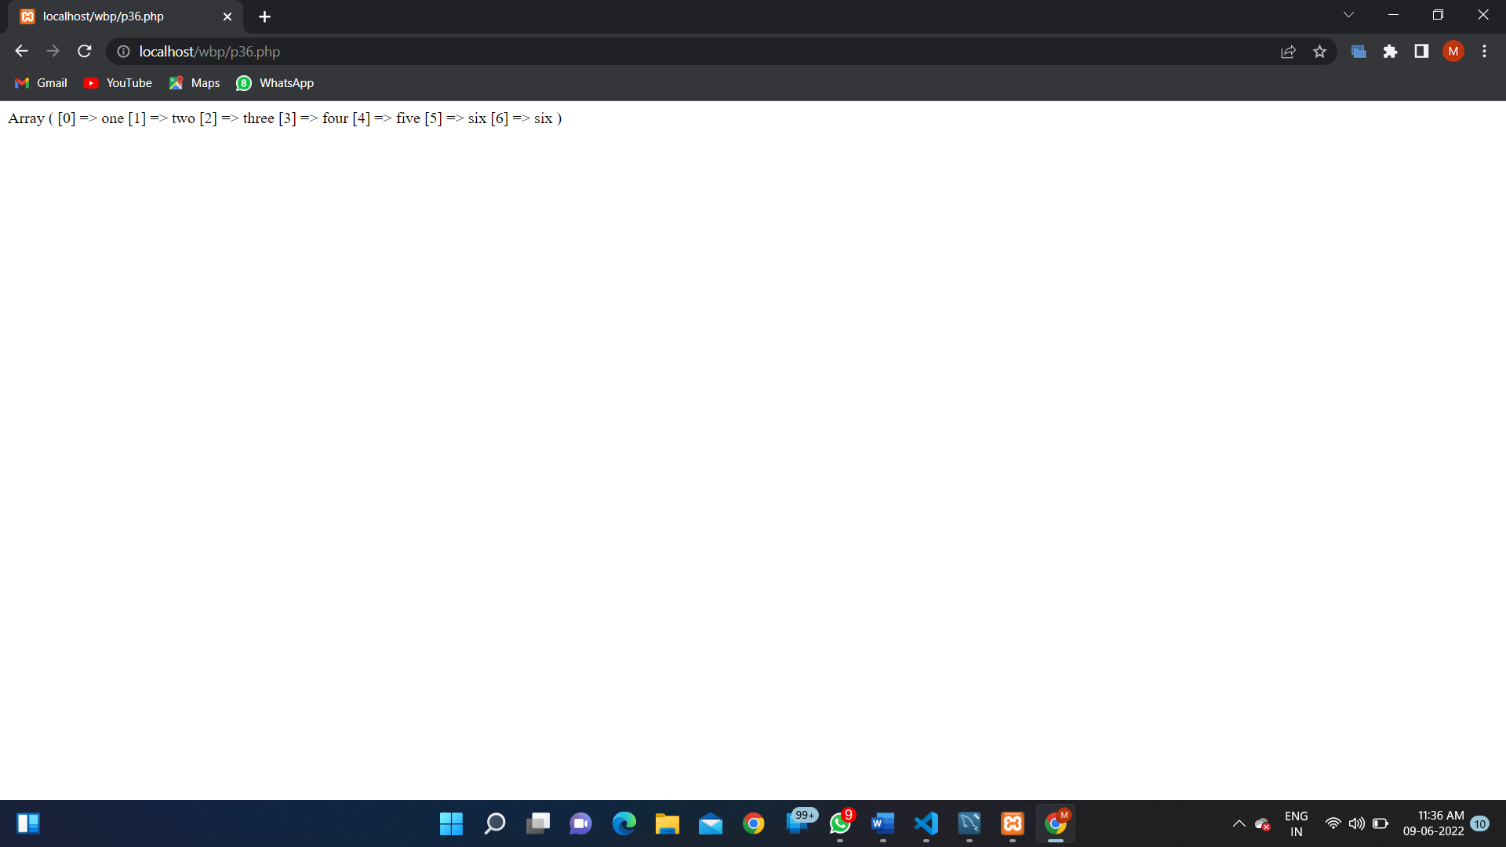

**PROGRAM 37:**

**SOURCE CODE:**

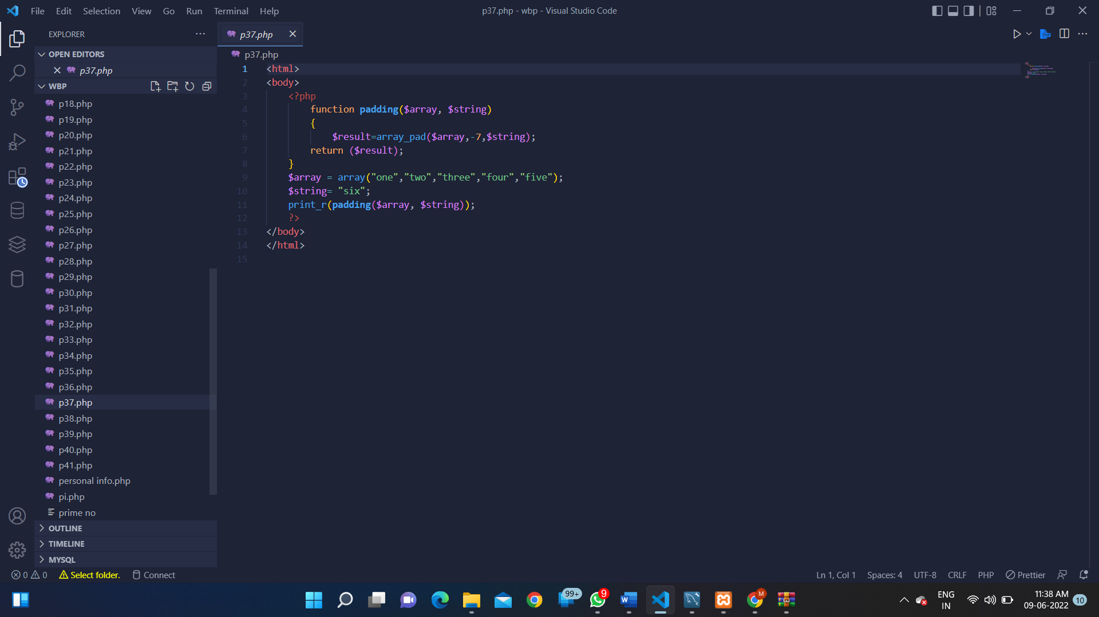

**OUTPUT:**

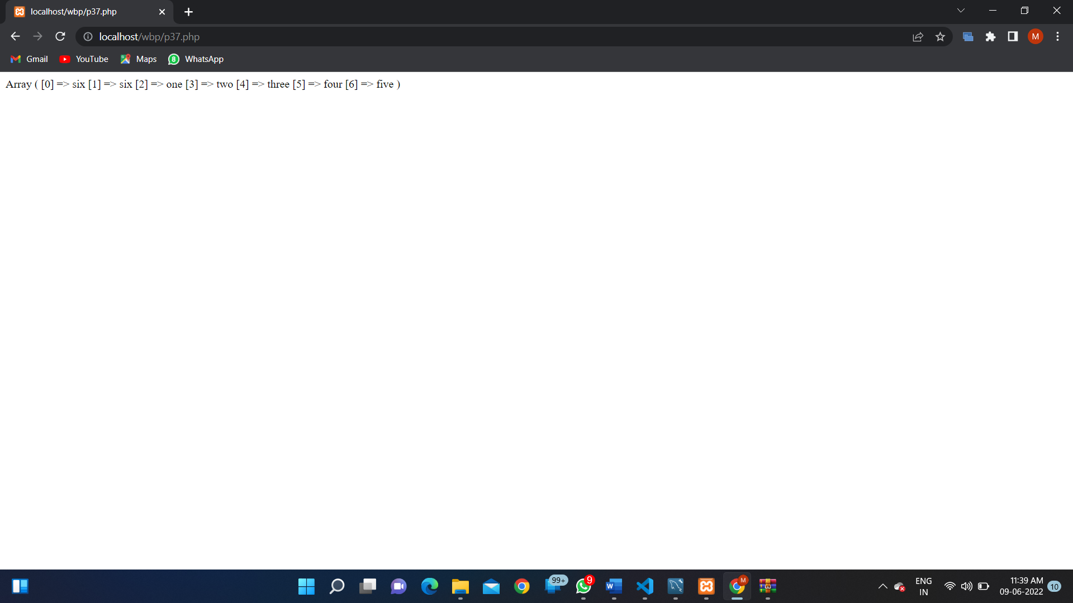

**PROGRAM 38:**

**SOURCE CODE:**

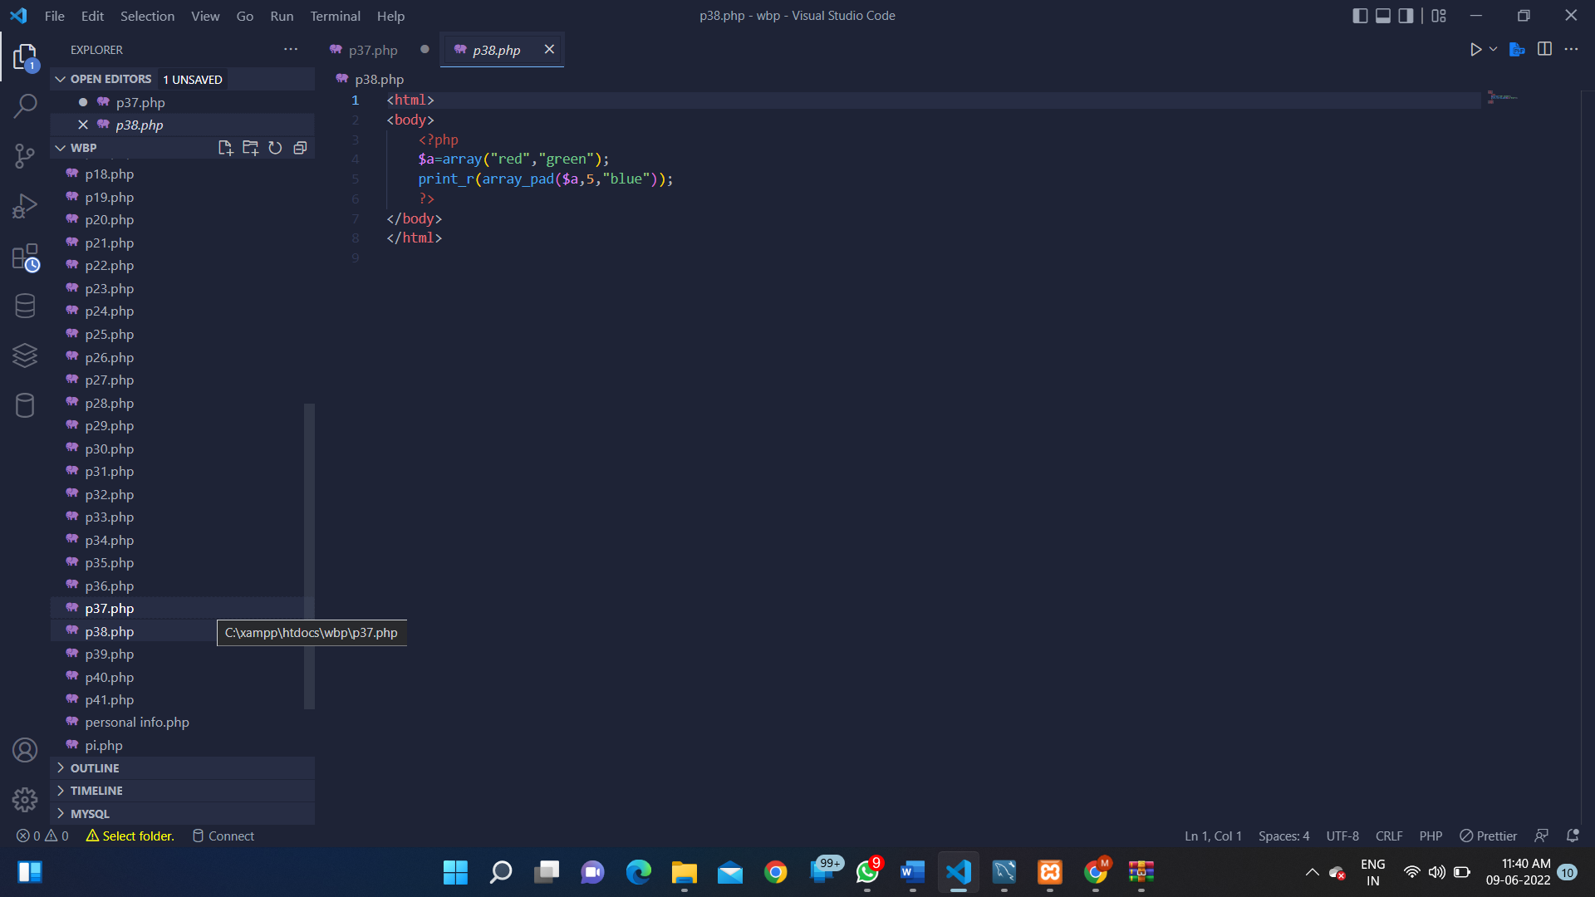

**OUTPUT:**

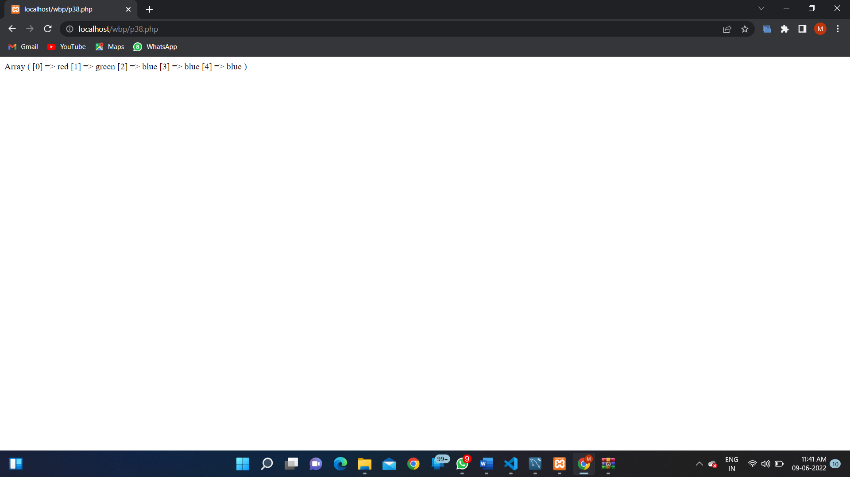

**PROGRAM 39:**

**SOURCE CODE:**

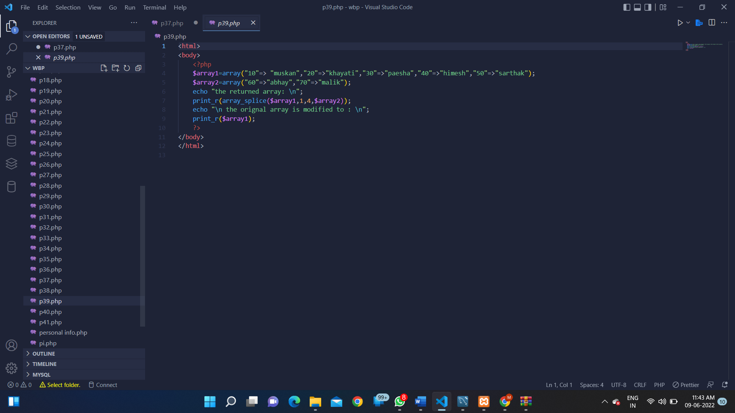

**OUTPUT:**

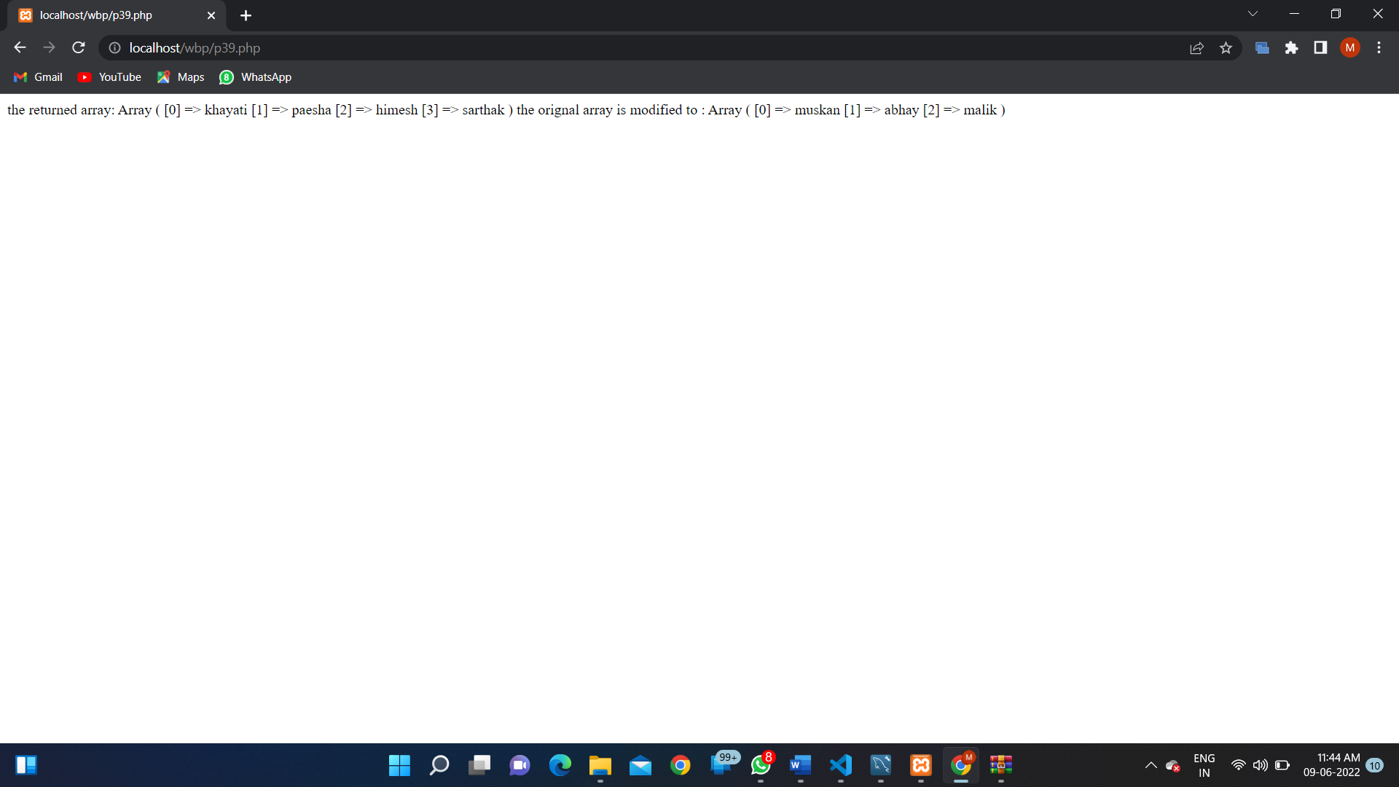

**PRORGAM 40:**

**SOURCE CODE:**

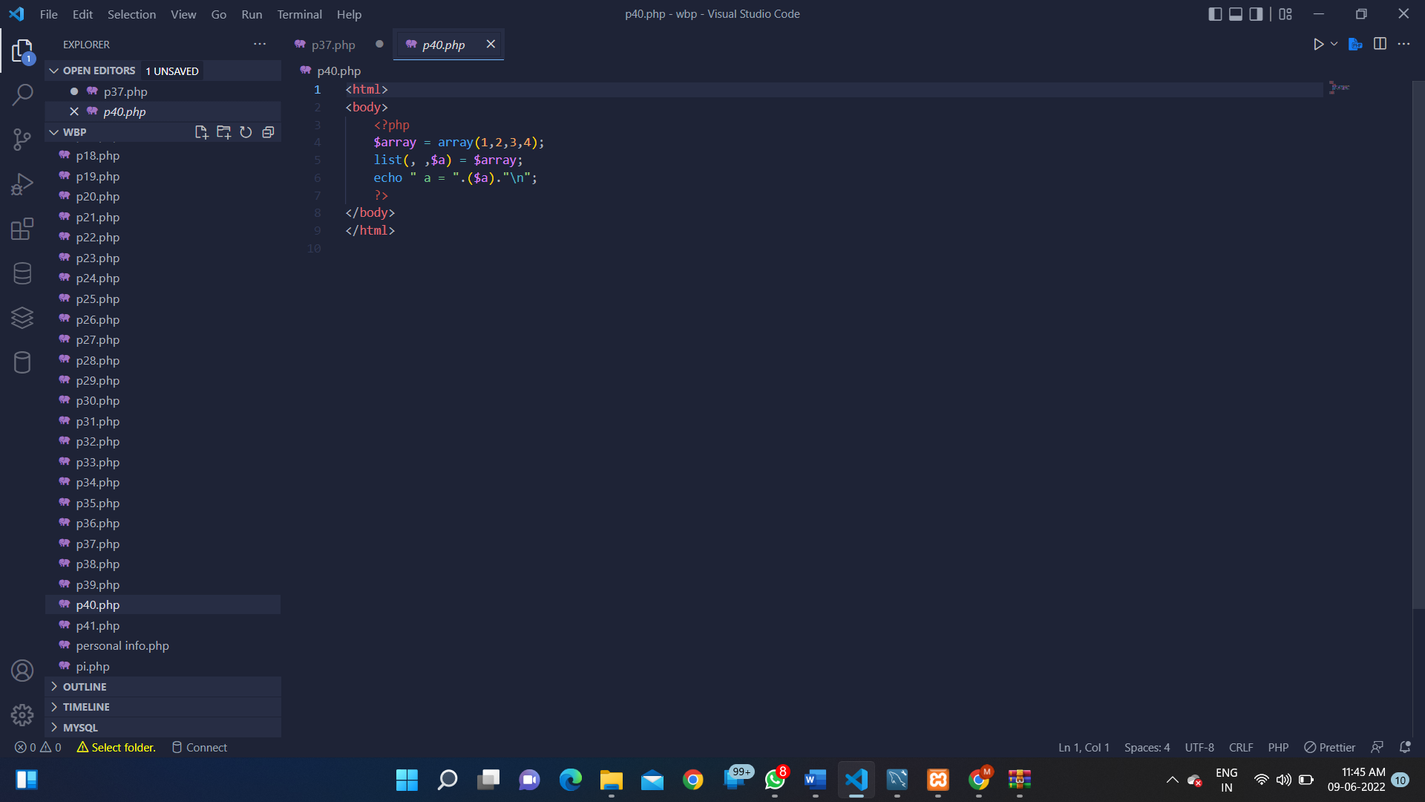

**OUTPUT:**

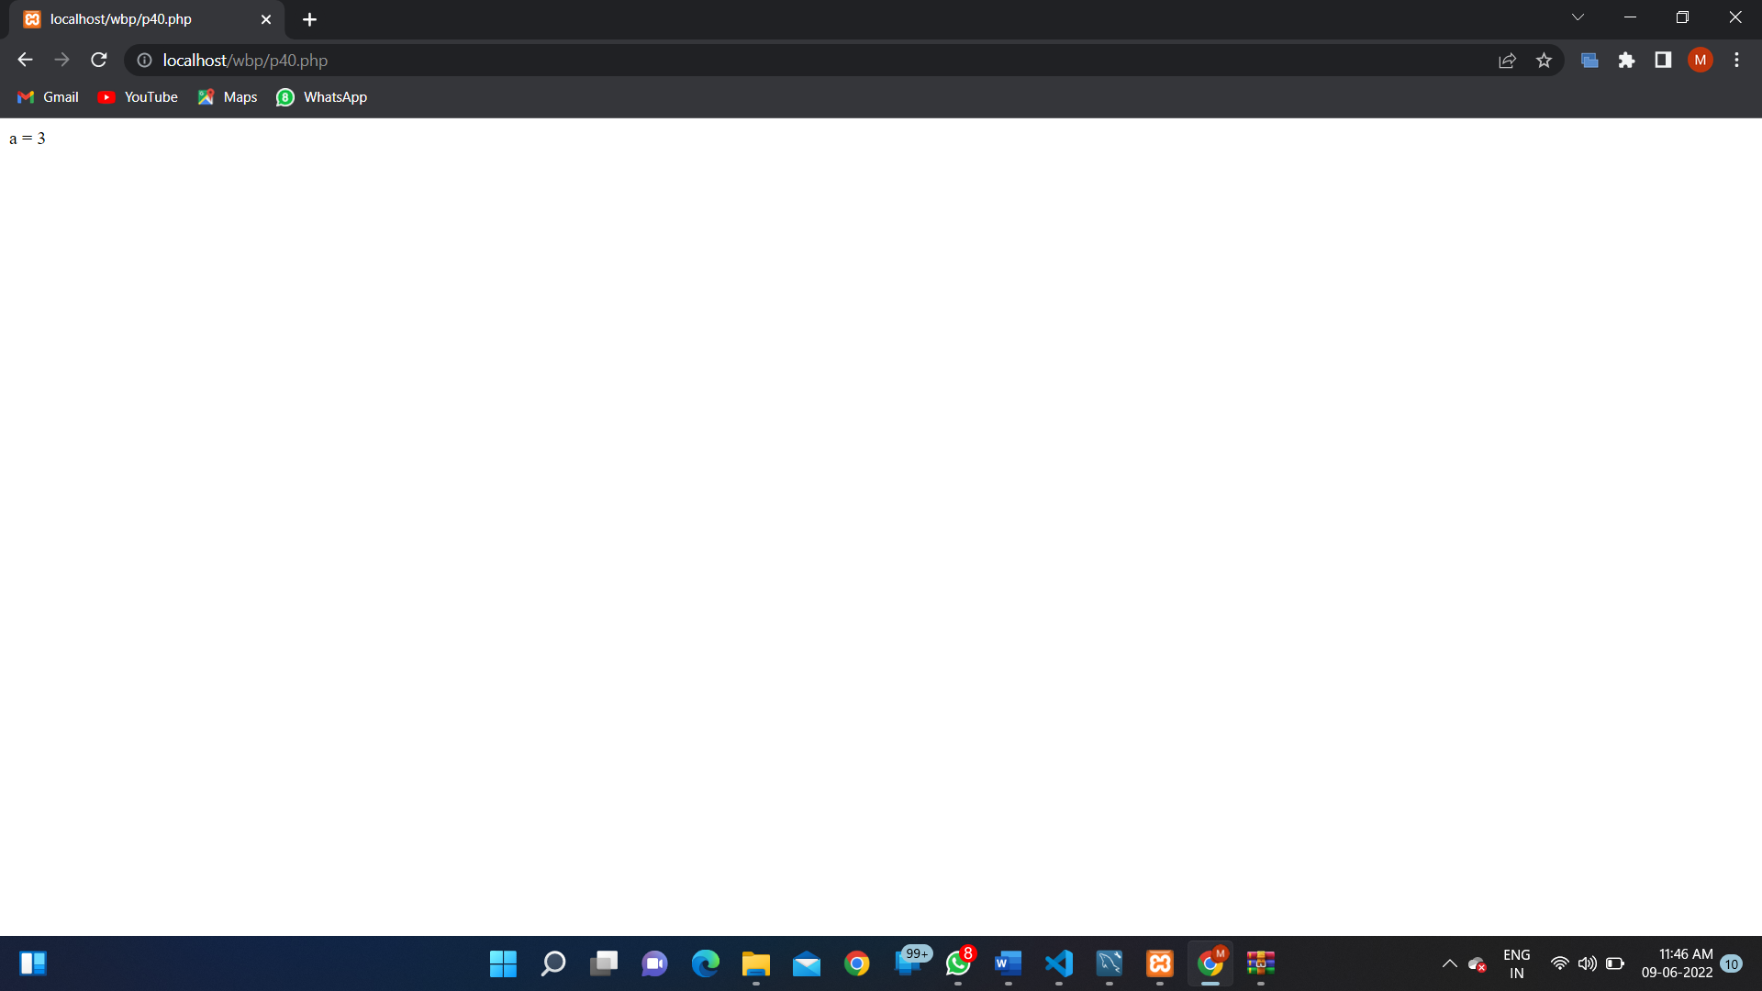

**PROGRAM 41:**

**SOURCE CODE:**

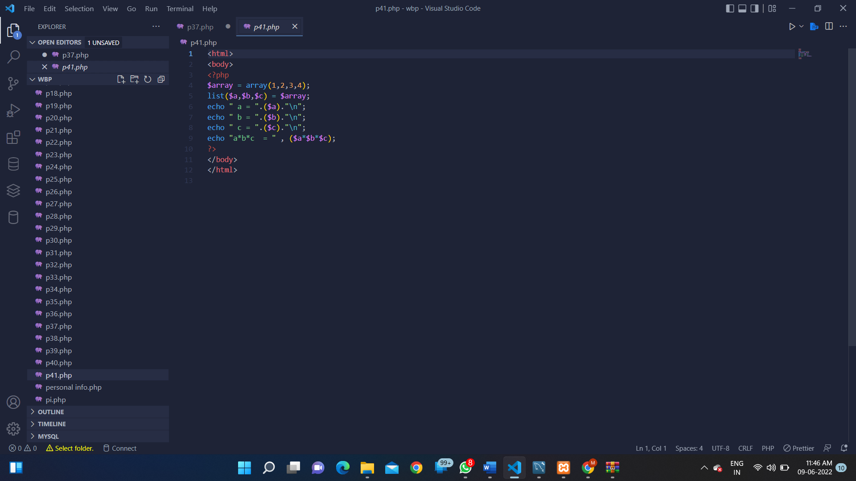

**OUTPUT:**

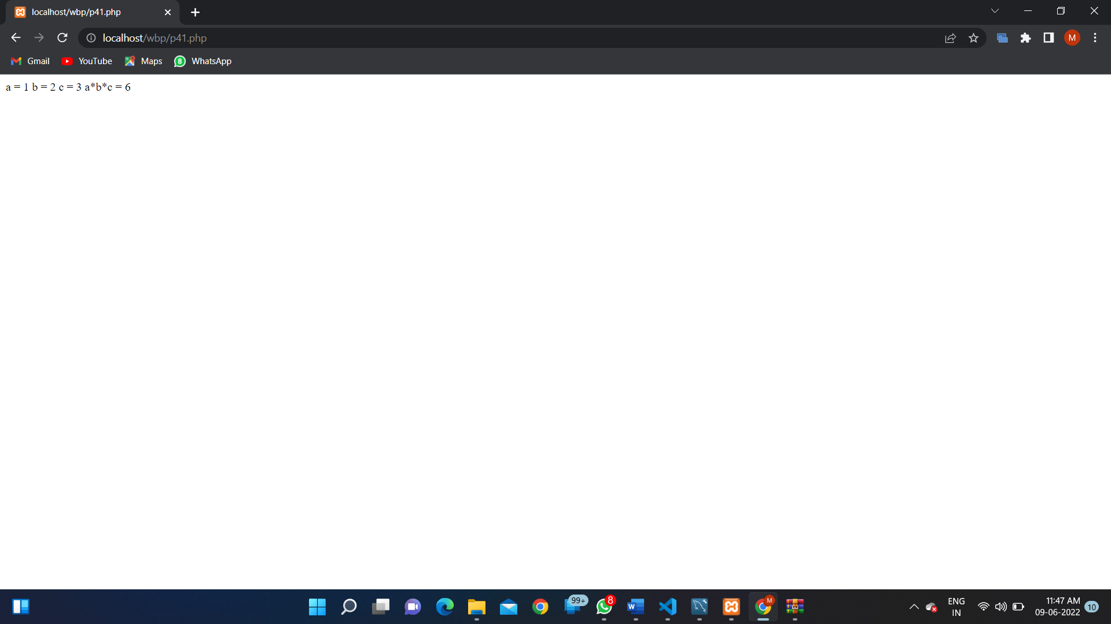

**PROGRAM 42:**

**SOURCE CODE:**

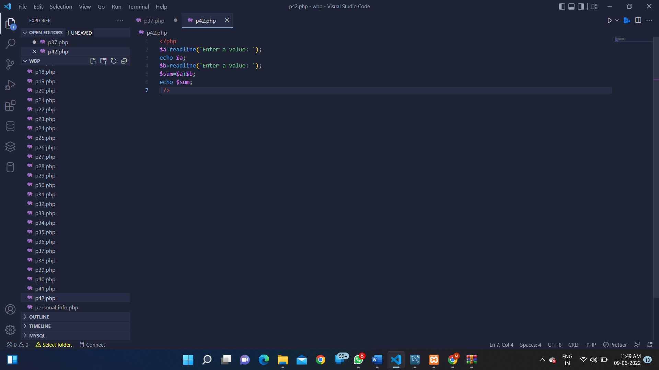

**OUTPUT:**

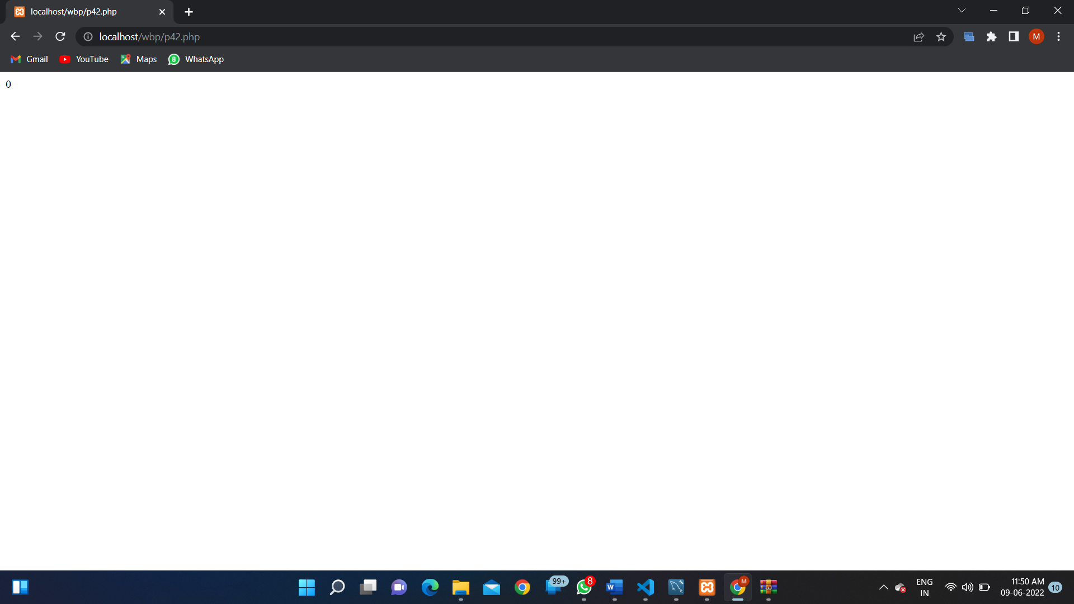

**PROGRAM 43:**

**SOURCE CODE:**

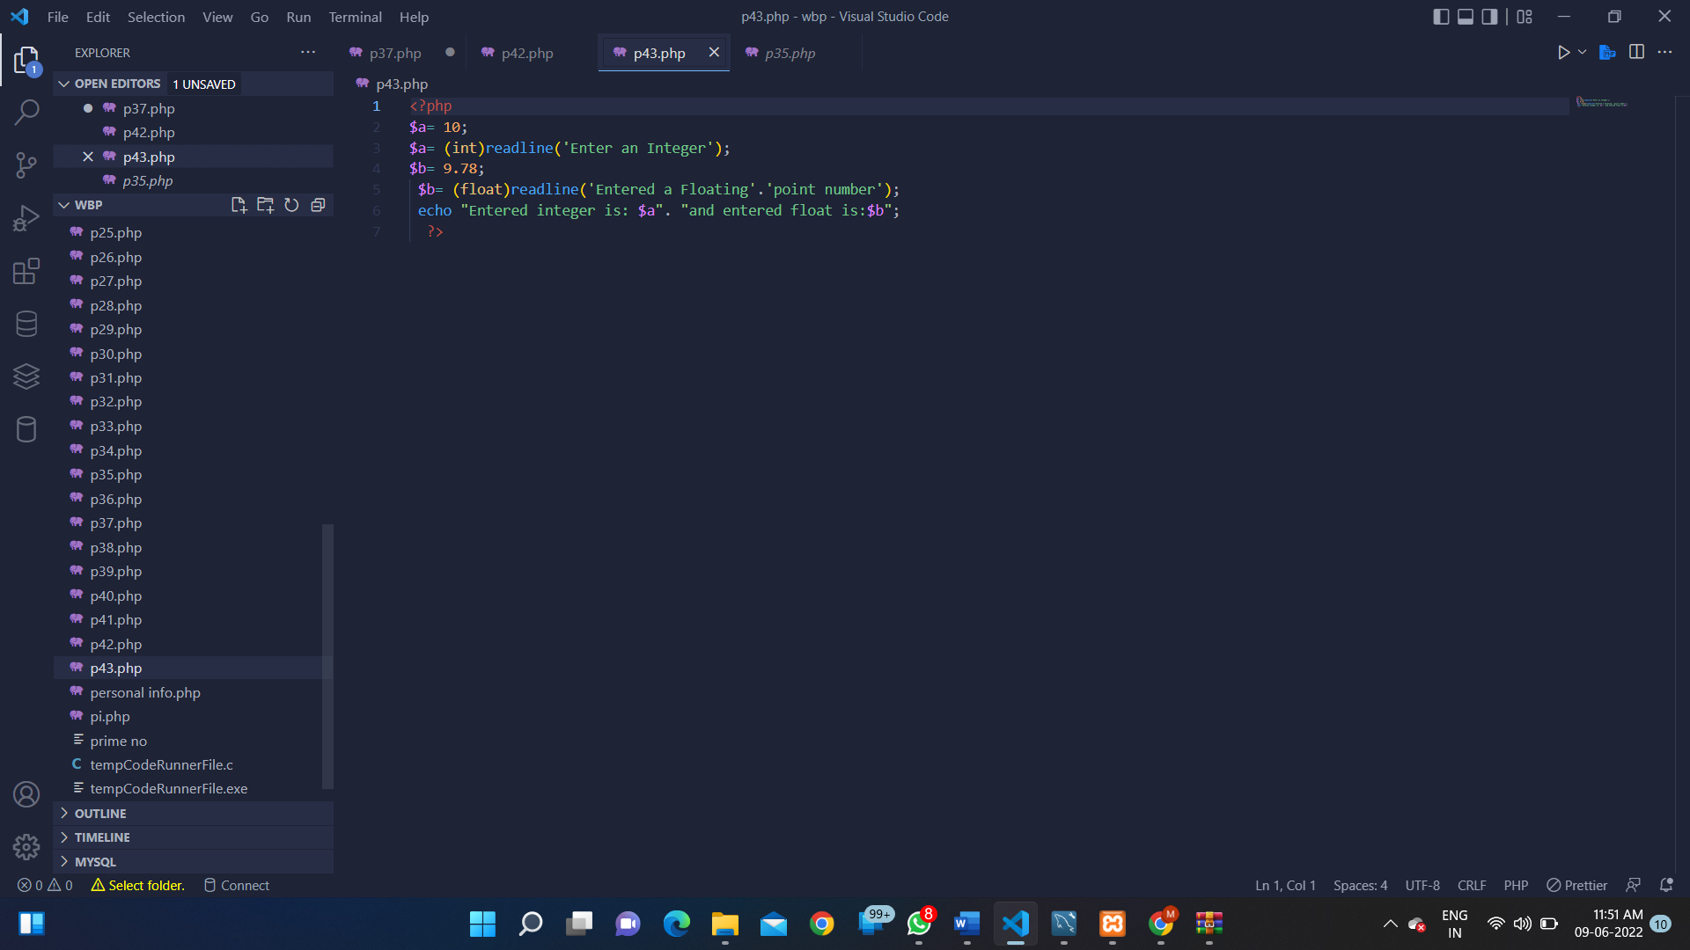

**OUTPUT:**

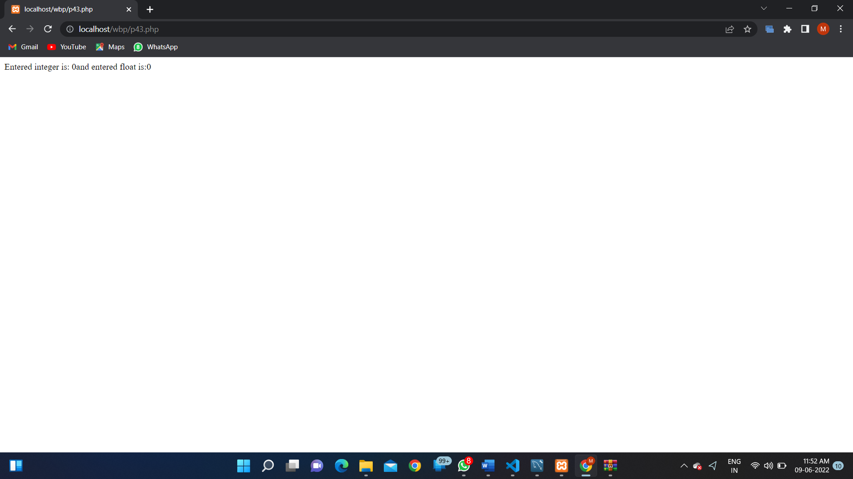

**PROGRAM 44:**

**SOURCE CODE:**

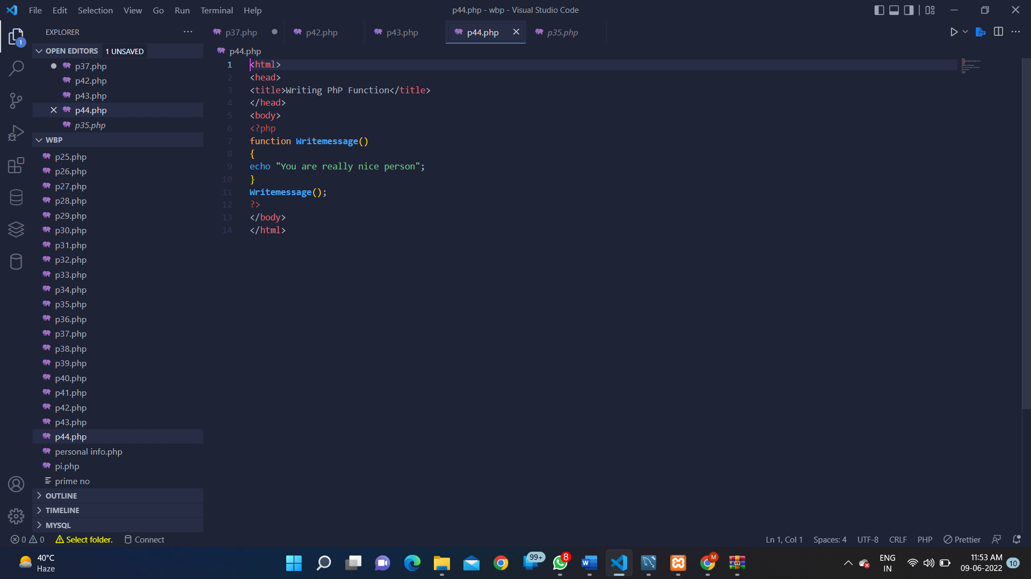

**OUTPUT:**

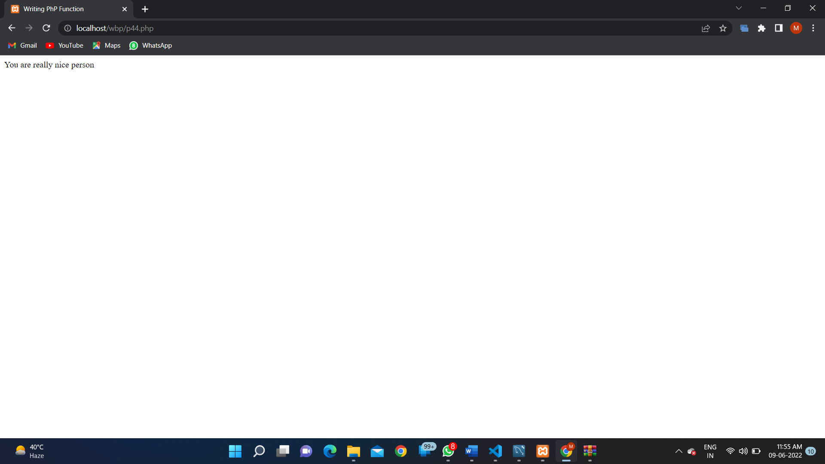

**PROGRAM 45:**

**SOURCE CODE:**

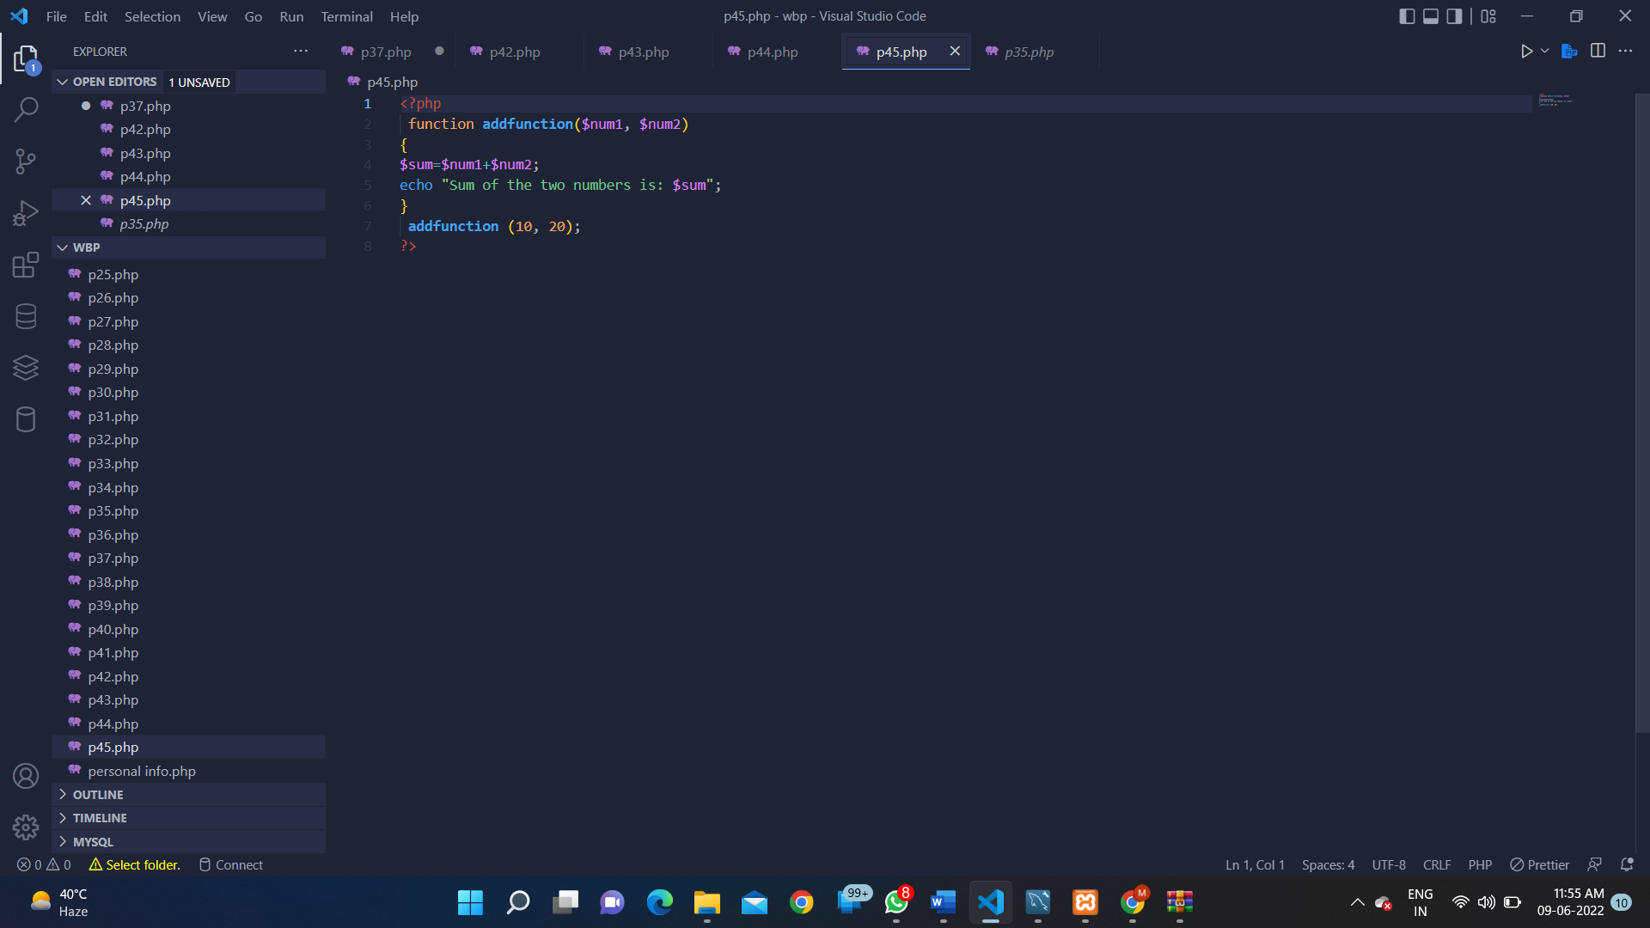

**OUTPUT:**

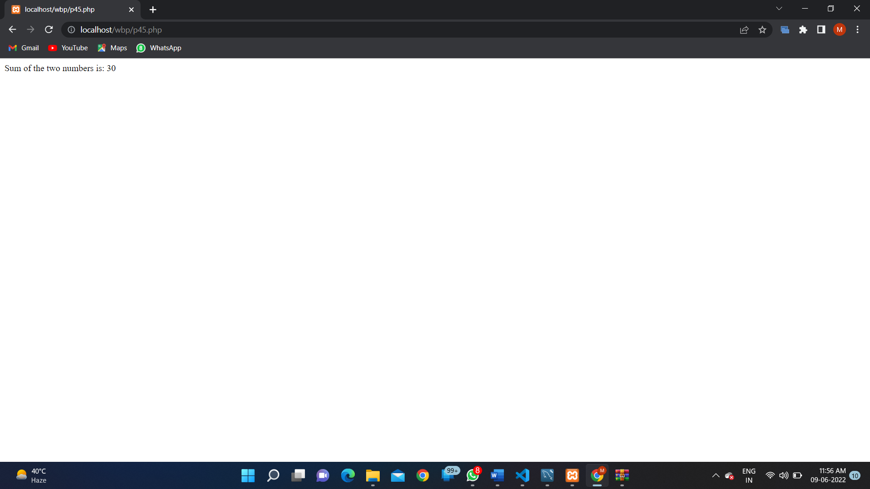

**PROGRAM 46:**

**SOURCE CODE:**

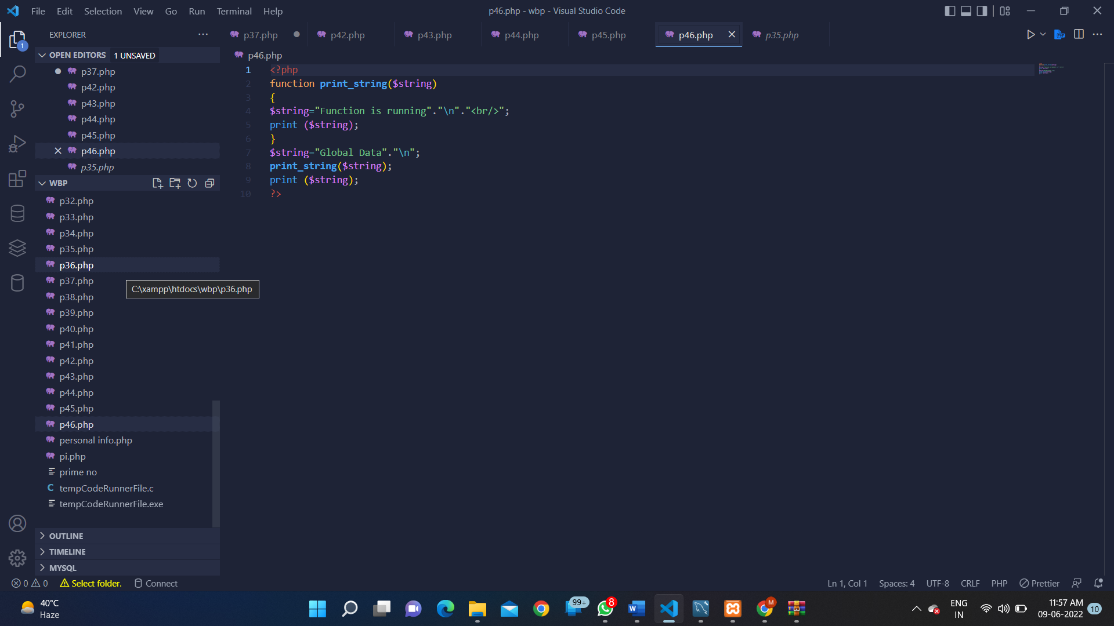

**OUTPUT:**

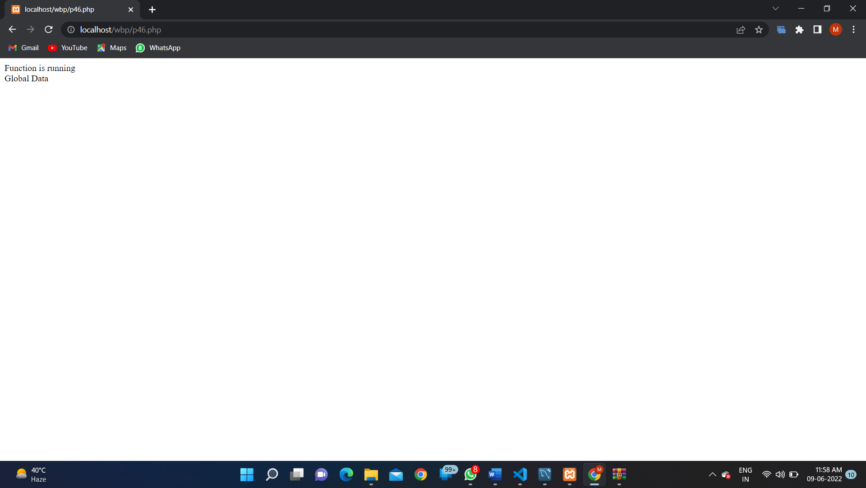

**PROGRAM 47:**

**SOURCE CODE:**

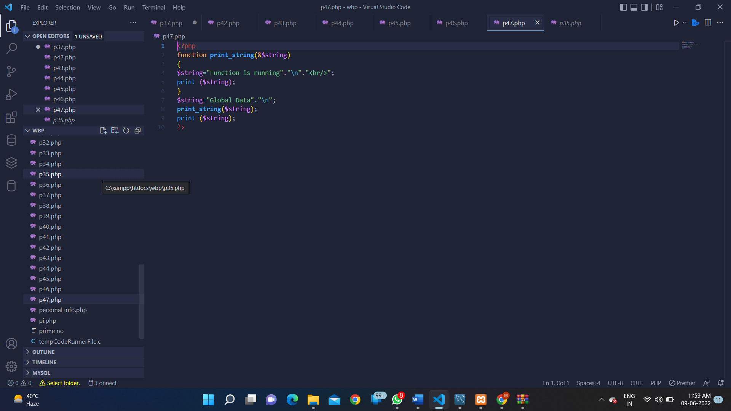

**OUTPUT:**

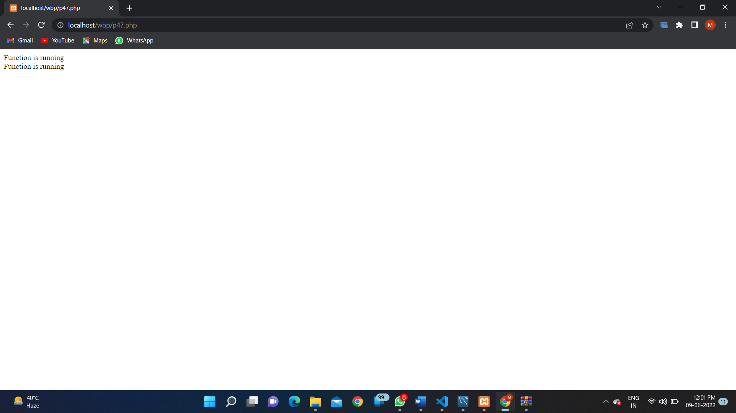

**PROGRAM 48:**

**SOURCE CODE:**

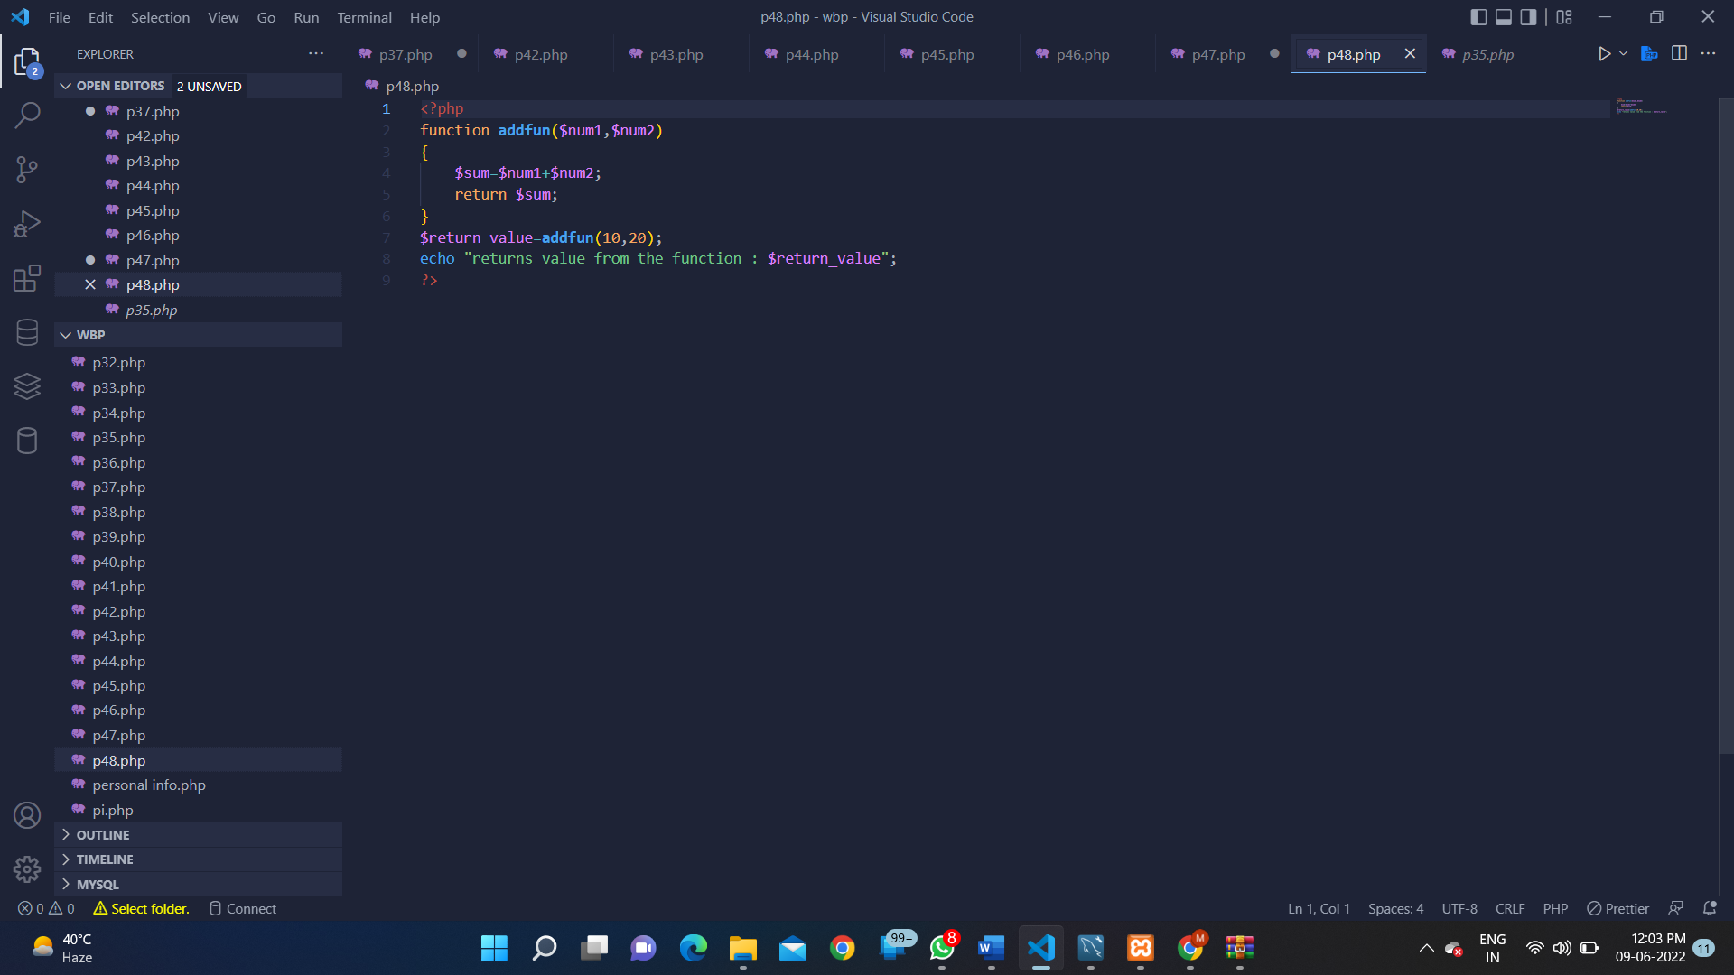

**OUTPUT:**

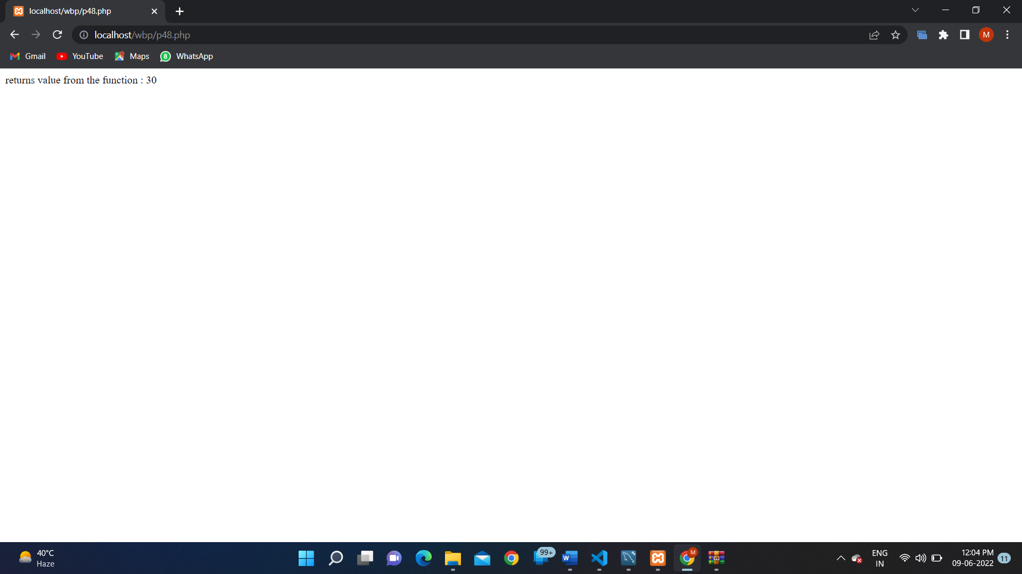

**PROGRAM 49:**

**SOURCE CODE:**

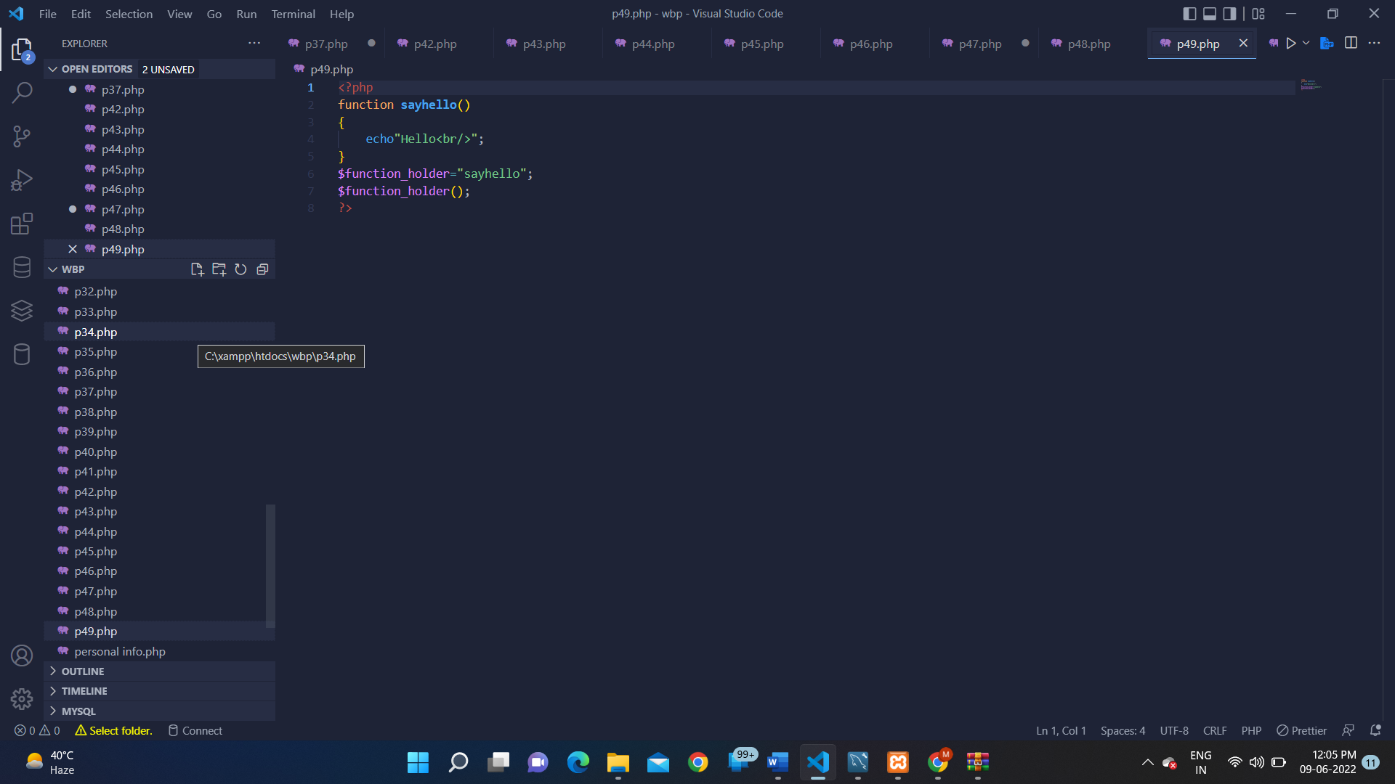

**OUTPUT:**

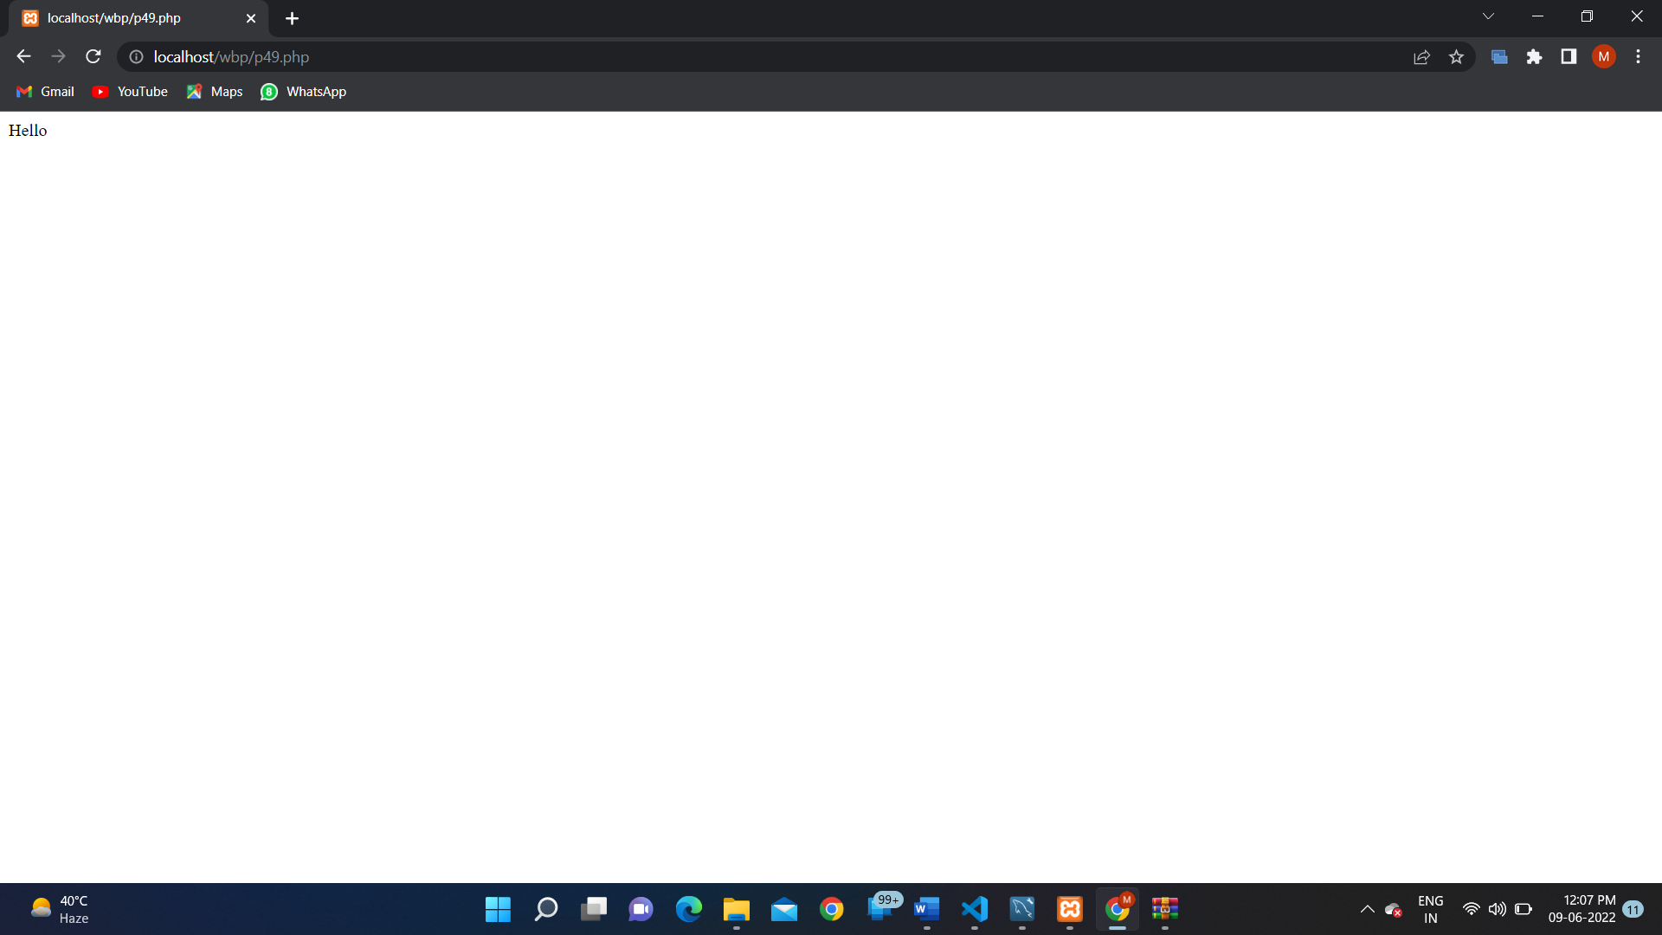

**PROGRAM 50:**

**SOURCE CODE:**

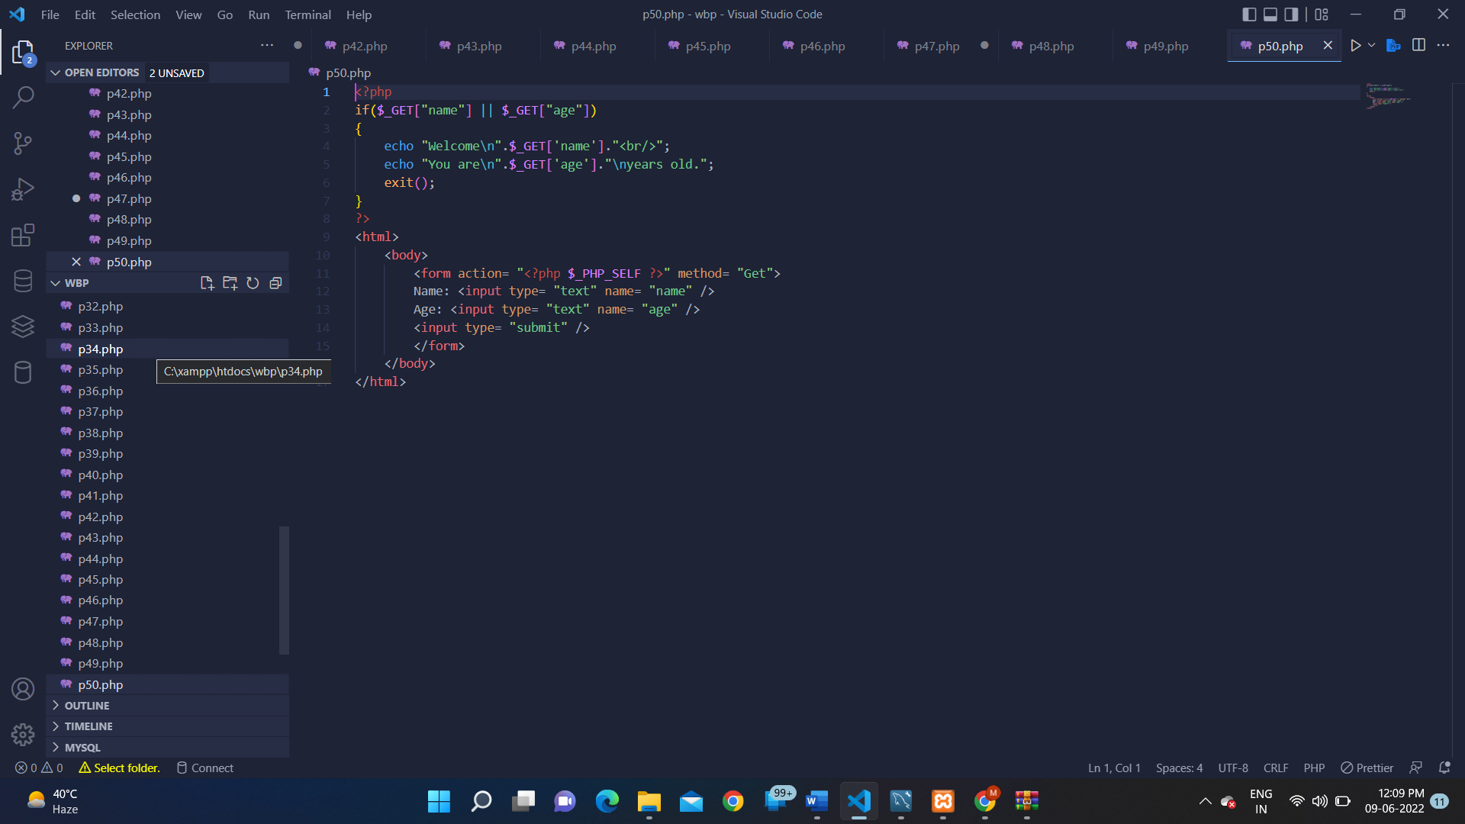

**OUTPUT:**

**PROGRAM 51:**

**SOURCE CODE:**

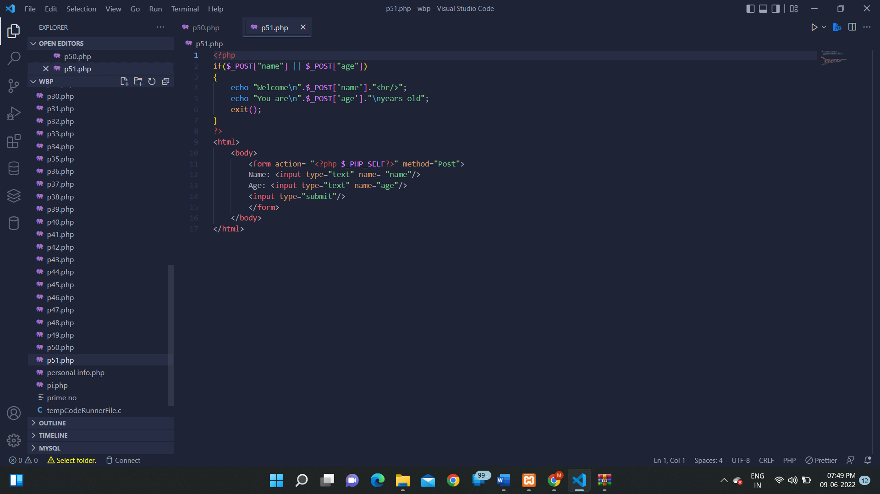

**OUTPUT:**

**PROGRAM 52:**

**SOURCE CODE:**

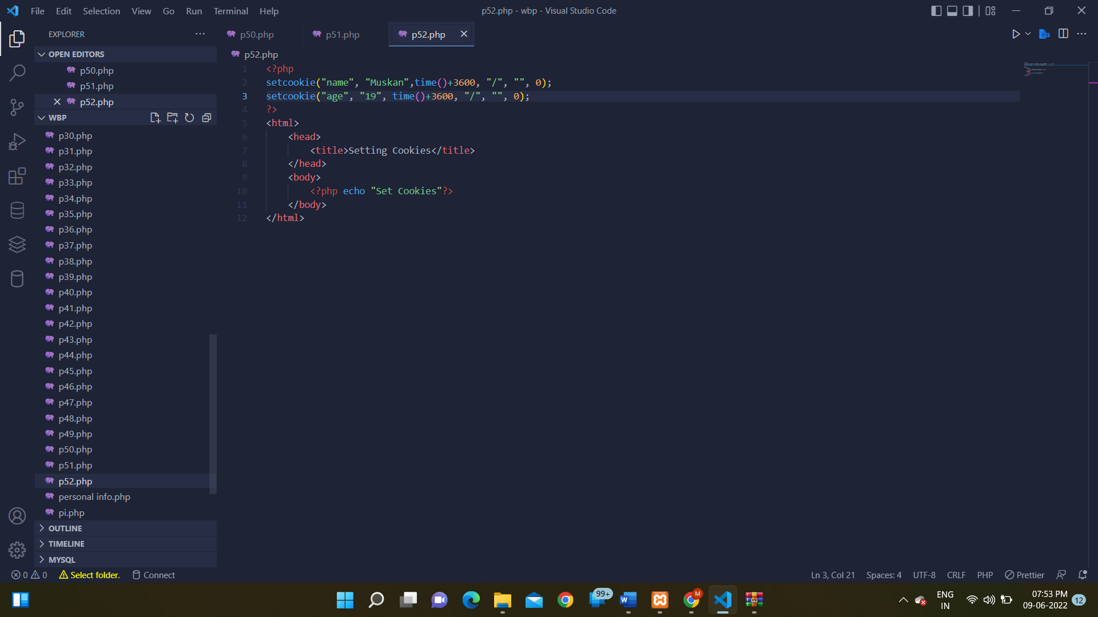

**OUTPUT:**

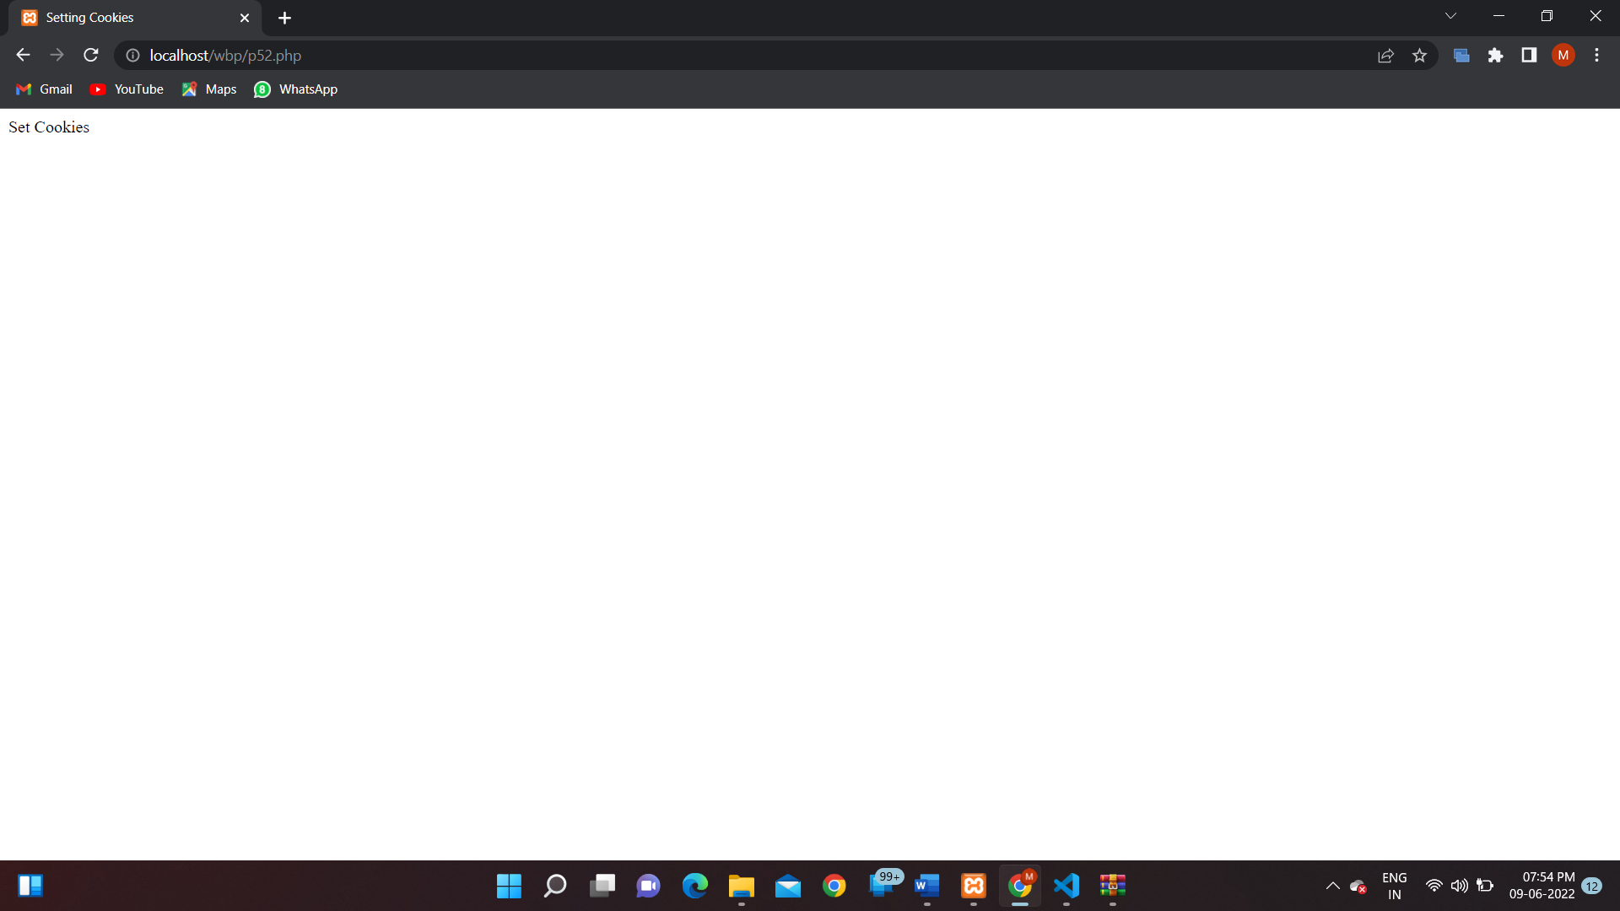

**PROGRAM 53:**

**SOURCE CODE:**

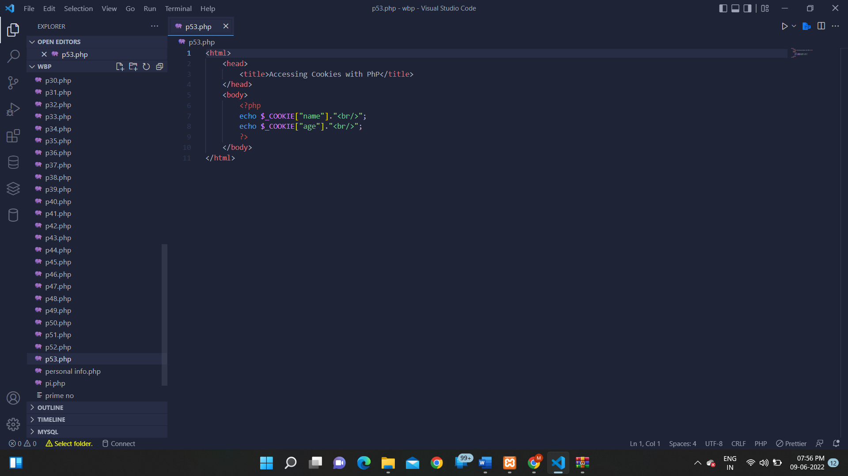

**OUTPUT:**

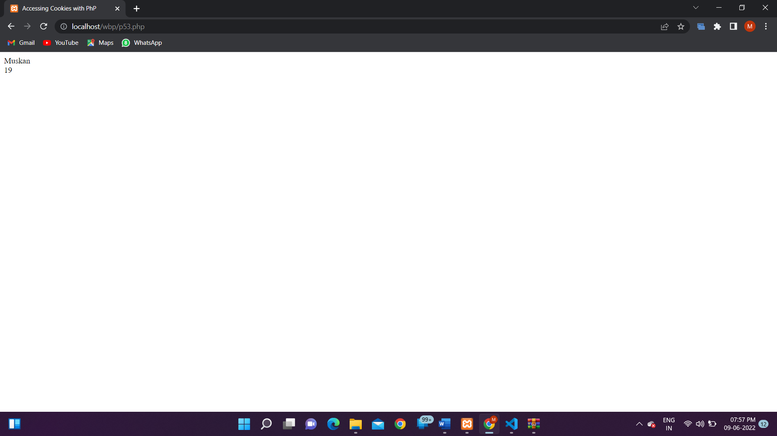

**PROGRAM 54:**

**SOURCE CODE:**

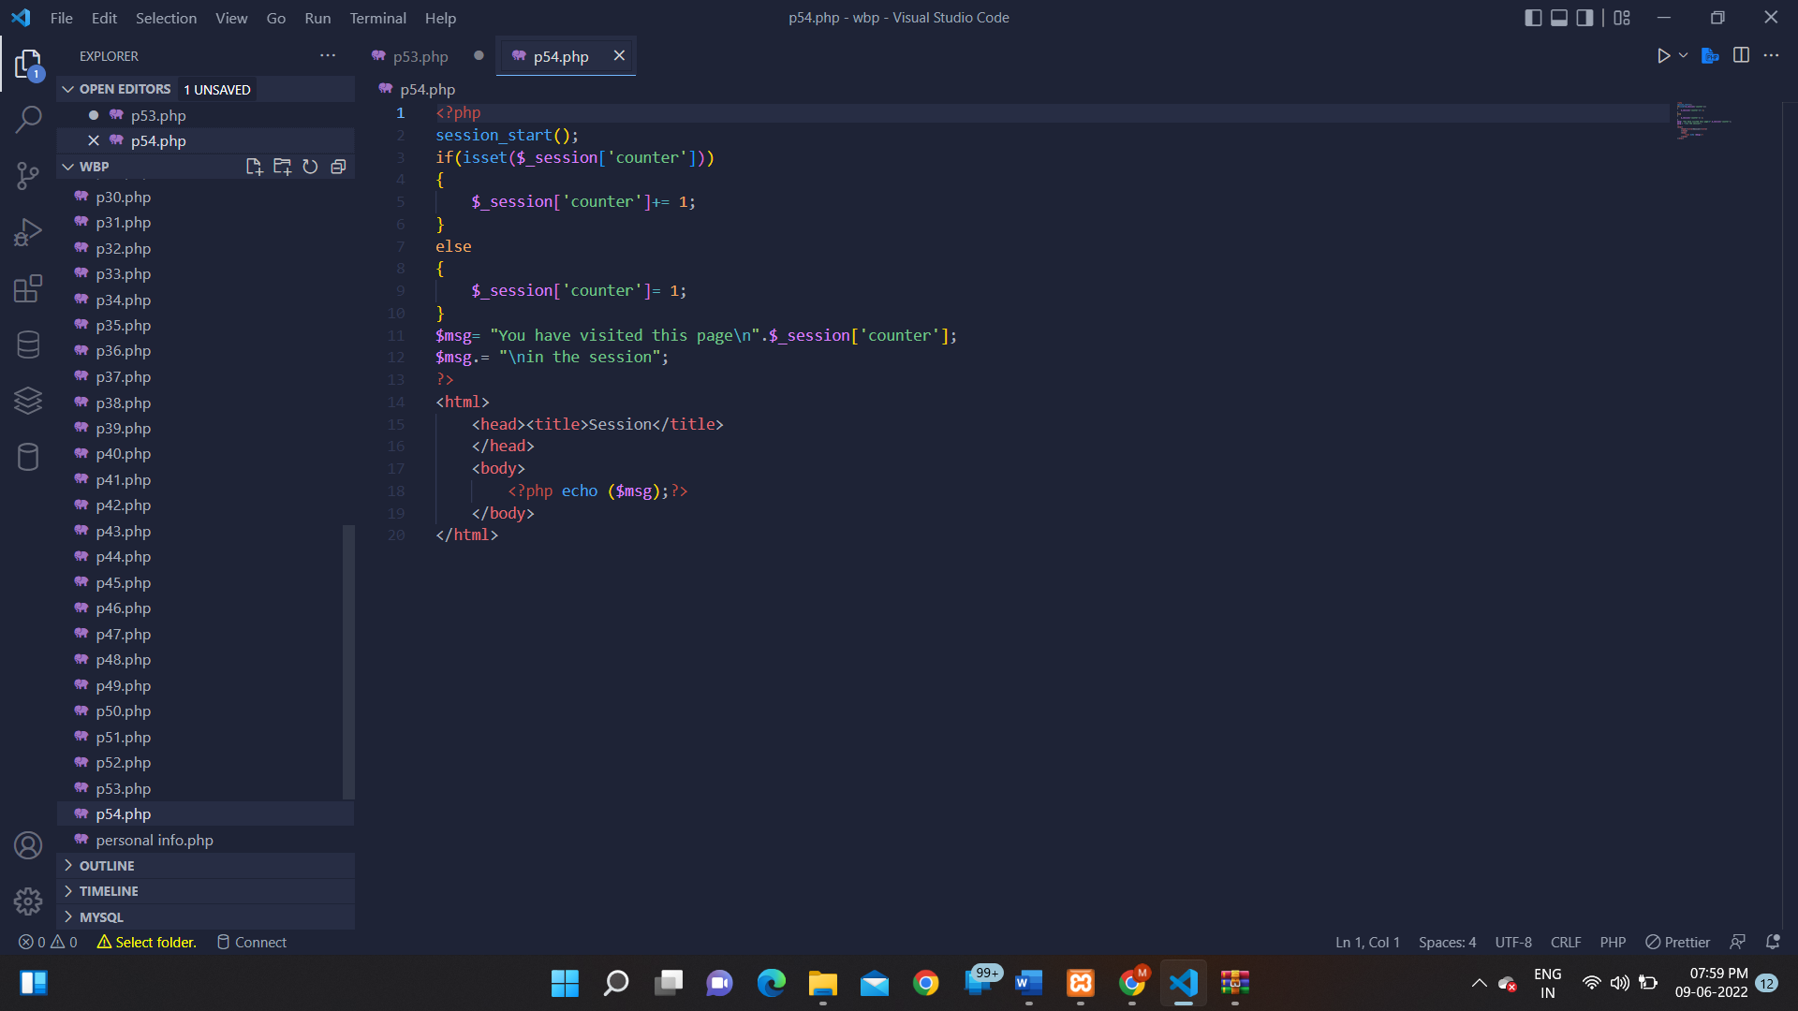

**OUTPUT:**

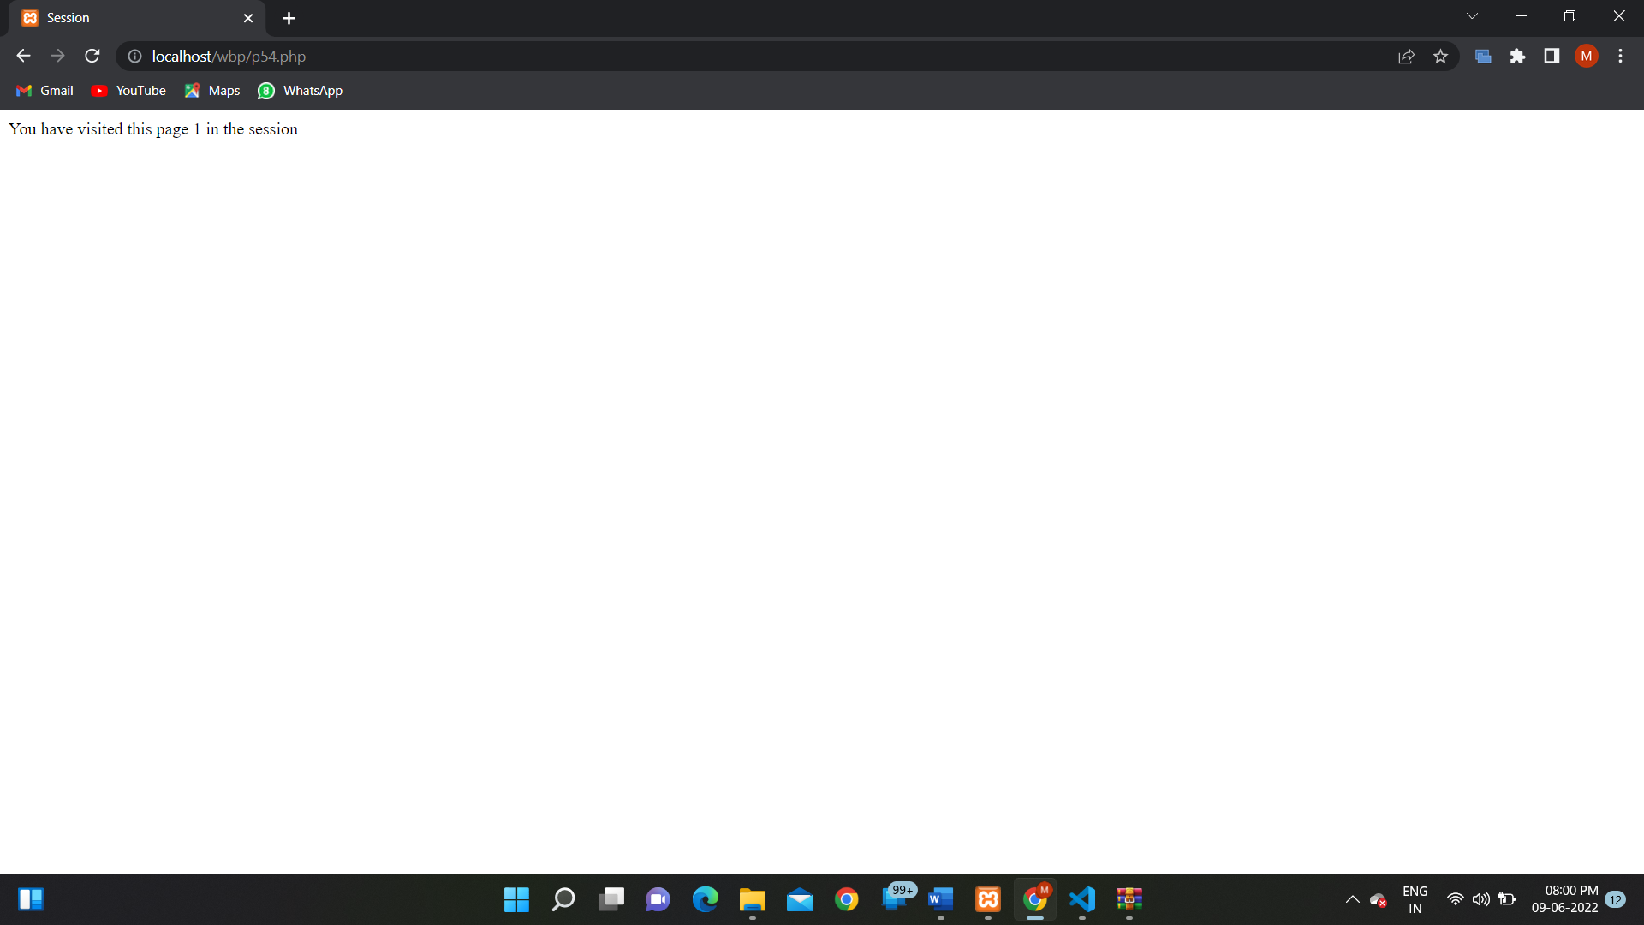

**PROGRAM 55:**

**SOURCE CODE:**

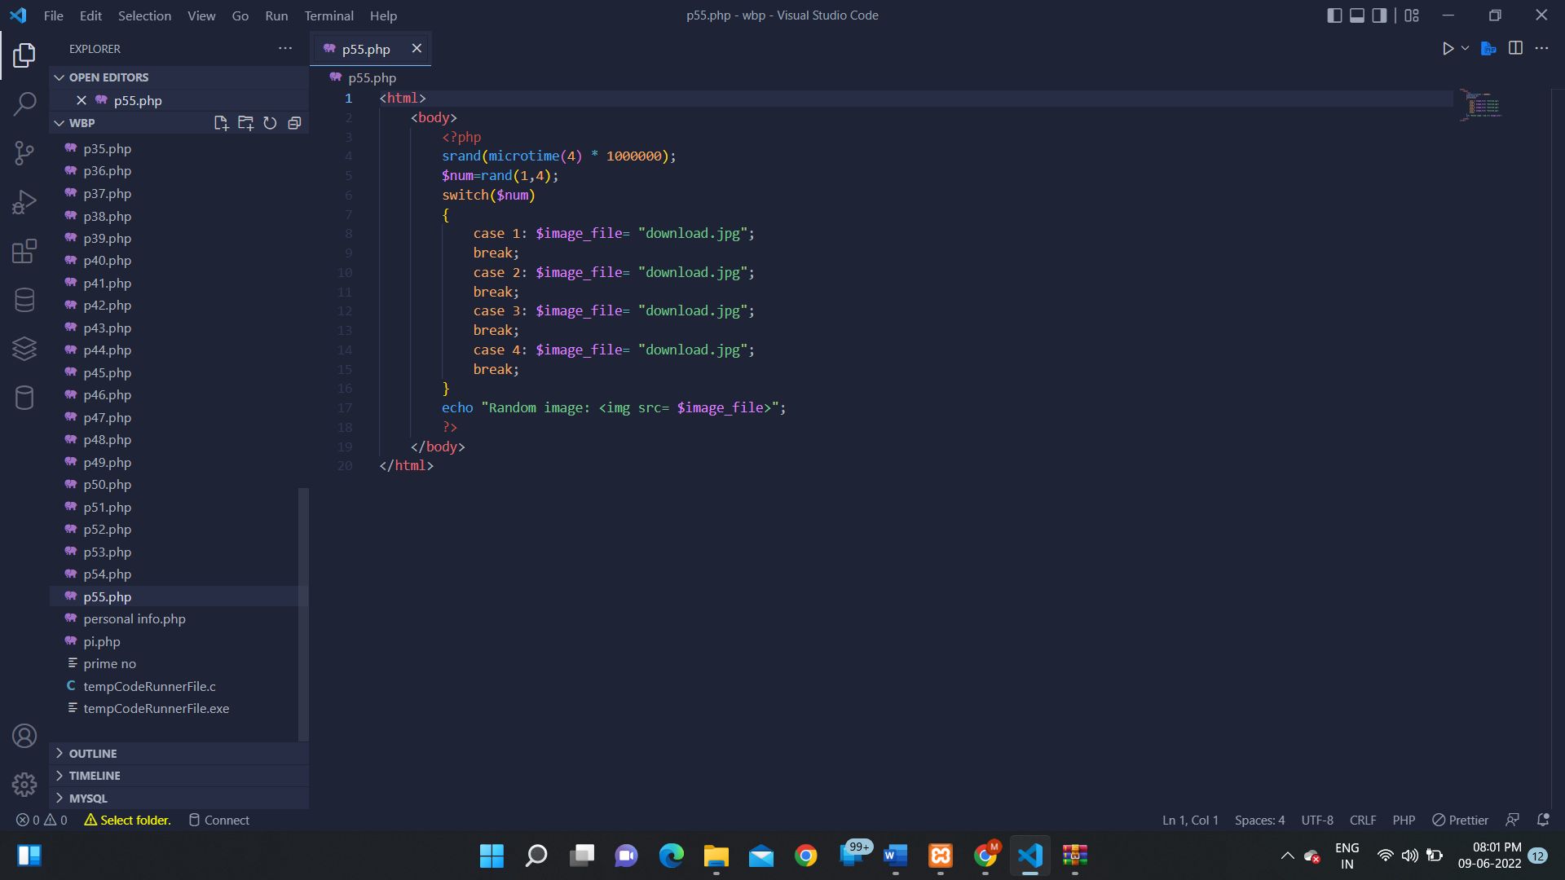

**OUTPUT:**

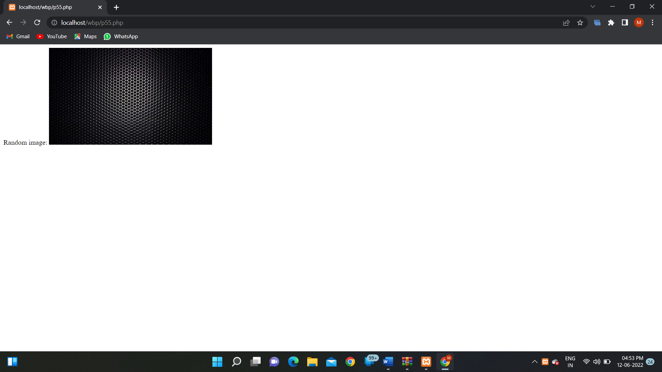

**PROGRAM 56:**

**SOURCE CODE:**

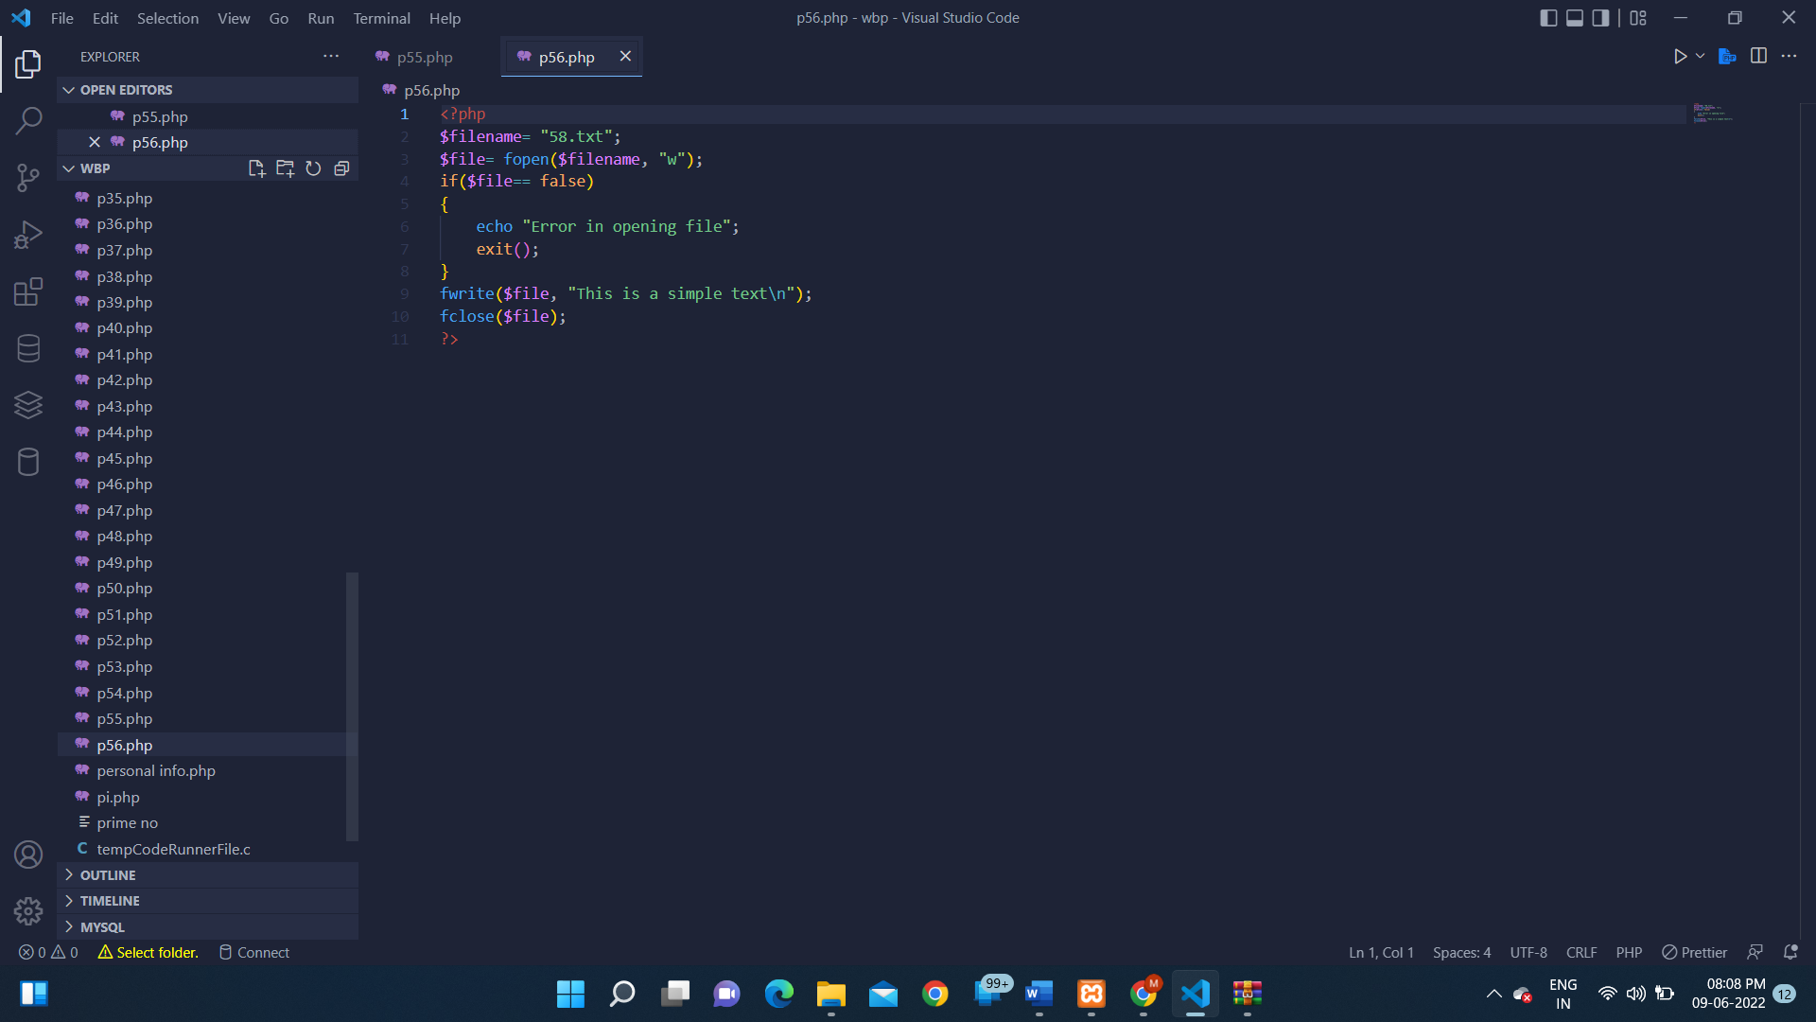

**OUTPUT:**

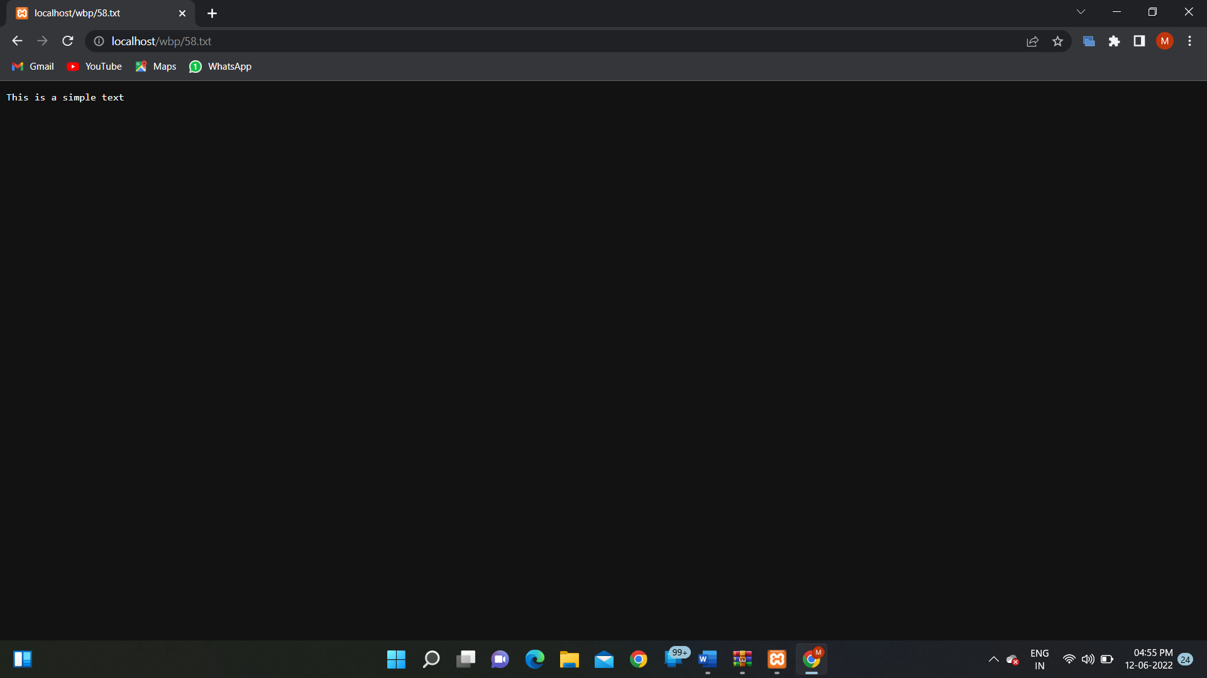

**PROGRAM 57:**

**SOURCE CODE:**

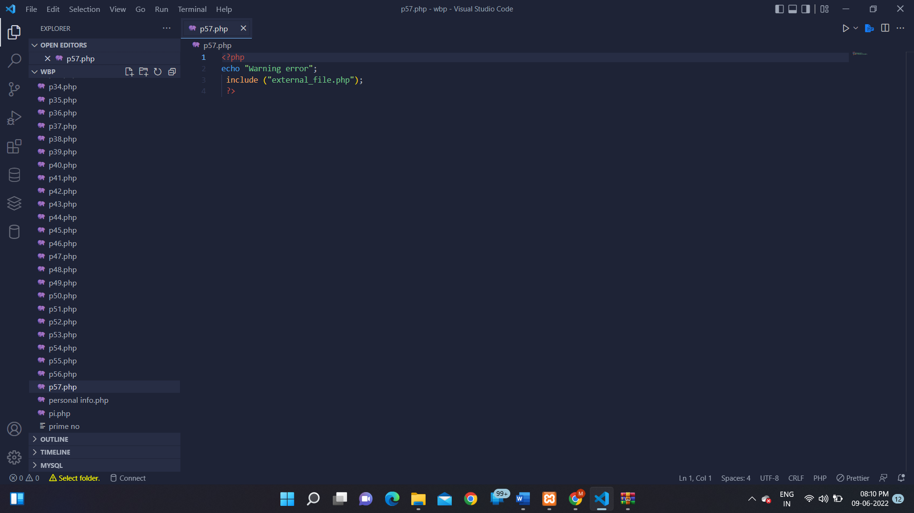

**OUTPUT:**

**PROGRAM 58:**

**SOURCE CODE:**

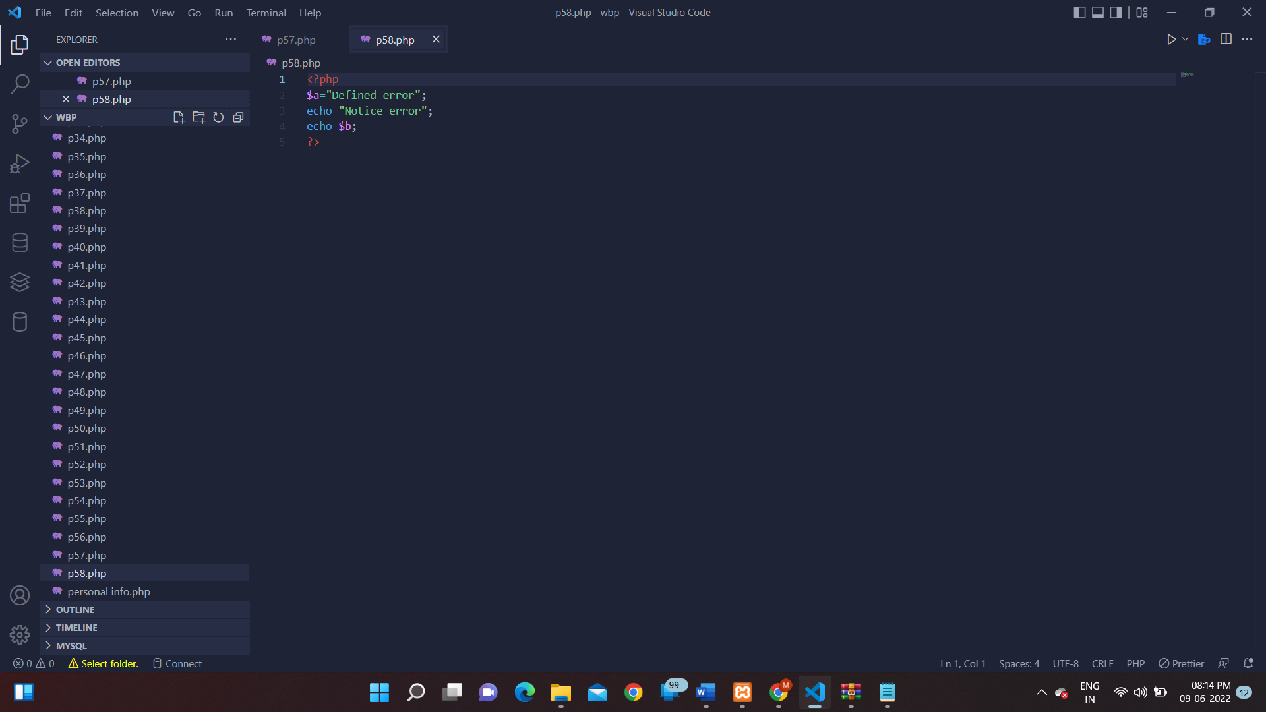

**OUTPUT:**

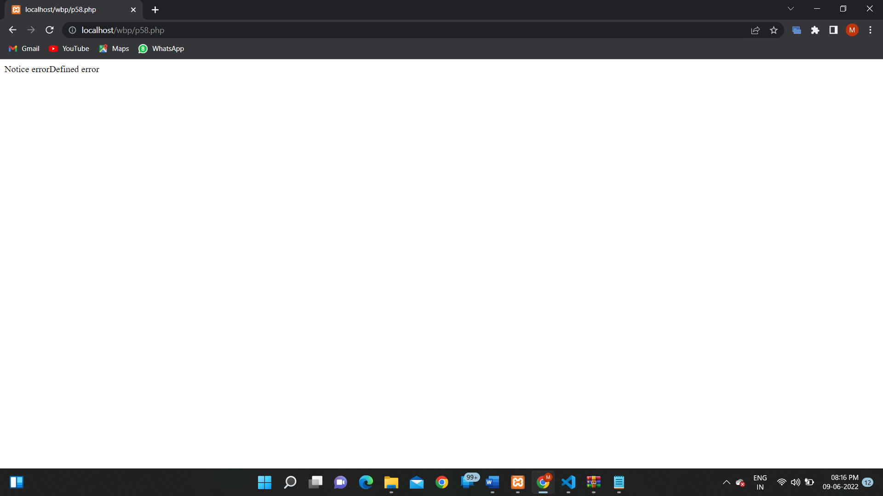

**PROGRAM 59:**

**SOURCE CODE:**

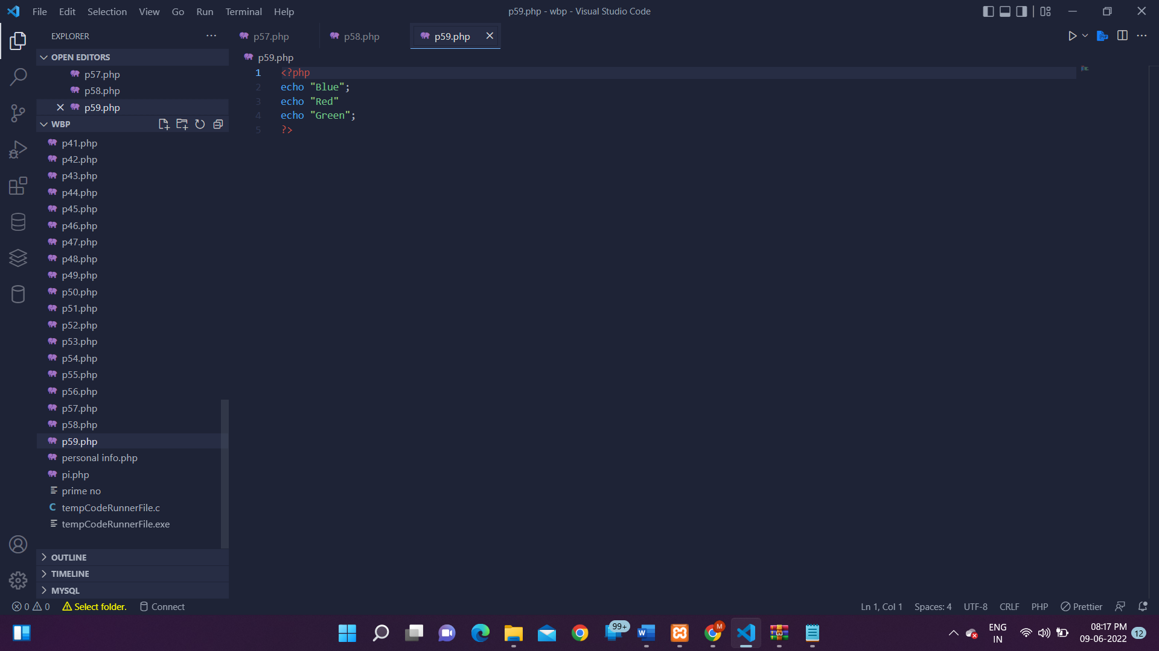

**OUTPUT:**

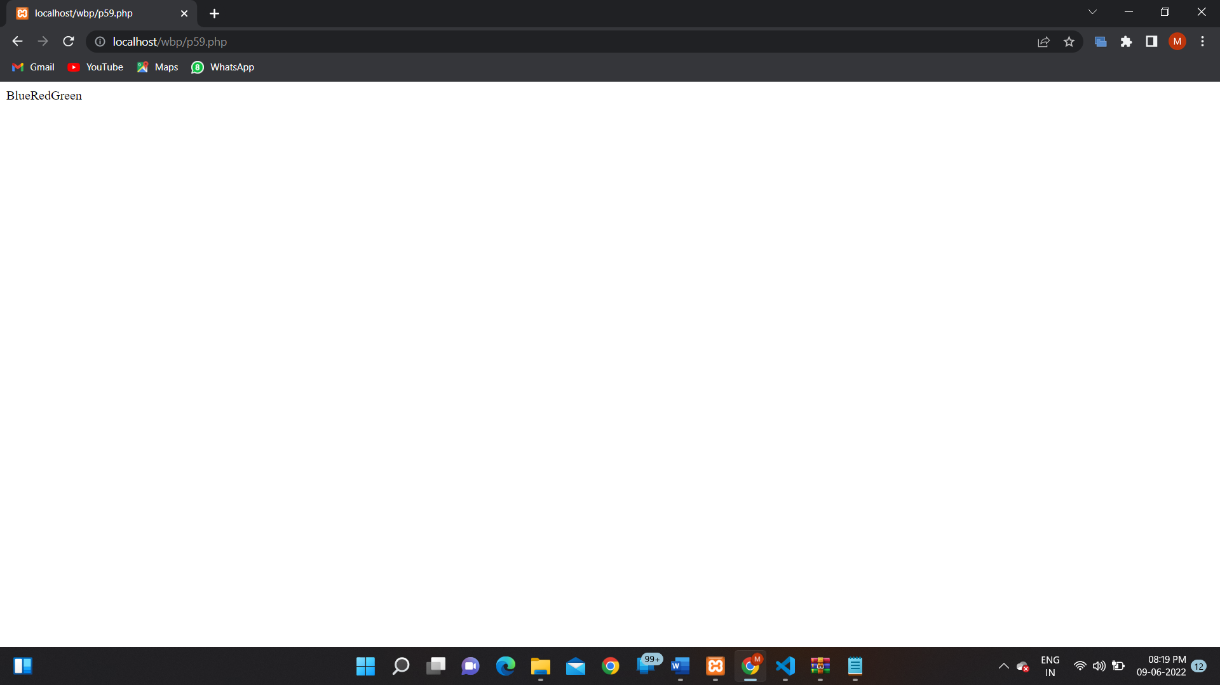

**PROGRAM 60:**

**SOURCE CODE:**

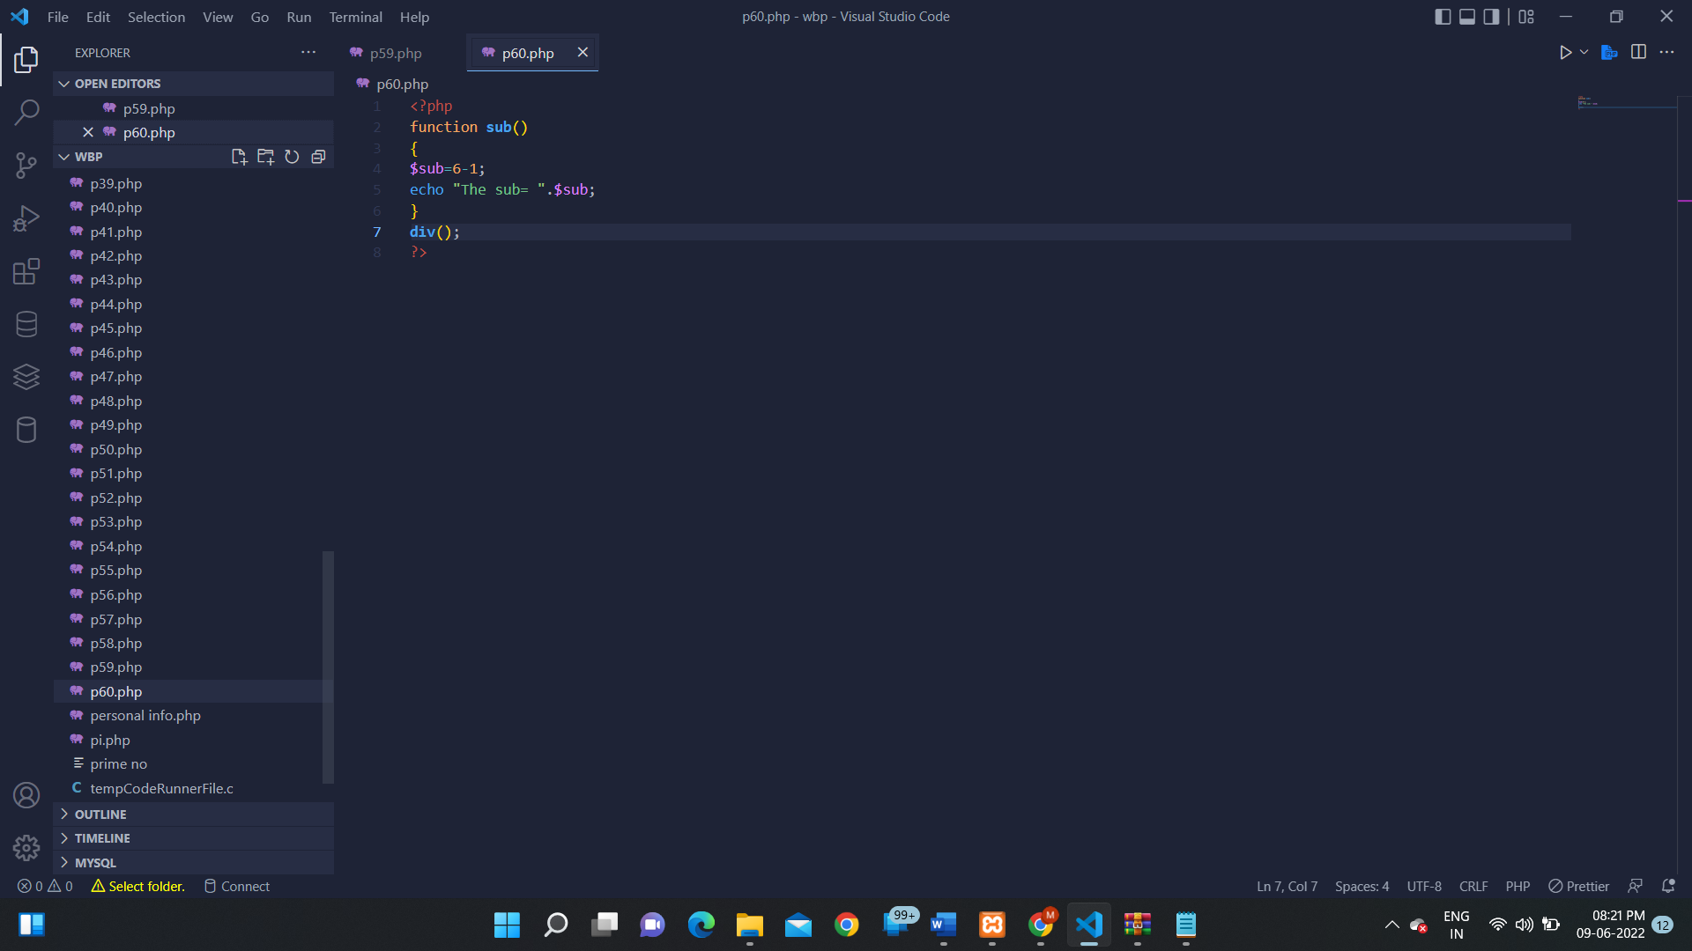

**OUTPUT:**

**PROGRAM 61:**

**SOURCE CODE:**

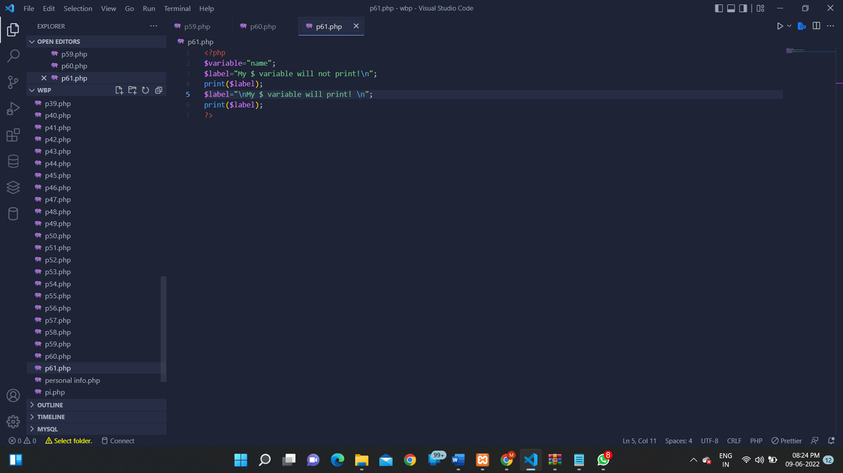

**OUTPUT:**

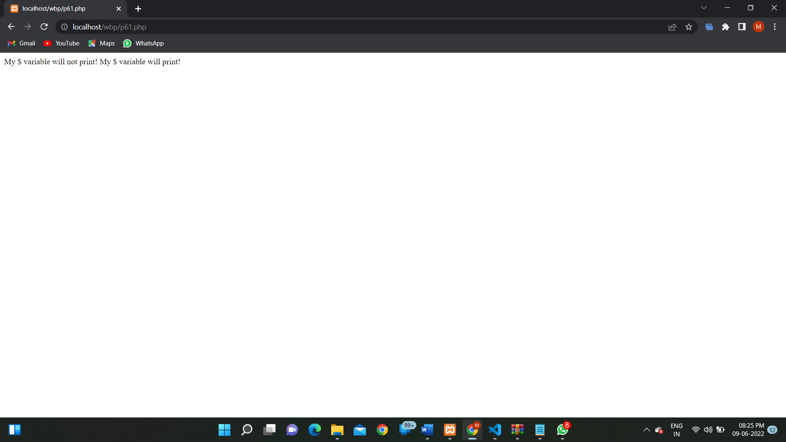

**PROGRAM 62:**

**SOURCE CODE:**

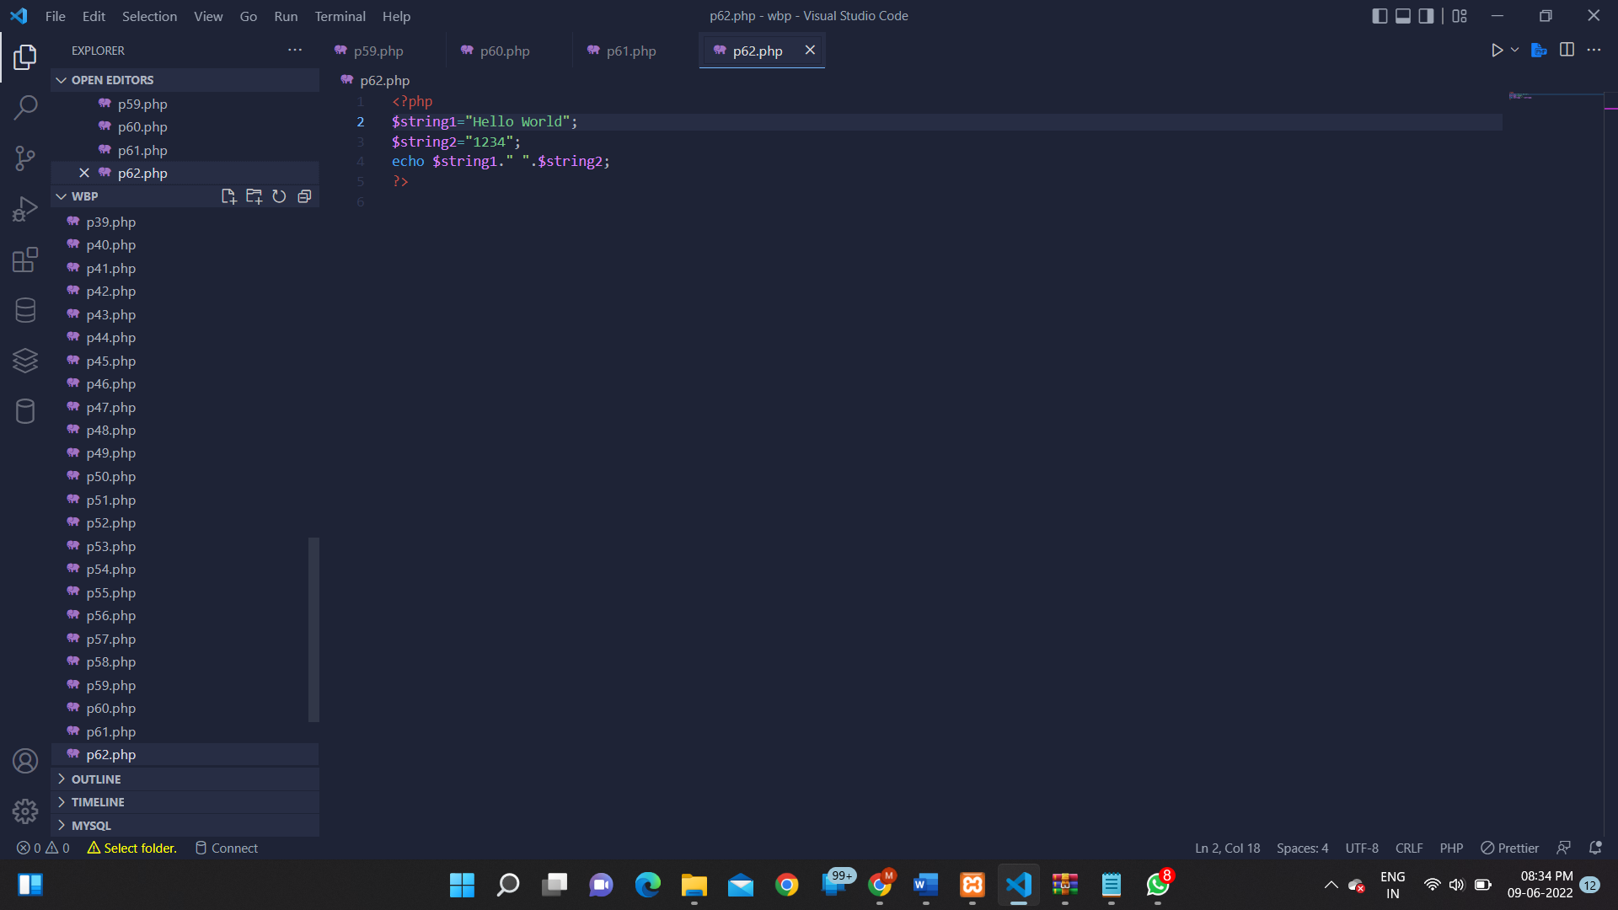

**OUTPUT:**

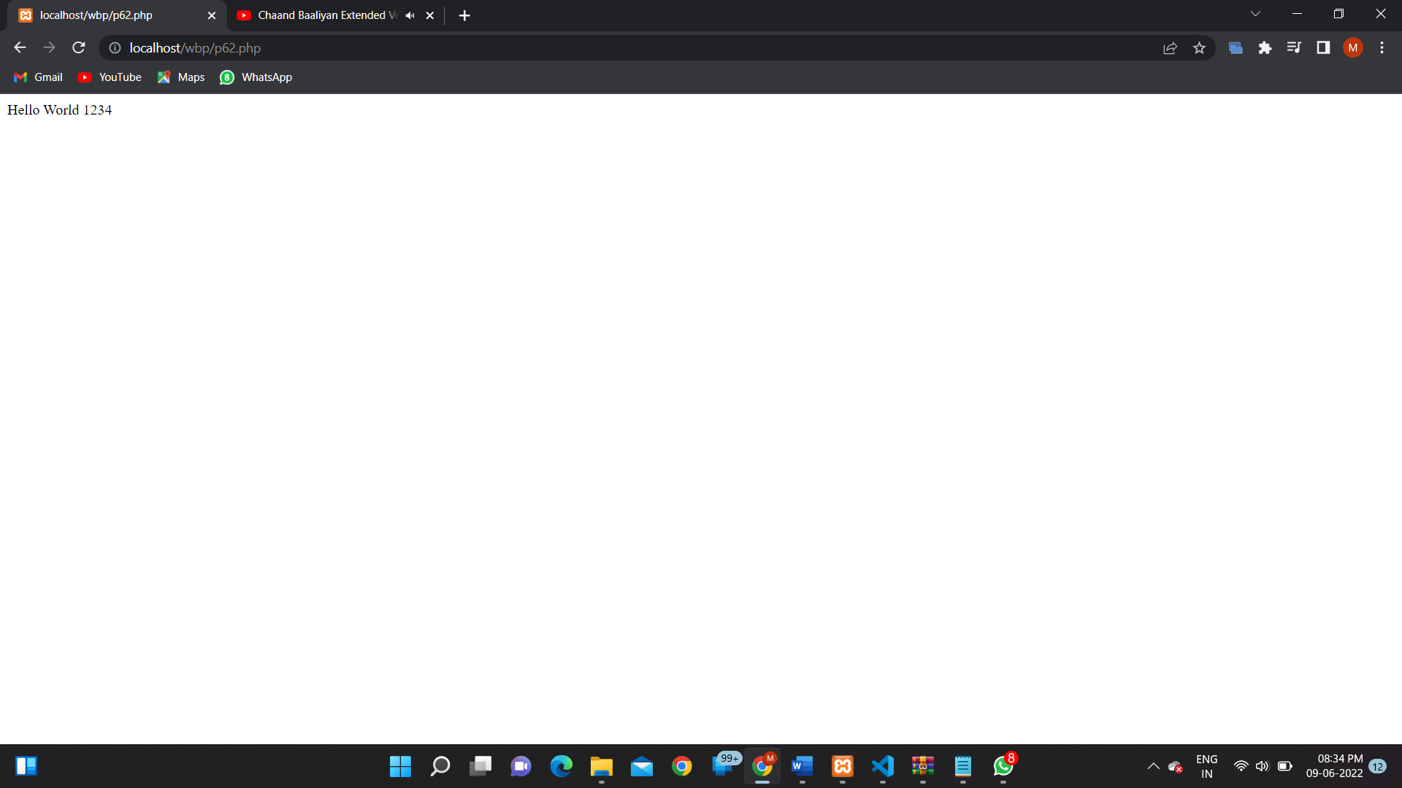

**PROGRAM 63:**

**SOURCE CODE:**

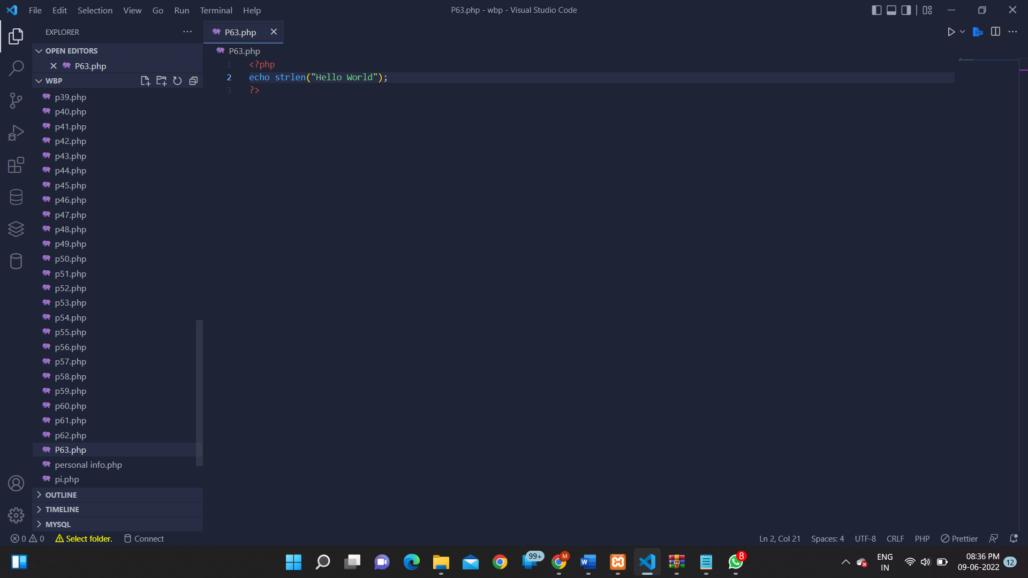

**OUTPUT:**

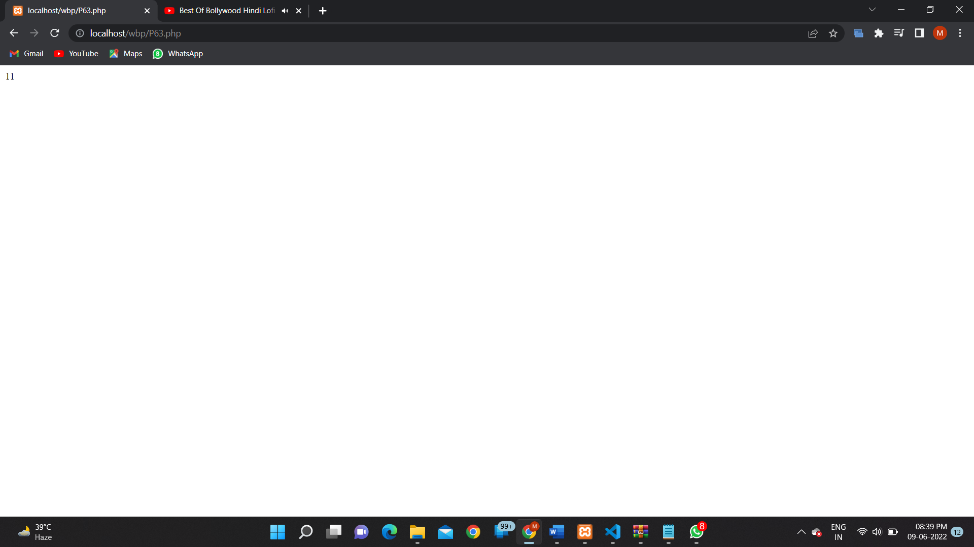

**PROGRAM 64:**

**SOURCE CODE:**

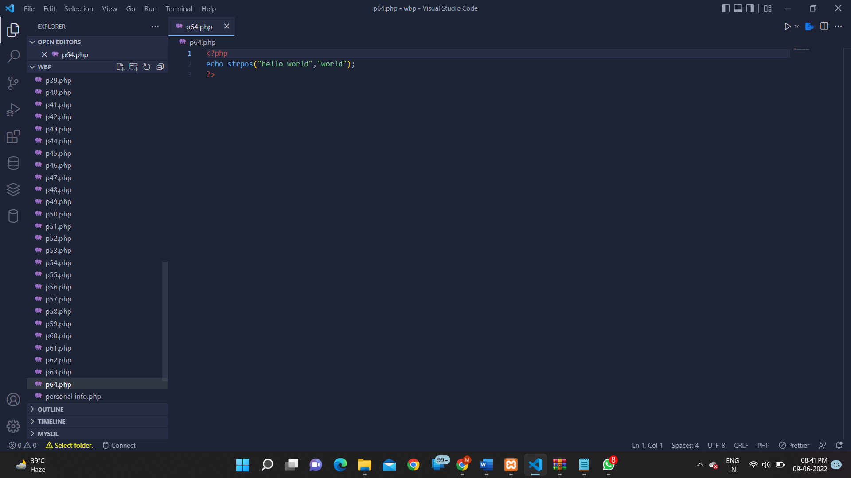

**OUTPUT:**

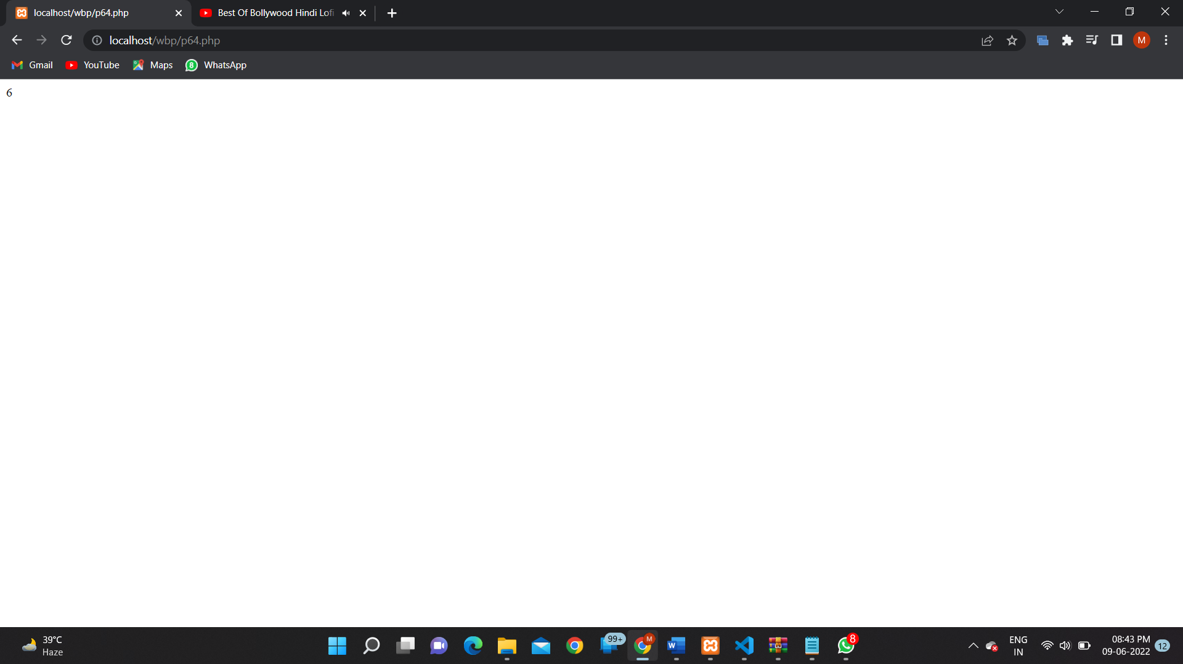

**PROGRAM 65:**

**SOURCE CODE:**

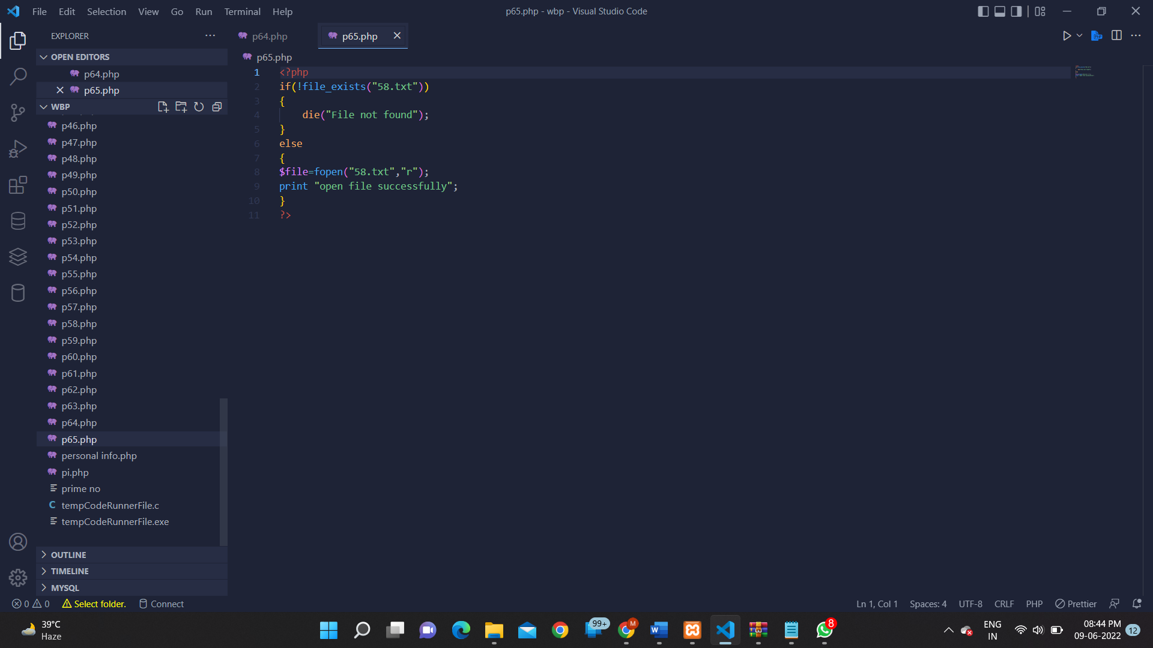

**OUTPUT:**

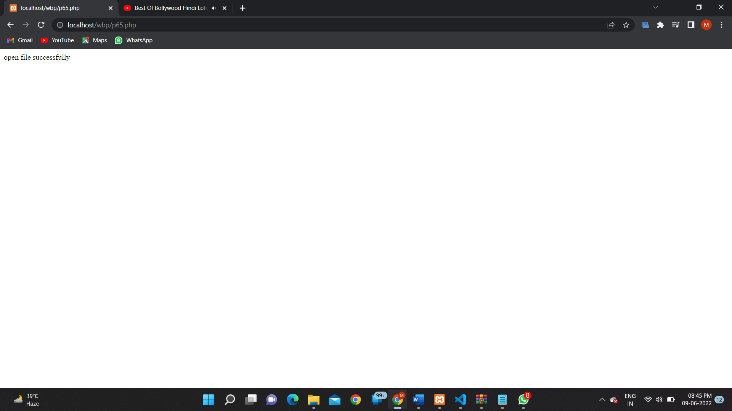

**PROGRAM 66:**

**SOURCE CODE:**

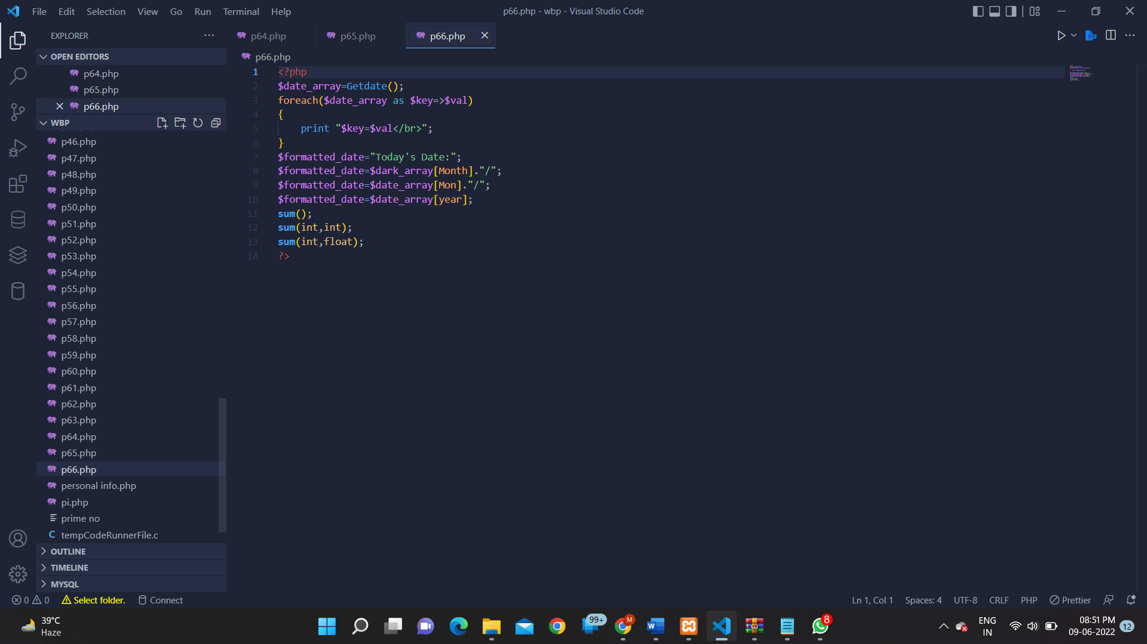

**OUTPUT:**

**PROGRAM 67:**

**SOURCE CODE:**

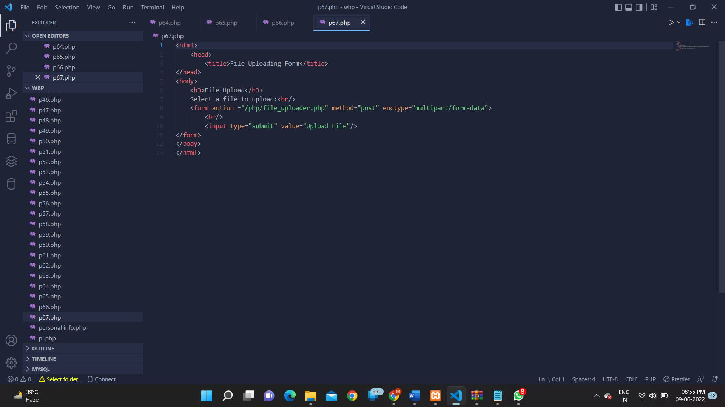

**OUTPUT:**

**PROGRAM 68:**

**SOURCE CODE:**

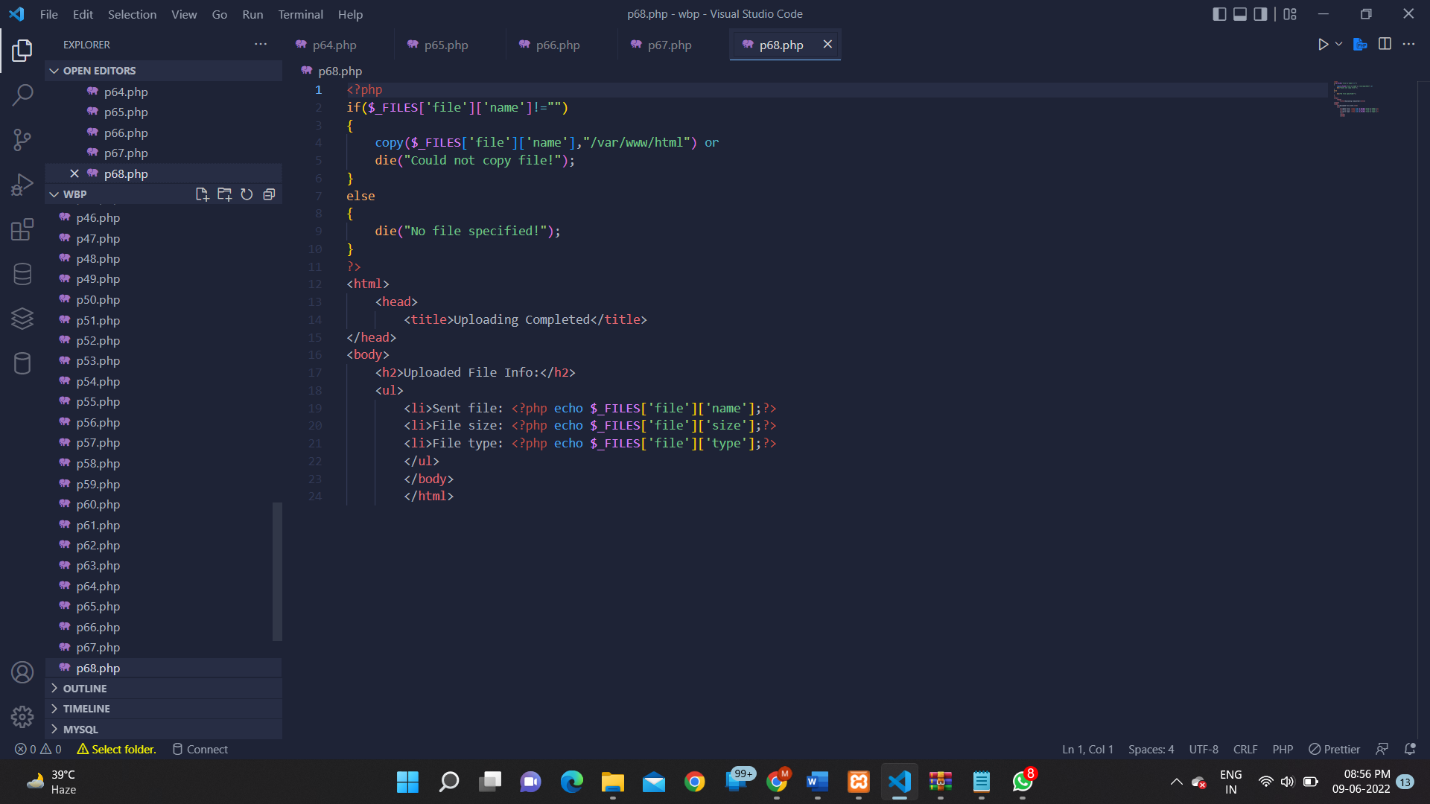

**OUTPUT:**

**PROGRAM 69:**

**SOURCE CODE:**

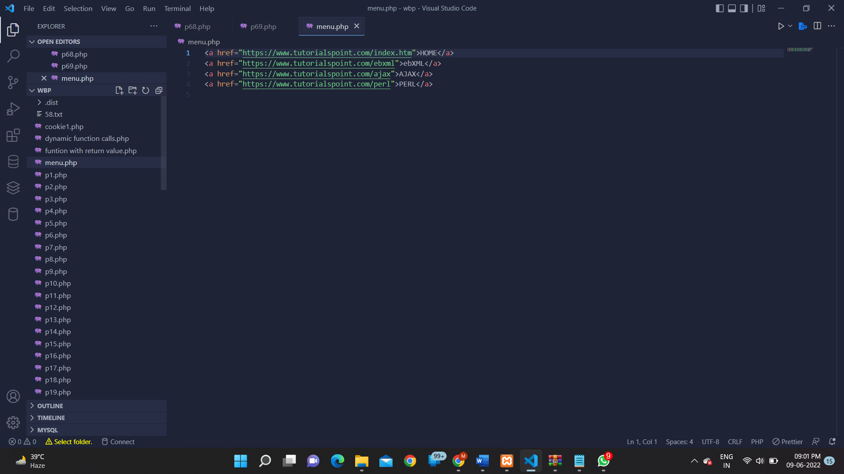

**OUTPUT:**

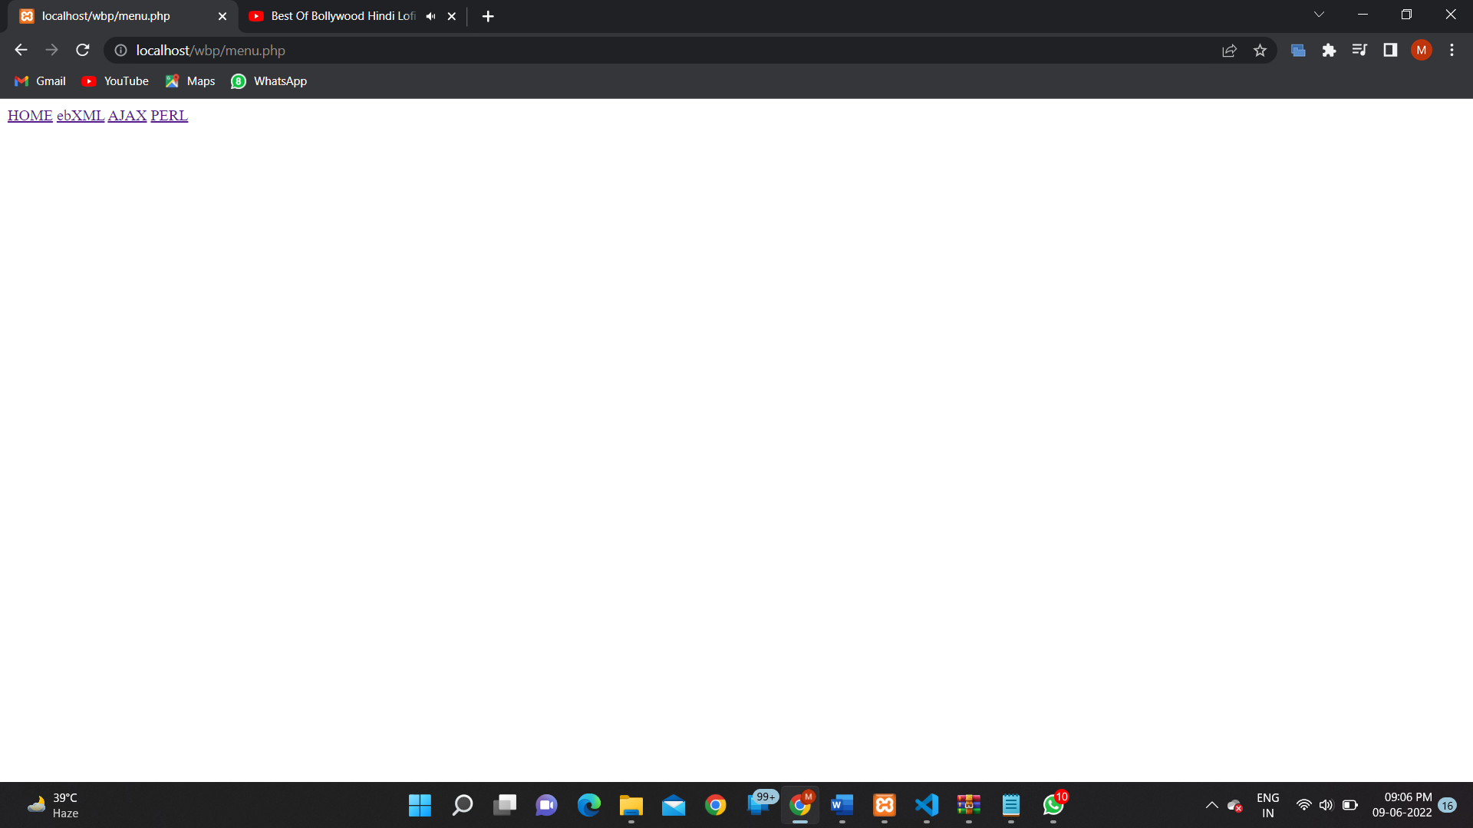

**PROGRAM 70:**

**SOURCE CODE:**

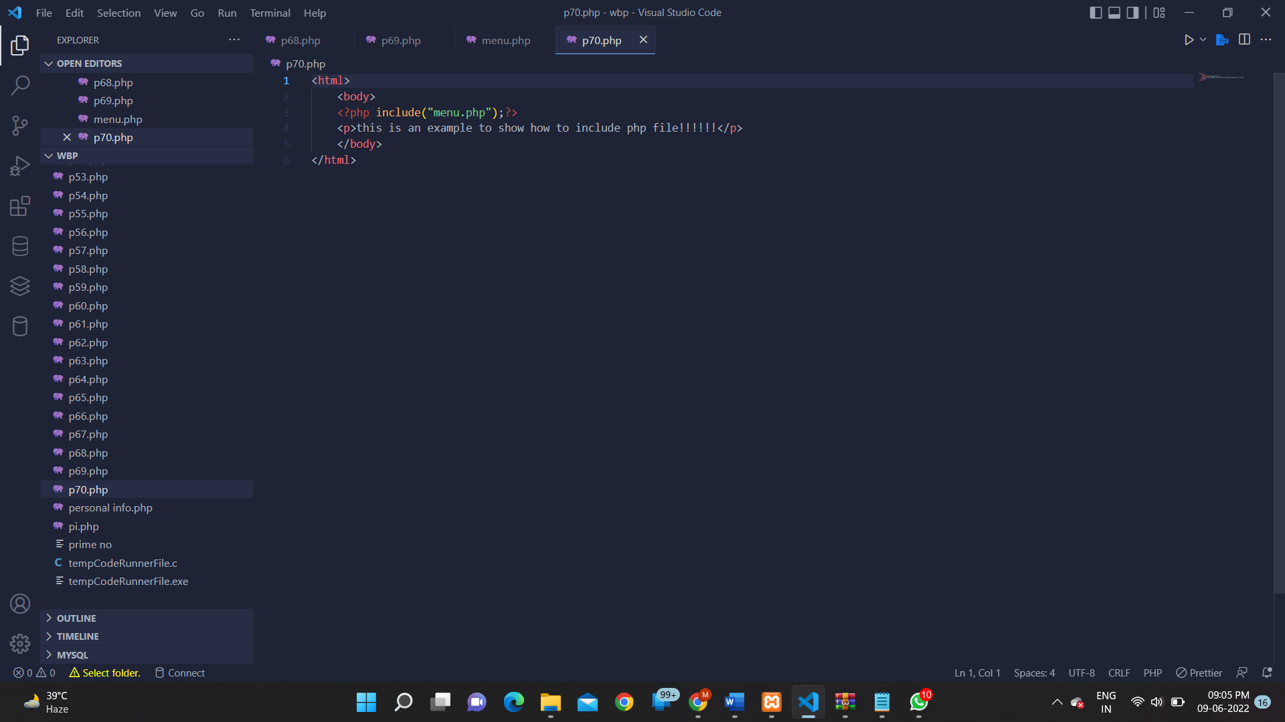

**OUTPUT:**

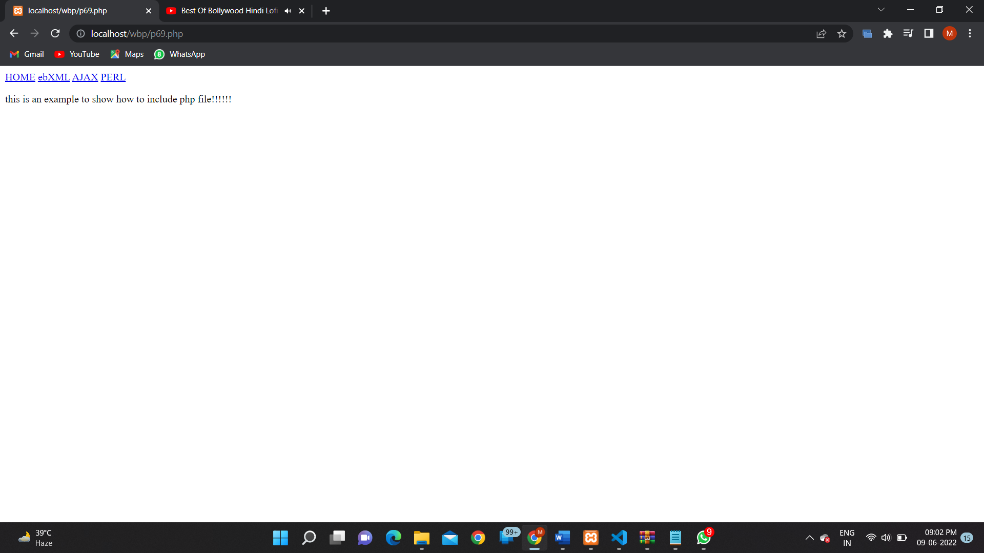

**PROGRAM 72:**

**SOURCE CODE:**

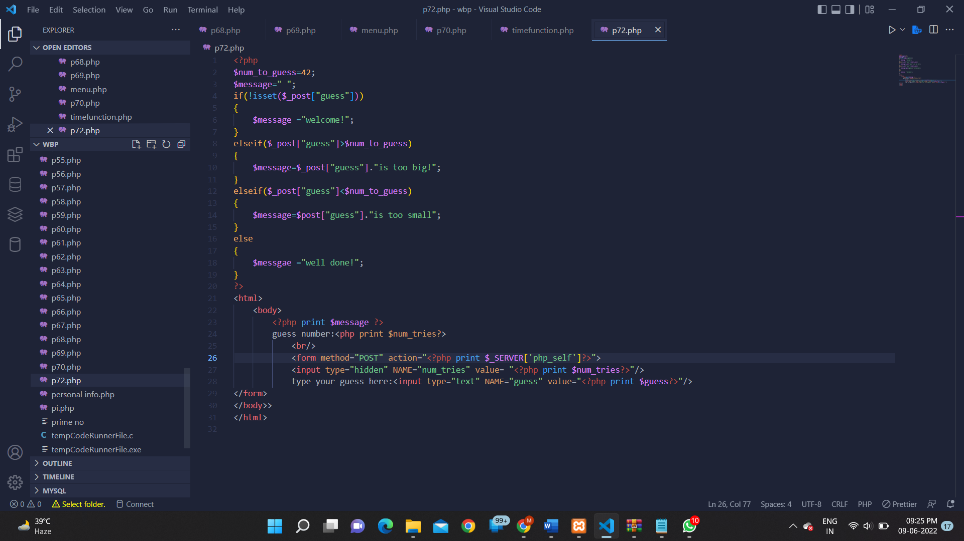

**OUTPUT:**